LE Advertising Extensions
  - Bluetooth® Specification Change Request

- Date 2016-Apr-19
- Revision D09r14
- Group Prepared By Core Specification Working Group
- Feedback Email core-main@bluetooth.org
Abstract:
This is the Change Request (CR) containing the removed, modified and added text for the Advertising Extension feature.

Reference to Bluetooth Specification
Volume Number | Part | Page / Section / Paragraph / Table / Figure / Equation
1 | A | 3.3.2.2  4.2.2.2  4.2.2.3  4.2.2.4
1 | E | New Section
2 | D | 2.3
2 | E | Various
3 | C | Various
6 | B | Various
6 | D | Various
CSS | A | 1
CSS | New Part | New Section

Owner of Part | Email Address | Related Errata
CSWG | core-main@bluetooth.org | NA

Revision History
Revision History | Date | Comments
D09R01 | 2015-10-16 | Initial Draft
D09R02 | 2015-11-10 | BARB comment resolutions to the FIPD (partial), GAP updates, other reviewer comment resolutions.
D09r03 | 2015-11-23 | BARB comment resolutions to the FIPD (complete), updates from F2F meeting, RSSI filtering additions
D09r04 | 2015-11-24 | Cleanup based on comments received by the CSWG
D09r05 | 2015-12-22 | Resolved comments from CSWG reviews
D09r06 | 2016-01-19 | - Resolved additional comments from CSWG  - Incorporated RSSI contribution  - Resolved Periodic HCI commands issues
D09r07 | 2016-02-10 | - Resolved many CSWG comments at F2F  - Removed RSSI filtering text – this feature split into a separate CR  - Removed Periodic_Advertising_ID  - Added text for chaining advertising data
D09r08 | 2016-02-18 | Resolved CSWG comments  - Renamed Periodic Advertising HCI events and command  - Added AUX_CHAIN_IND PDU  - Lots of HCI updates  - Added CSS section  - Remove RSSI filtering text  - Aux Offset rounding support  - Colored supplimental text to indicate inclusion into 5.0 is optional
D09r09 | 2016-02-19 | Resolved CSWG comments:  - Resolved all HCI comments resolved  - Resolved all GAP comments resolved  - Updated “Changes since FIPD” section  - Updated RF Path Compensation HCI Commands  - Connect Request mandated for connectable ADV_EXT_IND  - AdvData fragmenting text updated in HCI and LL  - Added text requiring LL to support 255 octet Advertising Channel PDU payloads  - Periodic Advertiser and device filtering interaction  - Extended Advertising Report event updated to only generate reports for advertisements with advertisers address (handles offloaded advertising transparently)
D09r10 | 2016-02-24 | Resolved CSWG comments  - Reorganized the events and commands into like groupings  - Renamed “LE Advertising Set Ended Event” to “LE Advertising Set Terminated Event”  - Resolved most of the HCI comments  - Resolved most of the GAP comments  - Resolved some of the LL comments  - Added Volume 1, Part E section on naming conventions  - Added acronyms for Advertising Set ID (SID) and Advertising Data ID (DID) subfields of the ADI to make it easier to read parts of the text  - Changed the scanner’s periodic advertising HCI commands/events to use Advertiser SID (from the ADI in the PDU) instead of Advertiser Set ID to avoid confusion with the advertising device’s periodic advertising HCI commands.
D09r11 | 2016-02-26 | Resolved CSWG comments
D09r12 | 2016-03-01 | BARB review version
D09r13 | 2016-04-08 | BARB resolutions
D09r14 | 2016-04-19 | CSWG F2F resolutions

Contributors
Name | Company
Robin Heydon | Qualcomm Technologies, Inc.
Joel Linsky | Qualcomm Atheros
Joel Linsky | Qualcomm Technologies, Inc.
Brian Redding | Qualcomm Atheros
Brian Redding | Qualcomm Technologies, Inc.
Tim Wei | IVT Corporation
Mayank Batra | Qualcomm Technologies, Inc.
Rasmus Abildgren | Samsung Electronics Co., Ltd.
Clive D.W. Feather | Samsung Electronics Co., Ltd.
Marcel Holtmann | Intel
Harish Balasubramaniam | Intel
Jeff Solum | Starkey
Bjarne Klemmensen | Oticon A/S
Angel Polo | Broadcom
Jonathan Tanner | Qualcomm Technologies, Inc.
L.C. Ko | MediaTek

DISCLAIMER AND COPYRIGHT NOTICE

This disclaimer applies to all draft specifications and final specifications adopted by the Bluetooth SIG Board of Directors (both of which are hereinafter referred to herein as a Bluetooth “Specification”). Your use of this Specification in any way is subject to your compliance with all conditions of such use, and your acceptance of all disclaimers and limitations as to such use, contained in this Specification. Any user of this Specification is advised to seek appropriate legal, engineering or other professional advice regarding the use, interpretation or effect of this Specification on any matters discussed in this Specification.
Use of Bluetooth Specifications and any related intellectual property is governed by the Promoters Membership Agreement among the Promoter Members and Bluetooth SIG (the “Promoters Agreement”), certain membership agreements between Bluetooth SIG and its Adopter and Associate Members, including, but not limited to, the Membership Application, the Bluetooth Patent/Copyright License Agreement and the Bluetooth Trademark License Agreement (collectively, the “Membership Agreements”) and the Bluetooth Specification Early Adopters Agreements (1.2 Early Adopters Agreements) among Early Adopter members of the unincorporated Bluetooth SIG and the Promoter Members (the “Early Adopters Agreement”). Certain rights and obligations of the Promoter Members under the Early Adopters Agreements have been assigned to Bluetooth SIG by the Promoter Members.
Use of the Specification by anyone who is not a member of Bluetooth SIG or a party to an Early Adopters Agreement (each such person or party, a “Member”) is prohibited. The use of any portion of a Bluetooth Specification may involve the use of intellectual property rights ("IPR"), including pending or issued patents, or copyrights or other rights. Bluetooth SIG has made no search or investigation for such rights and disclaims any undertaking or duty to do so. The legal rights and obligations of each Member are governed by the applicable Membership Agreements, Early Adopters Agreement or Promoters Agreement. No license, express or implied, by estoppel or otherwise, to any intellectual property rights are granted herein.
Any use of the Specification not in compliance with the terms of the applicable Membership Agreements, Early Adopters Agreement or Promoters Agreement is prohibited and any such prohibited use may result in (i) termination of the applicable Membership Agreements or Early Adopters Agreement and (ii) liability claims by Bluetooth SIG or any of its Members for patent, copyright and/or trademark infringement claims permitted by the applicable agreement or by applicable law.
THE SPECIFICATION IS PROVIDED “AS IS” WITH NO WARRANTIES WHATSOEVER, INCLUDING ANY WARRANTY OF MERCHANTABILITY, NONINFRINGEMENT, FITNESS FOR ANY PARTICULAR PURPOSE, SATISFACTORY QUALITY, OR REASONABLE SKILL OR CARE, OR ANY WARRANTY ARISING OUT OF ANY COURSE OF DEALING, USAGE, TRADE PRACTICE, PROPOSAL, SPECIFICATION OR SAMPLE.
Each Member hereby acknowledges that products equipped with the Bluetooth wireless technology ("Bluetooth Products") may be subject to various regulatory controls under the laws and regulations applicable to products using wireless non licensed spectrum of various governments worldwide. Such laws and regulatory controls may govern, among other things, the combination, operation, use, implementation and distribution of Bluetooth Products. Examples of such laws and regulatory controls include, but are not limited to, airline regulatory controls, telecommunications regulations, technology transfer controls and health and safety regulations. Each Member is solely responsible for the compliance by their Bluetooth Products with any such laws and regulations and for obtaining any and all required authorizations, permits, or licenses for their Bluetooth Products related to such regulations within the applicable jurisdictions. Each Member acknowledges that nothing in the Specification provides any information or assistance in connection with securing such compliance, authorizations or licenses. NOTHING IN THE SPECIFICATION CREATES ANY WARRANTIES, EITHER EXPRESS OR IMPLIED, REGARDING SUCH LAWS OR REGULATIONS.
ALL LIABILITY, INCLUDING LIABILITY FOR INFRINGEMENT OF ANY INTELLECTUAL PROPERTY RIGHTS OR FOR NONCOMPLIANCE WITH LAWS, RELATING TO USE OF THE SPECIFICATION IS EXPRESSLY DISCLAIMED. To the extent not prohibited by law, in no event will Bluetooth SIG or its Members or their affiliates be liable for any damages, including without limitation, lost revenue, profits, data or programs, or business interruption, or for special, indirect, consequential, incidental or punitive damages, however caused and regardless of the theory of liability, arising out of or related to any furnishing, practicing, modifying, use or the performance or implementation of the contents of this Specification, even if Bluetooth SIG or its Members or their affiliates have been advised of the possibility of such damages. BY USE OF THE SPECIFICATION, EACH MEMBER EXPRESSLY WAIVES ANY CLAIM AGAINST BLUETOOTH SIG AND ITS MEMBERS OR THEIR AFFILATES RELATED TO USE OF THE SPECIFICATION.
If this Specification is an intermediate draft, it is for comment only. No products should be designed based on it except solely to verify the prototyping specification at SIG sponsored IOP events and it does not represent any commitment to release or implement any portion of the intermediate draft, which may be withdrawn, modified, or replaced at any time in the adopted Specification.
Bluetooth SIG reserves the right to adopt any changes or alterations to the Specification it deems necessary or appropriate.
Copyright © 2015-2016. The Bluetooth word mark and logos are owned by Bluetooth SIG, Inc. All copyrights in the Bluetooth Specifications themselves are owned by Ericsson AB, Lenovo (Singapore) Pte. Ltd., Intel Corporation, Microsoft Corporation, Apple Inc., Nokia Corporation and Toshiba Corporation. Other third-party brands and names are the property of their respective owners.
Contents

1 Change Overview 11
1.1 Changes since FIPD 11
2 Change Request Instances 12
2.1 Volume 1, Part A: Architecture 12
2.1.1 [Modified Section] 3.2.2 LE Generic Packet Structure 12
2.1.2 [Modified Section] Section 3.2.2 LE Generic Packet Structure 13
2.1.3 [Modified Section] Section 3.3.2.2 Advertising Channels 13
2.1.4 [Modified Section] Section 4.2.2.2 Advertising Procedure 15
2.1.5 [Modified Section] Section 4.2.2.3 Scanning Procedure 16
2.1.6 [Modified Section] Section 4.2.2.5 Connecting Procedure 17
2.2 Volume 1, Part E: General Terminology and Interpretation 17
2.2.1 [New Section] X Naming Conventions 17
2.3 Volume 2, Part D: Error Codes 20
2.3.1 [Modified Section] 1.3 List of Error Codes 20
2.3.2 [Modified Section] 2.13 Request Rejected due to Limited Resources 20
2.3.3 [Modified Section] 2.57 Advertising Timeout 21
2.3.4 [New Section] 2.XXX Unknown Advertising Identifier 21
2.3.5 [New Section] 2.XXX Insufficient Resources 21
2.3.6 [New Section] 2.XXX Operation Cancelled by Host 21
2.4 Volume 2, Part E: Host Controller Interface 21
2.4.1 [Modified Section] 3.5 Controller Configuration 21
2.4.2 [Modified Section] 3.6 Device Discovery 23
2.4.3 [Modified Section] 3.7 Connection Setup 25
2.4.4 [Modified Section] 3.14 Host Flow Control 25
2.4.5 [Modified Section] 3.19 LE Controller Requirements 26
2.4.6 [Modified Section] 6.27 Supported Commands 27
2.4.7 [Modified Section] 7.1.49 Set Connectionless Slave Broadcast Command 28
2.4.8 [Modified Section] 7.7.65.2 LE Advertising Report Event 29
2.4.9 [New Section] 7.7.65.X LE Extended Advertising Report Event 29
2.4.10 [New Section] 7.7.65.X LE Periodic Advertising Sync Established Event 34
2.4.11 [New Section] 7.7.65.X LE Periodic Advertising Report Event 37
2.4.12 [New Section] 7.7.65.X LE Periodic Advertising Sync Lost Event 39
2.4.13 [New Section] 7.7.65.X LE Scan Timeout Event 40
2.4.14 [New Section] 7.7.65.X LE Advertising Set Terminated Event 40
2.4.15 [New Section] 7.7.65.X LE Scan Request Received Event 42
2.4.16 [Modified Section] 7.8.1 LE Set Event Mask Command 43
2.4.17 [Modified Section] 7.8.7 LE Set Advertising Data Command 43
2.4.18 [Modified Section] 7.8.9 LE Set Advertise Enable Command 43
2.4.19 [Modified Section] 7.8.12 LE Create Connection Command 44
2.4.20 [Modified Section] 7.8.12 LE Create Connection Cancel Command 44
2.4.21 [New Section] 7.8.X LE Set Advertising Set Random Address Command 45
2.4.22 [New Section] 7.8.X LE Set Extended Advertising Parameters Command 46
2.4.23 [New Section] 7.8.X LE Set Extended Advertising Data Command 53
2.4.24 [New Section] 7.8.X LE Set Extended Scan Response Data Command 56
2.4.25 [New Section] 7.8.X LE Set Extended Advertising Enable Command 59
2.4.26 [New Section] 7.8.X LE Read Maximum Advertising Data Length Command 61
2.4.27 [New Section] 7.8.X LE Read Number of Supported Advertising Sets Command 62
2.4.28 [New Section] 7.8.X LE Remove Advertising Set Command 63
2.4.29 [New Section] 7.8.X LE Clear Advertising Sets Command 64
2.4.30 [New Section] 7.8.X LE Set Periodic Advertising Parameters Command 65
2.4.31 [New Section] 7.8.X LE Set Periodic Advertising Data Command 68
2.4.32 [New Section] 7.8.X LE Set Periodic Advertising Enable Command 70
2.4.33 [New Section] 7.8.X LE Set Extended Scan Parameters Command 72
2.4.34 [New Section] 7.8.X LE Set Extended Scan Enable Command 75
2.4.35 [New Section] 7.8.X LE Extended Create Connection Command 78
2.4.36 [New Section] 7.8.X LE Periodic Advertising Create Sync Command 84
2.4.37 [New Section] 7.8.X LE Periodic Advertising Create Sync Cancel Command 87
2.4.38 [New Section] 7.8.X LE Periodic Advertising Terminate Sync Command 87
2.4.39 [New Section] 7.8.X LE Add Device To Periodic Advertiser List Command 89
2.4.40 [New Section] 7.8.X LE Remove Device From Periodic Advertiser List Command 90
2.4.41 [New Section] 7.8.X LE Clear Periodic Advertiser List Command 92
2.4.42 [New Section] 7.8.X LE Read Periodic Advertiser List Size Command 92
2.4.43 [New Section] 7.8.X LE Read Transmit Power Command 93
2.4.44 [New Section] 7.8.x LE Read RF Path Compensation Command 94
2.4.45 [New Section] 7.8.X LE Write RF Path Compensation Command 96
2.5 Volume 3, Part C: Generic Access Profile 97
2.5.1 [Modified Section] 2.2.2 Roles when Operating over an LE Physical Transport 97
2.5.2 [Modified Section] 2.2.2.5 Concurrent Operation in Multiple GAP Roles 98
2.5.3 [Modified Section] 9 Operational Modes and Procedures – LE Physical Transport 99
2.5.4 [Modified Section] 9.1.1 Broadcast Mode 99
2.5.5 [Modified Section] 9.1.2 Observation Procedure 100
2.5.6 [Modified Section] 9.2 Discovery Mode and Procedures 100
2.5.7 [Modified Section] 9.2.3 Limited Discoverable Mode 100
2.5.8 [Modified Section] 9.2.4 General Discoverable Mode 102
2.5.9 [Modified Section] 9.2.5 Limited Discovery Procedure 103
2.5.10 [Modified Section] 9.2.6 General Discovery Procedure 104
2.5.11 [Modified Section] 9.3.2 Non-Connectable Mode 105
2.5.12 The device may configure and enable multiple independent advertising sets. [Modified Section] 9.3.3 Directed Connectable Mode 105
2.5.13 The device may configure and enable multiple independent advertising sets. [Modified Section] 9.3.4 Undirected Connectable Mode 105
2.5.14 [Modified Section] 9.3.11 Connection Establishment Timing Parameters 106
2.5.15 [Modified Section] 9.3.12 Connection Establishment Timing Parameters 107
2.5.16 [Modified Section] 11 Advertising and Scan Response Data Format 108
2.5.17 [Modified Section] Appendix A (Normative): Timers and Constants 109
2.6 Volume 6, Part B: Link Layer Specification 110
2.6.1 [Modified Section] 1.4.1 Advertising and Data Channel Indices 110
2.6.2 [Modified Section] 2.1: Packet Format 111
2.6.3 [Modified Section] 2.1.2: Access Address 112
2.6.4 [Modified Section] 2.1.3: PDU 112
2.6.5 [New Section] 2.1.X Supplemental 112
2.6.6 [Modified Section] 2.3 Advertising Channel PDU 112
2.6.7 [New Section] 2.3.X Common Extended Advertising Payload Format 114
2.6.8 [New Section] 2.3.X.1 AdvA field 116
2.6.9 [New Section] 2.3.X.2 TargetA field 116
2.6.10 [New Section] 2.3.X.3 SuppInfo field 116
2.6.11 [New Section] 2.3.X.4 AdvDataInfo field 117
2.6.12 [New Section] 2.3.X.5 AuxPtr field 117
2.6.13 [New Section] 2.3.X.6 SyncInfo field 119
2.6.14 [New Section] 2.3.X.7 TxPower field 120
2.6.15 [New Section] 2.3.X.8 ACAD field 120
2.6.16 [New Section] 2.3.X.9 Host Advertising Data 120
2.6.17 [Modified Section] 2.3.1 Advertising PDUs 121
2.6.18 [Modified Section] 2.3.1.4 ADV_SCAN_IND 121
2.6.19 [New Section] 2.3.1.X ADV_EXT_IND 122
2.6.20 [New Section] 2.3.1.X AUX_ADV_IND 123
2.6.21 [New Section] 2.3.1.X AUX_SYNC_IND 124
2.6.22 [New Section] 2.3.1.X AUX_CHAIN_IND 124
2.6.23 [Modified Section] 2.3.2 Scanning PDUs 125
2.6.24 [Modified Section] 2.3.2.1 SCAN_REQ and AUX_SCAN_REQ 126
2.6.25 [New Section] 2.3.2.X AUX_SCAN_RSP 126
2.6.26 [Modified Section] 2.3.3 Initiating PDUs 127
2.6.27 [Modified Section] 2.3.3.1 CONNECT_IND and AUX_CONNECT_REQ 127
2.6.28 [New Section] 2.3.3.X AUX_CONNECT_RSP 127
2.6.29 [Modified Section] 3.1.1 CRC Generation 128
2.6.30 [New Section] 4.1 Frame Space 128
2.6.31 [Modified Section] 4.1.1 Inter Frame Space 129
2.6.32 [New Section] 4.1.2 Minimum AUX Frame Space 129
2.6.33 [Modified Section] 4.4.2 Advertising State 129
2.6.34 [Modified Section] 4.4.2.1 Advertising Channel Index Selection 131
2.6.35 [Modified Section] 4.4.2.2 Advertising Events 132
2.6.36 [New Section] 4.4.2.2.1 Advertising Interval 132
2.6.37 [New Section] 4.4.2.2.2 Extended Advertising Event 133
2.6.38 [Modified Section] 4.4.2.3 Connectable and Scannable Undirected Event Type 134
2.6.39 [Modified Section] 4.4.2.4 Connectable Directed Event Type 136
2.6.40 [New Section] 4.4.2.4.1 Connectable Directed Event Type using ADV_DIRECT_IND 137
2.6.41 [Modified Section] 4.4.2.4.2 Low Duty Cycle Connectable Directed Advertising 138
2.6.42 [Modified Section] 4.4.2.4.3 High Duty Cycle Connectable Directed Advertising 138
2.6.43 [New Section] 4.4.2.4.4 Connectable Directed Event Type using ADV_EXT_IND 139
2.6.44 [Modified Section] 4.4.2.5 Scannable Undirected Event Type 141
2.6.45 [New Section] 4.4.2.5.1 Scannable Undirected Event Type using ADV_SCAN_IND 141
2.6.46 [New Section] 4.4.2.5.2 Scannable Undirected Event Type using ADV_EXT_IND 143
2.6.47 [Modified Section] 4.4.2.6 Non-connectable Undirected Event Type 144
2.6.48 [New Section] 4.4.2.7 Connectable Undirected Event Type 146
2.6.49 [New Section] 4.4.2.9 Scannable Directed Event Type 148
2.6.50 [New Section] 4.4.2.10 Non-Connectable Directed Event Type 149
2.6.51 [New Section] 4.4.2.11 Advertising Data Sets 149
2.6.52 [New Section] 4.4.2.12 Using AdvDataInfo (ADI) 150
2.6.53 [New Section] 4.4.2.13 Periodic Advertising 150
2.6.54 [New Section] 4.4.2.13.1 Autonomous Periodic Advertising 151
2.6.55 [New Section] 4.4.2.13.2 On-Demand Periodic Advertising 152
2.6.56 [Modified Section] 4.4.3 Scanning State 153
2.6.57 [Modified Section] 4.4.3.2 Active Scanning 153
2.6.58 [New Section] 4.4.3.3 Advertising Data Sets 155
2.6.59 [New Section] 4.4.3.4 Periodic Advertisements 155
2.6.60 [New Section] 4.4.3.5 Duplicate Advertisement Report Filtering 156
2.6.61 [Modified Section] 4.4.4 Initiating State 156
2.6.62 [New Section] 4.4.4.1 Connect Requests on the Primary Advertising Channel 157
2.6.63 [New Section] 4.4.4.2 Connect Requests on the Secondary Advertising Channel 157
2.6.64 [Modified Section] 4.5 Connection State 158
2.6.65 [Modified Section] 4.5.3 Connection Event Transmission Window 159
2.6.66 [Modified Section] 4.5.4 Connection Setup – Master Role 159
2.6.67 [Modified Section] 4.5.5 Connection Setup – Slave Role 160
2.6.68 [Modified Section] 4.6 Feature Support 161
2.6.69 [New Section] 4.6.X LE Extended Advertising 162
2.6.70 [New Section] 4.6.X LE Periodic Advertising 163
2.7 Volume 6, Part D: Message Sequence Charts 163
2.7.1 [Modified Section] 3.2 Directed Advertising 163
2.7.2 [NEW SECTION] 2.X Periodic Advertiser List 163
2.7.3 [NEW SECTION] 3.X Advertising Using ADV_EXT_IND 164
2.7.4 [NEW SECTION] 3.X Scan Request Notifications 165
2.7.5 [NEW SECTION] 3.X Advertising Duration Ended 165
2.7.6 [NEW SECTION] 3.X Periodic Advertising 166
2.7.7 [NEW SECTION] 4.X Active Scanning on the primary advertising channel 169
2.7.8 [NEW SECTION] 4.X Active scanning on the secondary advertising channel 171
2.7.9 [NEW SECTION] 4.X Scan Timeout 173
2.7.10 [NEW SECTION] 4.X Periodic Scanning 173
2.7.11 [NEW SECTION] 4.X Periodic Scanning Cancel 176
2.7.12 [NEW SECTION] 4.X Periodic Scanning Timeout 176
2.7.13 [NEW SECTION] 4.X Periodic Scanning Terminate 177
2.7.14 [NEW SECTION] 5.X Initiating a Connection on the secondary advertising channel 178
2.8 Core Specification Supplement (CSS) 180
2.8.1 [Modified Part] Part A: Host Data Types Specification 180
2.8.2 [Modified Section] 1 Host Data Types Definitions and Formats 180
2.8.3 [New Part] Part X: Controller Data Types Specification 180
3 References 183

Change Overview

Changes since FIPD
- New AUX_CHAIN_IND PDU added to support fragmented advData for advertising events, scan responses and periodic advertising.
- ADI field coverage change
  - ADI in the ADV_EXT_IND packet refers to all advData in the AUX_ADV_IND, AUX_CHAIN_IND and AUX_SYNC_IND packets pointed to by the AuxPtr and SyncInfo fields. All ADI fields used in the AUX_ADV_IND, AUX_CHAIN_IND and AUX_SYNC_IND packets are the same value used in the ADV_EXT_IND packet.
  - ADI in a scannable ADV_EXT_IND packet refers to the advData in the AUX_SCAN_RSP packet (AUX_ADV_IND shall not have advData).
  - ADI shall be reserved for future use for any other advertising PDU
  - ADI’s Data ID field applies to the advData in the AUX_ADV_IND packet pointed to by the AuxPtr field
  - ADI’s Set ID field applies to all packets pointed to by the AuxPtr (AUX_ADV_IND or AUX_CHAIN_IND) or SyncInfo field (AUX_SYNC_IND).
- Connection requests only supported on secondary advertising channel when connectable advertising events use the extended advertising PDUs.
- Scan request only supported on secondary advertising channel when scannable advertising events use the extended advertising PDUs.
- Scannable advertising not permitted to have advData in AUX_ADV_IND
- New error codes added
- Architecture and GAP updates including changes for LR feature
- Significant HCI event and command changes
- SyncInfo field added channel index to support legacy channel selection algorithm (this change was actually made in the FIPD during BARB comment resolution)
- Added RSSI Filtering List to Link Layer
  - RSSI Filtering removed from CR and moved to separate document
- Added CSS section to capture initial Additional Controller Advertising Data (ACAD) types.
  - Channel map updates during periodic advertising
- AUX_ADV_IND offset timing variability allows for controller scheduling flexiblity
- Scan responses (AUX_SCAN_RSP) shall occur prior to the start of the next advertising event
- Added Naming Conventions for PDUs to Volume 1, Part E per Errata 6673.
- LE Feature bit definitions added
- Requirement on scanners to support 255 octet advertising channel PDU payload.
- Note: This CR assumes the current channel selection algorithm for connection in v4.0-4.2. Channel Selection Algorithm #2 feature to included changes necessary for the Advertising Extension feature.

Change Request Instances
This section contains the proposed text changes to the existing specification language. For commentary on motivations for specific changes, please see the previous section.

Volume 1, Part A: Architecture

[Modified Section] 3.2.2 LE Generic Packet Structure
[Note to Editor: Append the following after Figure 3.X+2: LE Coded PHY packet structure]
When using the LE Coded PHY, it is recommended to carefully consider the impact of radio-on time for power consumption and duty cycle for scheduling and coexistence over the air. The LE Coded PHY with S=8 coding (125 kb/s) represents the worst case, when considering radio-on time and duty cycle, where each packet sent over the air will be approximately 8 times larger than LE 1M.

Table 3.X+1 illustrates the on-air time of advertising events with different sizes of AdvData. The first is using connectable undirected advertising events where the AdvData is sent on the primary advertising channel. The second is using events where the AdvData is offloaded to the secondary advertising channel. The usage of the primary and secondary advertising channel is described in Section 3.2.2.2. Numbers in parentheses are hypothetical and show cases which are not valid in a compliant implementation.

AdvData  [Bytes] | Connectable Undirected Advertising Event  [µs] |  | Connectable Undirected Advertising Event using Offloading  [µs]
AdvData  [Bytes] | LE 1M | Coded  S=8 | LE 1M | Coded  S=8
0 | 384 | (3,312) | 504 | 4,352
15 | 744 | (6,192) | 624 | 5,312
31 | 1,128 | (9,264) | 752 | 6,336
100 | (2,784) | (22,512) | 1,304 | 10,752
237 | (6,072) | (48,816) | 2,400 | 19,520

Table 3.X+1: On-air time for various advertising events

Note: The events without offloading were calculated using three ADV_IND PDUs, while the events with offloading used three ADV_EXT_IND PDUs containing only an AuxPtr field plus one AUX_ADV_IND PDU with AdvA present and holding the AdvData.

Table 3.X+2 illustrates, for a range of payload sizes, the difference in Link Layer Data Channel PDU packet durations for connections over LE 1M PHY and LE Coded PHY with S=8 coding. Connection duty cycle for a specific implementation may be easily calculated from this information.
Payload [bytes] | LL Data Channel PDU  [µs]
Payload [bytes] | LE 1M | LE Coded  S=8
0 | 80 | 720
15 | 200 | 1680
31 | 328 | 2704
100 | 880 | 7120
255 | 2120 | 17040
Table 3.X+2: On-air time for various data channel packets

[Modified Section] Section 3.2.2 LE Generic Packet Structure
Section 3.3.2 LE Generic Packet Structure
[Modification after Figure 3.6]
The physical link identifier is not contained in the link layer air interface packet. The physical channel identifiers are either fixed or are determined at connection setup. All LE packets include the Access Address. This is used to identify communications on a physical channel, and to exclude or ignore packets on different physical channels that are using the same PHY channels in physical proximity. The Access Address determines whether the packet is directed to the advertising physical channel (and thus an advertising physical link) used for non-periodic advertising, the advertising physical channel used for periodic advertising, or to a piconet physical channel (and thus an active physical link to a device). The LE advertising physical channel used for non-periodic advertising, and thus all LE advertising physical links, use a fixed Access Address. The LE advertising physical channel used for periodic advertising and LE piconet physical channels use a randomly generated 32-bit value as their Access Address. This provides a high number of periodic advertisements and a high number of active devices that can be addressed in an LE piconet.

[Modified Section] Section 3.3.2.2 Advertising Channels
Section 3.3.2.2 Advertisement broadcast Advertising channels
3.3.2.2.1 Overview

TheAn LE advertising channel are is used to set up connections between two devices or to communicate broadcast information between unconnected devices.

3.3.2.2.2 Characteristics

There are two LE advertising channels: the primary advertising channel and the secondary advertising channel.

The LE primary advertisement broadcast advertising channel is a set of three fixed PHY channels spread evenly across the LE frequency spectrum. The number of primary advertising PHY channels can be reduced by the advertising device in order to reduce interference. All advertising packets use a fixed Access Address. The primary advertising channel may use either the LE 1M or LE Coded PHY.

The primary advertising channel is divided into advertising events where each advertising event can hop on all three advertising PHY channels. Consecutive advertising events begin on the first advertising PHY channel. The advertising events occur at regular intervals which are slightly modified with a random delay to aid in interference avoidance.

On the LE primary advertising broadcast channel the advertising device controls access to the channel. The advertising device starts its transmission in an advertising event and transmits advertising packets on one or more of the three advertising PHY channels. Each advertising packet is sent on a different advertising PHY channel at a fixed interval. Four Five types of advertising events can be used, with each advertising event type having different sized advertising packets. These advertising packets can vary in length from 16 11 to 47 octets.

Some advertising events sent by the advertising device permit the listening device to concurrently send scan requests or connection requests packets on the same advertising PHY channel in which the advertising packet was received. The advertising device can send a scan response packet again on the same advertising PHY channel within the same advertising event. The scan response packet can vary in length from 16 11 to 47 octets.

The secondary advertising channel is a set of 37 fixed PHY channels spread across the LE frequency spectrum. These are the same fixed LE PHY channels used by the data channel. The secondary advertising channel uses the same channel indices as the data channel. Advertising packets used on the secondary advertising channel can vary in length from 10 to 266 octets on the Uncoded PHY. Advertising packets on the secondary advertising channel are not part of the advertising event but are part of the extended advertising event. These extended advertising events begin at the same time as the advertising event on the primary advertising channel and conclude with the last packet on the secondary advertising channel.

The secondary advertising channel is used to offload data that would otherwise be transmitted on the primary advertising channel. Advertising packets on the secondary advertising channel (“auxiliary packets”) are scheduled by the advertiser when sufficient over-the-air time is available. The advertising packet on the primary advertising channel contains the PHY channel and the offset to the start time of the auxiliary packet.

The secondary advertising channel can use any PHY. All advertising packets on the secondary advertising channel in the same extended advertising event use the same PHY, which is specified in the advertising packet on the primary advertising channel.

The secondary advertising channel is also used to provide “periodic advertising”, which is sent on a periodic basis with each packet at a predictable interval from the previous one. Occasional advertisements on the primary advertising channel, with associated auxiliary packets, allow the periodic advertisements to be found. Periodic advertisements are not part of either the advertising or extended advertising events.

3.3.2.2.3 Topology

An LE advertising channel can be shared by any number of LE devices. Any number of LE devices can transmit advertising packets while sharing the same three advertising PHY channels. Any number of scanning devices can listen on the advertising channel. An advertising device can advertise and be connected on an LE piconet channel simultaneously. Scanning devices may also be connected to one or more LE piconet channels simultaneously.

[Modified Section] Section 4.2.2.2 Advertising Procedure

4.2.2.2 Advertising Procedure
An advertiser uses the advertising procedure to perform unidirectional broadcasts to devices in the area. The unidirectional broadcast occurs without a connection between the advertising device and the listening devices. The advertising procedure can be used to establish connections with nearby initiating devices or used to provide periodic broadcast of user data to scanning devices listening on the advertising channel. The advertising procedure uses the primary advertising physical channel for all advertising broadcasts. However, some of the data may be offloaded on to the secondary advertising channel in one or more auxiliary packets to reduce both the occupancy of the primary advertising channel and the total on-air time and also to allow the data to be longer than the maximum that will fit into a single packet.

An LE device connected in an LE piconet may advertise using any type of advertising event. Time spent advertising while connected needs to be balanced with the connection requirements needed to maintain the already established connection(s) (if the device is a slave in the piconet then it needs to maintain its connection with the master and if the device is the master it needs to maintain its connection(s) with the one or more slaves in the piconet).

Advertising devices may receive scan requests from listening devices in order to get additional user data from the advertising device. Scan responses are sent by the advertising device to the device making the scan request over the same advertising physical channel. Whereas the broadcast user data sent as part of the advertising packets is typically dynamic in nature, scan response data is generally static in nature.

An advertising device may receive connection requests from initiator devices on the advertising broadcast physical channel. If the advertising device was using a connectable advertising event and the initiating device is not being filtered by the device filtering procedure, the advertising device ceases advertising and enters the connected mode. The device can begin advertising again after it is in the connected mode.

When advertising on LE Uncoded PHYs, scan requests, and scan responses can take place on the same PHY channel as the original advertisement or can be offloaded to the secondary advertising channel. In some cases when advertising on the LE Uncoded PHY, connection request and connection responses are offloaded to the secondary advertising channel. When advertising on the LE Coded PHY, scan requests, scan responses, connection requests, and connection responses are always offloaded. As with advertising data, offloading is carried out by having the initial advertisement on the primary advertising channel point to an auxiliary packet on the secondary advertising channel. Scan requests and scan responses, connection requests, and connection responses are made on the same PHY and same channel as the auxiliary packet.

[Modified Section] Section 4.2.2.3 Scanning Procedure

4.2.2.3 Scanning Procedure

A scanning device uses the scanning procedure to listen for unidirectional broadcasts of user data from advertising devices using the advertising physical channel. A scanning device can request additional user data from an advertising device by making a scan request over the advertising physical channel. The advertising device responds to these requests with additional user data sent to the scanning device over the advertising physical channel.

The scanning procedure can be used while connected to other LE devices in an LE piconet. Time spent scanning while connected needs to be balanced with the connection requirements needed to maintain the already established connection with the other LE devices in the piconet.

If the broadcasts are connectable advertising events and the scanning device is in the initiator mode, it can initiate a connection by sending a connection request on the primary advertising broadcast physical channel or secondary advertising channel to the advertising device. Once the connection request is sent on the primary channel, the scanning device ceases the initiator mode scanning for additional broadcasts and enters the connected mode. When the connection request is sent on the secondary channel, the scanning device leaves the initiator mode, ceasing scanning for additional broadcasts, and enters the connected mode when it receives the connection response. The device can use the scanning procedure after it enters the connected mode. For a master device, using the initiator mode and scanning for connectable advertisements is how additional devices can be added to the master's LE piconet.

[Modified Section] Section 4.2.2.5 Connecting Procedure

4.2.2.5 Connecting Procedure

The procedure for forming connections is asymmetrical and requires that one Bluetooth device carries out the advertising procedure while the other Bluetooth device carries out the scanning procedure. The advertising procedure can be targeted, so that only one device will respond to the advertising. The scanning device can also target an advertising device by first discovering that the advertising device is present in a connectable manner, and in the given area, and then scanning only connectable advertising events from that device using the device filter. After receiving connectable advertising events from the targeted advertising device, it can initiate a connection by sending the connection request to the targeted advertising device over the primary advertising broadcast physical channel or secondary advertising channel.

Time spent scanning while connected needs to be balanced with the connection requirements needed to maintain the already established connection with the other LE devices in the piconet.

Volume 1, Part E: General Terminology and Interpretation

[New Section] X Naming Conventions
X Naming Conventions
X.1 BR/EDR
This section is not currently used.
X.2 Bluetooth Low Energy
X.2.1 Link Layer PDUs
A consistent naming scheme is used for Link Layer PDUs to make their purpose and usage clearer.
The PDU name consists of up to five components. Each component is entirely uppercase. Those components that are present are separated by a single underscore (e.g. if only three of the five components are present, there are two underscores, not four). In order, these components are:
- Where the PDU is used (optional)
- When the PDU is used (mandatory)
- What the PDU does (optional but usually present)
- Version (optional)
- How the PDU is used (mandatory)
The first component (“where”) indicates which physical channel the PDU is used on. The values currently used are shown in table X.1.
Value | Meaning
none | PDU is used on the primary advertising channel or any non-advertising channel
AUX | PDU is used on the secondary advertising channel
Table X.1: first component (“where”) values
The second component (“when”) indicates which kind of Link Layer procedure makes use of the PDU. The values currently used are shown in table X.2.
Value | Meaning
ADV | Normal advertising
SYNC | Periodic advertising
SCAN | Scanning
CONNECT | Connecting
CHAIN | Fragmented Data
LL | Data Link Layer
DATA | Reliable data | See note 1
Table X.2: second component (“when”) values
Note 1: This name is not currently used in the specification.
The third component (“what”) distinguishes different PDUs that are found in the same context. While it is normally present, it is sometimes omitted where there is a “default” or “usual” case. This component may contain more than one word, separated by underlines.
For example, the different cases for normal advertising are shown in table X.3.
Value | Meaning
none | Various
DIRECT | Connectable directed
NONCON | Non-connectable undirected
SCAN | Scannable undirected
Table X.3: third component (“what”) values for normal advertising
As another example, each Link Layer PDU has a value for this component based on the specific procedure it is used for.
The fourth component (“version”) distinguishes between PDUs with the same purpose but different contents (usually because the original PDU was found to be insufficient to handle new features). The values currently used are shown in table X.4.
Value | Meaning
none | Original version of the PDU
EXT | Extended version of the PDU
Table X.4: fourth component (“version”) values
The fifth and final component (“how”) indicates how the PDU fits into a procedure. The values currently used are shown in table X.5.
Value | Meaning
IND | An indication that doesn’t expect a reply
REQ | A request that expects a response
RSP | A response to a request
Table X.5: fifth component (“how”) values
Some examples of this convention in use, showing how the PDU name breaks up into the five components, are given in table X.6.
PDU name | Components
PDU name | where | when | what | version | how
ADV_IND |  | ADV |  |  | IND
ADV_DIRECT_IND |  | ADV | DIRECT |  | IND
ADV_EXT_IND |  | ADV |  | EXT | IND
AUX_ADV_IND | AUX | ADV |  |  | IND
AUX_CHAIN_IND | AUX | CHAIN |  |  | IND
SCAN_REQ |  | SCAN |  |  | REQ
AUX_SYNC_IND | AUX | SYNC |  |  | IND
LL_PHY_UPDATE_IND |  | LL | PHY_UPDATE |  | IND
LL_LENGTH_REQ |  | LL | LENGTH |  | REQ
LL_LENGTH_RSP |  | LL | LENGTH |  | RSP
LL_REJECT_IND |  | LL | REJECT |  | IND
LL_REJECT_EXT_INT |  | LL | REJECT | EXT | IND
Table X.6: examples
Thus AUX_SYNC_IND is a PDU used for synchronous advertising on the secondary advertising channel that does not expect a response.

Volume 2, Part D: Error Codes

[Modified Section] 1.3 List of Error Codes
[Editor Note: Change Entry in Table 1.1]
0x0D | Connection Request Rejected due to Limited Resources
0x3C | Directed Advertising Timeout

[Editor Note: Append Entry to the end of Table 1.1]
0x42 | Unknown Advertising Identifier
0x43 | Limit Reached
0x44 | Operation Cancelled by Host

[Modified Section] 2.13 Request Rejected due to Limited Resources
2.13 CONNECTION REQUEST REJECTED DUE TO LIMITED
RESOURCES (0x0D)
The Connection Request Rejected Due To Limited Resources error code indicates that
a connection request was rejected due to limited resources. The error could be a temporary condition so later requests may succeed without error.

[Modified Section] 2.57 Advertising Timeout
2.57 DIRECTED ADVERTISING TIMEOUT (0x3C)
The Directed Advertising Timeout error code indicates that directed advertising for a fixed duration completed without a connection being created. or, for directed advertising, that advertising completed without a connection being created.

[New Section] 2.XXX Unknown Advertising Identifier
2.XXX UNKNOWN ADVERTISING IDENTIFIER (0x42)
The Unknown Advertising Identifier error code indicates that a command was sent from the Host that should identify an Advertising or Sync handle, but the Advertising or Sync handle does not exist.

[New Section] 2.XXX Limit Reached
2.XXX LIMIT REACHED (0x43)
The Limit Reached error code indicates that number of operations requested has been reached and has indicated the completion of the activity (e.g. advertising or scanning).

[New Section] 2.XXX Operation Cancelled by Host
2.XXX OPERATION CANCELLED BY HOST (0x44)
The Operation Cancelled by Host error code indicates a request to the Controller issued by the Host and still pending was successfully cancelled.

Volume 2, Part E: Host Controller Interface

[Modified Section] 3.5 Controller Configuration
Name | Vers. | Summary description | Supported Controllers
LE Set Advertising Set Random Address Command | Shanghai | The LE Set Advertising Random Address command will set the random address used in advertising. | LE
LE Set Extended Advertising Parameters Command | Shanghai | The LE Set Extended Advertising Parameters command will set the parameters used for advertising. | LE
LE Set Periodic Advertising Parameters Command | Shanghai | The LE Set Periodic Advertising Parameters command will set the parameters used for periodic advertising. | LE
LE Set Extended Advertising Data Command | Shanghai | The LE Set Extended Advertising Data command will set the advertising data transmitted when advertising. | LE
LE Set Periodic Advertising Data Command | Shanghai | The LE Set Periodic Advertising Data command will set the periodic advertising data transmitted when advertising. | LE
LE Set Extended Scan Response Data Command | Shanghai | The LE Set Extended Scan Response Data command will set the data transmitted in a scan response. | LE
LE Scan Request Received Event | Shanghai | The LE Scan Request Received event indicates that a scan request has been received. | LE
LE Set Extended Advertising Enable Command | Shanghai | The LE Set Extended Advertising Enable command will enable or disable advertising. | LE
LE Set Periodic Advertising Enable Command | Shanghai | The LE Set Periodic Advertising Enable command will enable or disable advertising. | LE
LE Read Maximum Advertising Data Length Command | Shanghai | The LE Read Maximum Advertising Data Length command will read the maximum length of advertising data that the advertising Controller supports in a given advertising set. | LE
LE Read Number of Supported Advertising Sets Command | Shanghai | The LE Read Number of Supported Advertising Sets command will read the maximum number of advertising sets supported by the advertising Controller at the same time. | LE
LE Read Transmit Power Command | Shanghai | The LE ReadTransmit Power command will read the minimum and maximum transmit powers supported by the Controller for advertising packets. | LE
LE Write RF Path Compensation Command | Shanghai | The LE Write RF Path Compensation command is used to indicate the RF path gain or loss from the RF transceiver output to the antenna output contributed by intermediate components. | LE
LE Read RF Path Compensation Command | Shanghai | The LE Read RF Path Compensation command is used to read the RF Path Compensation Value. | LE
LE Remove Advertising Set Command | Shanghai | The LE Remove Advertising Set command will remove an advertising set from the Controller. | LE
LE Clear Advertising Sets Command | Shanghai | The LE Clear Advertising Sets command will remove all existing advertising sets from the Controller. | LE
LE Advertising Set Terminate Event | Shanghai | The LE Advertising Set Terminate event indicates that advertising in a given advertising set has stopped. | LE
Table 3.6: Controller configuration (Sheet 4 of 4)

[Modified Section] 3.6 Device Discovery
Name | Vers. | Summary description | Supported Controllers
LE Set Extended Scan Parameters Command | Shanghai | The LE Set Extended Scan Parameters command will set the parameters used for scanning on the primary advertising channel. | LE
LE Set Extended Scan Enable Command | Shanghai | The LE Set Extended Scan Enable command will enable or disable scanning on the primary advertising channels. | LE
LE Extended Advertising Report Event | Shanghai | The LE Extended Advertising Report event indicates that a advertising packet has been received. | LE
LE Periodic Advertising Create Sync Command | Shanghai | The LE Periodic Advertising Create Sync command is used to start receiving periodic advertising packets from an advertiser. | LE
LE Periodic Advertising Create Sync Cancel Command | Shanghai | The LE Periodic Advertising Create Sync Cancel command is used to cancel a pending LE Periodic Advertising Create Sync command. | LE
LE Periodic Advertising Terminate Sync Command | Shanghai | The LE Periodic Advertising Terminate Sync command is used to end receiving of periodic advertising identified by Sync_Handle. | LE
LE Periodic Advertising Report Event | Shanghai | The LE Periodic Advertising Report event indicates that a periodic advertising packet has been received. | LE
LE Periodic Advertising Sync Lost Event | Shanghai | The LE Periodic Advertising Sync Lost event indicates the Controller has ended receiving Periodic Advertiser identified by Sync Handle. | LE
LE Periodic Advertising Report Event | Shanghai | The LE Periodic Advertising Report event provides the Host with the data received from a Periodic Advertising packet. | LE
LE Periodic Advertising Sync Established Event | Shanghai | The LE Periodic Advertising Sync Established event indicates that the Controller has started receiving periodic advertising packets from an advertiser. | LE
LE Scan Timeout Event | Shanghai | The LE Scan Timeout event indicates that scanning has finished. | LE
Table 3.7: Device discovery (Sheet 3 of 3)

[Modified Section] 3.7 Connection Setup
Name | Vers. | Summary description | Supported Controllers
LE Extended Create Connection Command | Shanghai | The LE Extended Create Connection Command is used to create a new connection supporting different initiating PHYs. | LE
Table 3.8: Connection Setup (Sheet 6 of 6)

[Modified Section] 3.14 Host Flow Control
Name | Vers. | Summary description | Supported Controllers
LE Add Device To Periodic Advertiser List Command | Shanghai | The LE Add Device To Periodic Advertiser List command will add a device to the Periodic Advertiser List. | LE
LE Remove Device From Periodic Advertiser List Command | Shanghai | The LE Remove Device From Periodic Advertiser List command will remove a single device from the Periodic Advertiser List. | LE
LE Clear Periodic Advertiser List Command | Shanghai | The LE Clear Periodic Advertiser List command will clear the Periodic Advertiser List. | LE
LE Read Periodic Advertiser List Size Command | Shanghai | The LE Read Periodic Advertiser List Size command will read the maximum number of Periodic Advertiser List entries that the Controller supports. | LE
Table 3.15: Host flow control

[Modified Section] 3.19 LE Controller Requirements
Name | LE Feature Requirements
LE Set Advertising Set Random Address Command | C15
LE Set Extended Advertising Parameters Command | C16
LE Set Extended Advertising Data Command | C16
LE Set Extended Scan Response Data Command | C16
LE Scan Request Received Event | C16
LE Set Extended Advertising Enable Command | C16
LE Read Maximum Advertising Data Length Command | C16
LE Read Number of Supported Advertising Sets Command | C16
LE Remove Advertising Set Command | C16
LE Clear Advertising Sets Command | C16
LE Advertising Set Terminated Event | C16
LE Set Periodic Advertising Parameters Command | C17
LE Set Periodic Advertising Data Command | C17
LE Set Periodic Advertising Enable Command | C17
LE Set Extended Scan Parameters Command | C18
LE Set Extended Scan Enable Command | C18
LE Scan Timeout Event | C18
LE Extended Advertising Report Event | C18
LE Extended Create Connection Command | C18
LE Periodic Advertising Create Sync Command | C19
LE Periodic Advertising Create Sync Cancel Command | C19
LE Periodic Advertising Terminate Sync Command | C19
LE Periodic Advertising Report Event | C19
LE Periodic Advertising Sync Established Event | C19
LE Periodic Advertising Sync Lost Event | C19
LE Add Device To Periodic Advertiser List Command | C19
LE Remove Device From Periodic Advertiser List Command | C19
LE Clear Periodic Advertiser List Command | C19
LE Read Periodic Advertiser List Size Command | C19
LE Read Transmit Power Command | O
LE Read RF Path Compensation Command | C20
LE Write RF Path Compensation Command | C20
Table 3.20: Bluetooth Controller supporting LE requirements
C15: Mandatory if LE Feature (Extended Advertising) are supported, otherwise excluded.
C16: Mandatory if LE Feature (Extended Advertising) is supported and the Controller supports any advertising states, otherwise excluded.
C17: Mandatory if LE Feature (Periodic Advertising) is supported and the Controller supports any advertising states, otherwise excluded.
C18: Mandatory if LE Feature (Extended Advertising) is supported and the Controller supports any scanning or initiating states, otherwise excluded.
C19: Mandatory if LE Feature (Periodic Advertising) is supported and the Controller supports any scanning states, otherwise excluded.
C20: Mandatory if the Controller supports sending Transmit Power in advertisements, otherwise optional.

[Modified Section] 6.27 Supported Commands
[Note to Editor: Add to the end of the table]
Octet | Bit | Command Supported
36 | 0 | LE Enhanced Transmitter Test Command
36 | 1 | ReservedLE Set Advertising Set Random Address Command
36 | 2 | ReservedLE Set Extended Advertising Parameters Command
36 | 3 | ReservedLE Set Extended Advertising Data Command
36 | 4 | ReservedLE Set Extended Scan Response Data Command
36 | 5 | ReservedLE Set Extended Advertising Enable Command
36 | 6 | ReservedLE Read Maximum Advertising Data Length Command
36 | 7 | ReservedLE Read Number of Supported Advertising Sets Command
37 | 0 | LE Remove Advertising Set Command
37 | 1 | LE Clear Advertising Sets Command
37 | 2 | LE Set Periodic Advertising Parameters Command
37 | 3 | LE Set Periodic Advertising Data Command
37 | 4 | LE Set Periodic Advertising Enable Command
37 | 5 | LE Set Extended Scan Parameters Command
37 | 6 | LE Set Extended Scan Enable Command
37 | 7 | LE Extended Create Connection Command
38 | 0 | LE Periodic Advertising Create Sync Command
38 | 1 | LE Periodic Advertising Create Sync Cancel Command
38 | 2 | LE Periodic Advertising Terminate Sync Command
38 | 3 | LE Add Device To Periodic Advertiser List Command
38 | 4 | LE Remove Device From Periodic Advertiser List Command
38 | 5 | LE Clear Periodic Advertiser List Command
38 | 6 | LE Read Periodic Advertiser List Size Command
38 | 7 | LE Read Transmit Power Command
39 | 0 | LE Read RF Path Compensation Command
39 | 1 | LE Write RF Path Compensation Command
39 | 2 | Reserved
39 | 3 | Reserved
39 | 4 | Reserved
39 | 5 | Reserved
39 | 6 | Reserved
39 | 7 | Reserved

[Modified Section] 7.1.49 Set Connectionless Slave Broadcast Command
Description:
The Set_Connectionless_Slave_Broadcast command controls the Connectionless Slave Broadcast functionality in the BR/EDR Controller. Connectionless slave broadcast mode may be enabled or disabled by the Enable parameter. If this command is issued with Enable = 0, and the synchronization train substate is active, then the Controller shall also exit the synchronization train substate.

The LT_ADDR indicated in the Set_Connectionless_Slave_Broadcast shall be pre-allocated using the HCI_Set_Reserved_LT_ADDR command. If the LT_ADDR has not been reserved, the Unknown Connection Identifier (0x02) error code shall be returned. If the controller is unable to reserve sufficient bandwidth for the requested activity, the ConnectionRequest Rejected Due to Limited Resources (0x0D) error code shall be returned.

[Modified Section] 7.7.65.2 LE Advertising Report Event

Description:
The LE Advertising Report event indicates that one or more Bluetooth devices have responded to an active scan or received some information during a passive scan. The Controller may queue these advertising reports and send information from multiple devices in one LE Advertising Report event.

If both the LE Extended Advertising Report event and the LE Advertising Report event have been unmasked, then only the LE Extended Advertising Report event is used when sending advertising reports to the Host.

[New Section] 7.7.65.X LE Extended Advertising Report Event
Event | Event Code | Event Parameters
LE Extended Advertising Report | 0x3E | Subevent_Code,  Num_Reports,  Event_Type[i],  Address_Type[i],  Address[i],  Primary_PHY[i],  Secondary_PHY[i],  Advertising_SID[i],  Tx_Power[i],  RSSI[i],  Periodic_Advertising_Interval[i],  Data_Length[i],  Data[i]

Description:
The LE Extended Advertising Report event indicates that one or more Bluetooth devices have responded to an active scan or that some information was received during a passive scan. The Controller shall only generate an advertising report after the advertiser’s address has been received from an advertising PDU associated with the advertising report. The Controller may coalesce multiple advertising reports from the same or different advertisers into a single LE Extended Advertising Report event, provided all the parameters from all the advertising reports fit in a single HCI event.
If both the LE Extended Advertising Report event and the LE Advertising Report event have been unmasked, then only the LE Extended Advertising Report event is used when sending advertising reports to the Host.
The Controller may split the data from a single advertisement (whether one PDU or several) into several reports. If so, each report except the last shall have an Event_Type with a data status field of “incomplete, more data to come” while the last shall have the value “complete”; the Address_Type, Address, Advertising_SID, Primary_PHY, and Secondary_PHY fields shall be the same in all the reports.
An Event_Type with a data status field of “incomplete, data truncated” indicates that the Controller attempted to receive an AUX_CHAIN_IND PDU but was not successful.
Where the event being reported used a legacy advertising PDU, the Controller shall set the Event_Type to the value specified in table 7.X.
PDU type | Event_Type
ADV_IND | 0010011b
ADV_DIRECT_IND | 0010101b
ADV_SCAN_IND | 0010010b
ADV_NONCONN_IND | 0010000b
SCAN_RSP | 0011000b
Table 7.X: Event_Type values for legacy PDUs
If the Event_Type indicates a legacy PDU (bit 4 = 1), the Primary_PHY parameter shall indicate the LE 1M PHY and the Secondary_PHY parameter shall be ignored. Otherwise, the Primary_PHY parameter indicates the PHY used to send the advertising PDU on the primary advertising channel and Secondary_PHY parameter indicates the PHY used to send the advertising PDU on the secondary advertising channel.
The Periodic_Advertising_Interval event parameter is set to zero when no periodic advertising exists as part of the advertising set.
When multiple advertising packets are used to complete a single advertising report (e.g. a packet containing an ADV_EXT_IND PDU combined with one containing an AUX_ADV_IND PDU), the RSSI and TxPower event parameters shall be set based on the last packet received.

Event Parameters:
Subevent_Code: Size: 1 Octet
Value | Parameter Description
0x0D | Subevent code for the LE Extended Advertising Report event

Num_Reports: Size: 1 Octet
Value | Parameter Description
0x01 – 0x0E | Number of separate reports in the event
All other values | Reserved for future use

Event_Type[i]: Size: 2 Octets * Num_Reports
Bit number | Parameter Description
0 | Connectable advertising
1 | Scannable advertising
2 | Directed advertising
3 | Scan response
4 | Legacy advertising PDUs used
5-6 | Data status:  00b = complete  01b = incomplete, more data to come  10b = incomplete, data truncated, no more to come  11b = Reserved for future use
All other bits | Reserved for future use

Address_Type[i]: Size: 1 Octet * Num_Reports
Value | Parameter Description
0x00 | Public Device Address
0x01 | Random Device Address
0x02 | Public Identity Address (corresponds to Resolved Private Address)
0x03 | Random (static) Identity Address (corresponds to Resolved Private Address)
All other values | Reserved for future use

Address[i]: Size: 6 Octets * Num_Reports
Value | Parameter Description
0xXXXXXXXXXXXX | Public Device Address, Random Device Address, Public Identity Address or Random (static) Identity Address of the advertising device.

Primary_PHY[i]: Size: 1 Octet * Num_Reports
Value | Parameter Description
0x01 | Advertiser PHY is LE 1M
0x03 | Advertiser PHY is LE Coded
All other values | Reserved for future use

Secondary_PHY[i]: Size: 1 Octet * Num Reports
Value | Parameter Description
0x01 | Advertiser PHY is LE 1M
0x02 | Advertiser PHY is LE 2M
0x03 | Advertiser PHY is LE Coded
All other values | Reserved for future use

Advertising_SID[i]: Size: 1 Octet * Num_Reports
Value | Parameter Description
0x00 – 0x0F | Value of the Advertising SID subfield in the ADI field of the PDU
0xFF | No Advertising SID
All other values | Reserved for future use

Tx_Power[i]: Size: 1 Octet * Num_Reports
Value | Parameter Description
N = 0xXX | Size: 1 Octet (signed integer)  Range: -127 ≤ N ≤ +126  Units: dBm
127 | Tx Power information not available

RSSI[i]: Size: 1 Octet * Num_Reports
Value | Parameter Description
N | Size: 1 Octet (signed integer)  Range: -127 ≤ N ≤ +20  Units: dBm
127 | RSSI is not available
All other values | Reserved for future use

Periodic_Advertising_Interval[i]: Size: 2 Octets * Num_Reports
Value | Parameter Description
0 | No periodic advertising
N = 0xXXXX | Interval of the periodic advertising  Range: 0x0006 to 0xFFFF  Time = N * 1.25 ms  Time Range: 7.5 ms to 81,918.75 ms

Data_Length[i]: Size: 1 Octet * Num_Reports
Value | Parameter Description
0 – 236 | Length of the Data[i] field for each device which responded
All other values | Reserved for future use

Data[i]: Size: Data_Length[i] Octets * Num_Reports
Value | Parameter Description
 | Data_Length[i] octets of advertising or scan response data formatted as defined in [Vol 3] Part C, Section 11

[New Section] 7.7.65.X LE Periodic Advertising Sync Established Event
Event | Event Code | Event Parameters
LE Periodic Advertising Sync Established | 0x3E | Subevent_Code,  Status,  Sync_Handle,  Advertising_SID,  Advertiser_Address_Type,  Advertiser_Address,  Advertiser_PHY,  Advertising_Interval,  Advertiser_Clock_Accuracy

Description:
The LE Periodic Advertising Sync Established event indicates that the Controller has received the first periodic advertising packet from an advertiser after the LE_Periodic_Advertising_Create_Sync Command has been sent to the Controller.
The Sync_Handle shall be assigned by the Controller.
This event indicates to the Host which issued an LE_Periodic_Advertising_Create_Sync command and received a Command Status event if the periodic advertising reception failed or was successful.
Event Parameters:
Subevent_Code: Size: 1 Octet
Value | Parameter Description
0x0E | Subevent code for LE Periodic Advertising Sync Established event

Status: Size: 1 Octet
Value | Parameter Description
0x00 | Periodic advertising sync successful
0x01 – 0xFF | Periodic advertising sync failed. See [Vol 2] Part D, Error Codes for a list of error codes and descriptions.

Sync_Handle: Size: 2 Octets (12 bits meaningful)
Value | Parameter Description
0xXXXX | Sync_Handle to be used to identify the periodic advertiser  Range: 0x0000-0x0EFF
All other values | Reserved for future use

Advertising_SID: Size: 1 Octet
Value | Parameter Description
0x00 – 0x0F | Value of the Advertising SID subfield in the ADI field of the PDU
0xFF | No Advertising SID
All other values | Reserved for future use

Advertiser_Address_Type: Size: 1 Octet
Value | Parameter Description
0x00 | Public Device Address or Public Identity Address
0x01 | Random Device Address or Random (static) Identity Address
0x02 | Public Identity Address (corresponds to Resolved Private Address)
0x03 | Random (static) Identity Address (corresponds to Resolved Private Address)
All other values | Reserved for future use

Advertiser_Address: Size: 6 Octets
Value | Parameter Description
0xXXXXXXXXXXXX | Public Device Address, Random Device Address, Public Identity Address, or Random (static) Identity Address of the advertiser.

Advertiser_PHY: Size: 1 Octet
Value | Parameter Description
0x01 | Advertiser PHY is LE 1M
0x02 | Advertiser PHY is LE 2M
0x03 | Advertiser PHY is LE Coded
All other values | Reserved for future use

Advertising_Interval: Size: 2 Octets
Value | Parameter Description
N = 0xXXXX | Advertising interval  Range: 0x0020 to 0x4000  Time = N * 0.625 ms  Time Range: 20 ms to 10.24 s

Advertiser_Clock_Accuracy: Size: 1 Octet
Value | Parameter Description
0x00 | 500 ppm
0x01 | 250 ppm
0x02 | 150 ppm
0x03 | 100 ppm
0x04 | 75 ppm
0x05 | 50 ppm
0x06 | 30 ppm
0x07 | 20 ppm
All other values | Reserved for future use

[New Section] 7.7.65.X LE Periodic Advertising Report Event
Event | Event Code | Event Parameters
LE Periodic Advertising Report | 0x3E | Subevent_Code,  Sync_Handle,  Tx_Power,  RSSI,  Data_Status,  Data_Length,  Data

Description:
The LE Periodic Advertising Report event indicates that the Controller has received a Periodic Advertising packet.
The Sync_Handle parameter indicates the identifier for the periodic advertisements specified by the Advertising SID subfield of the ADI field in the ADV_EXT_IND PDU.
The Controller may split the data from a single periodic advertisement (whether one PDU or several) into several reports. If so, each report except the last shall have an Data_Status of “incomplete, more data to come” while the last shall have the value “complete”.
An Data_Status of “incomplete, data truncated” indicates that the Controller attempted to receive an AUX_CHAIN_IND PDU but was not successful.
Event Parameters:
Subevent_Code: Size: 1 Octet
Value | Parameter Description
0x0F | Subevent code for LE Periodic Advertising Report event

Sync_Handle: Size: 2 Octets (12 bits meaningful)
Value | Parameter Description
0xXXXX | Sync_Handle to be used to identify the periodic advertiser from which data has been received.  Range: 0x0000-0x0EFF
All other values | Reserved for future use

Tx_Power: Size: 1 Octet
Value | Parameter Description
N = 0xXX | Size: 1 Octet (signed integer)  Range: -127 ≤ N ≤ +126  Units: dBm
127 | Tx Power information not available

RSSI: Size: 1 Octet
Value | Parameter Description
N | Size: 1 Octet (signed integer)  Range: -127 ≤ N ≤ +20  Units: dBm
127 | RSSI is not available
All other values | Reserved for future use

Data_Status: Size: 1 Octet
Value | Parameter Description
0x00 | Data complete
0x01 | Data incomplete, more data to come
0x02 | Data incomplete, data truncated, no more to come
All other values | Reserved for future use

Data_Length: Size: 1 Octet
Value | Parameter Description
0 – 248 | Length of the Data field
All other values | Reserved for future use

Data: Size: Data_Length Octets
Value | Parameter Description
Variable | Data received from a Periodic Advertising packet

[New Section] 7.7.65.X LE Periodic Advertising Sync Lost Event

Event | Event Code | Event Parameters
LE Periodic Advertising Sync Lost | 0x3E | Subevent_Code,  Sync_Handle

Description:
The LE Periodic Advertising Sync Lost event indicates that the Controller has not received a Periodic Advertising packet identified by Sync_Handle within the timeout period.
Event Parameters:
Subevent_Code: Size: 1 Octet
Value | Parameter Description
0x10 | Subevent code for LE Periodic Advertising Sync Lost event

Sync_Handle: Size: 2 Octets (12 bits meaningful)
Value | Parameter Description
0xXXXX | Sync_Handle to be used to identify the periodic advertiser.  Range: 0x0000-0x0EFF
All other values | Reserved for future use

[New Section] 7.7.65.X LE Scan Timeout Event
Event | Event Code | Event Parameters
LE Scan Timeout | 0x3E | Subevent_Code

Description:
The LE Scan Timeout event indicates that scanning has ended because the duration has expired.
Event Parameters:
Subevent_Code: Size: 1 Octet
Value | Parameter Description
0x11 | Subevent code for the LE Scan Timeout event

[New Section] 7.7.65.X LE Advertising Set Terminated Event
Event | Event Code | Event Parameters
LE Advertising Set Terminated | 0x3E | Subevent_Code,  Status,  Advertising_Handle,  Connection_Handle,  Num_Completed_Extended_Advertising_Events

Description:
The LE Advertising Set Terminated event indicates that the Controller has terminated advertising in the advertising sets specified by the Advertising_Handle parameter.
This event shall be generated every time connectable advertising in an advertising set results in a connection being created.
The Connection_Handle parameter is only valid when advertising ends because a connection was created.
If Max_Extended_Advertising_Events parameter in the LE_Set_Extended_Advertising_Enable command is non-zero, the Num_Completed_Extended_Advertising_Events parameter shall be set to the number of completed extended advertising events the Controller transmitted when either the duration elapsed or the maximum number of extended advertising events was reached; otherwise it shall be set to zero.
If advertising has terminated as a result of the advertising duration elapsing, the status parameter shall be set to Advertising Timeout (0x3C).
If advertising has terminated because the Max_Extended_Advertising_Events was reached, the status parameter shall be set to Limited Reached (0x43).
Event Parameters:
Subevent_Code: Size: 1 Octet
Value | Parameter Description
0x12 | Subevent code for LE Advertising Set Terminated event

Status: Size: 1 Octet
Value | Parameter Description
0x00 | Advertising successfully ended with a connection being created
0x01 – 0xFF | Advertising ended for another reason. See [Vol 2] Part D, Error Codes for a list of error codes and descriptions.

Advertising_Handle: Size: 1 Octet
Value | Parameter Description
0x00 – 0xEF | Advertising_Handle in which advertising has ended
All other values | Reserved for future use

Connection_Handle: Size: 2 Octets (12 Bits meaningful)
Value | Parameter Description
0xXXXX | Connection_Handle of the connection whose creation ended the advertising  Range: 0x0000 – 0x0EFF (0x0F00 – 0x0FFF Reserved for future use)

Num_Completed_Extended_Advertising_Events: Size: 1 Octet
Value | Parameter Description
0xXX | Number of completed extended advertising events transmitted by the Controller

[New Section] 7.7.65.X LE Scan Request Received Event
Event | Event Code | Event Parameters
LE Scan Request Received | 0x3E | Subevent_Code,  Advertising_Handle,  Scanner_Address_Type,  Scanner_Address

Description:
The LE Scan Request Received event indicates that a SCAN_REQ PDU or an AUX_SCAN_REQ PDU has been received by the advertiser. The request contains a device address from a scanner that is allowed by the advertising filter policy. The advertising set is identified by Advertising_Handle.
The Scanner_Address_Type and Scanner_Address indicate the type of the address and the address of the scanner device.
Event Parameters:
Subevent_Code: Size: 1 Octet
Value | Parameter Description
0x13 | Subevent code for LE Scan Request Received event

Advertising_Handle: Size: 1 Octet
Value | Parameter Description
0x00 – 0xEF | Used to identify an advertising set
All other values | Reserved for future use

Scanner_Address_Type: Size: 1 Octet
Value | Parameter Description
0x00 | Public Device Address
0x01 | Random Device Address
0x02 | Public Identity Address (corresponds to Resolved Private Address)
0x03 | Random (static) Identity Address (corresponds to Resolved Private Address)
All other values | Reserved for future use

Scanner_Address: Size: 6 Octets
Value | Parameter Description
0xXXXXXXXXXXXX | Public Device Address, Random Device Address, Public Identity Address or Random (static) Identity Address of the advertising device.

[Modified Section] 7.8.1 LE Set Event Mask Command
Command Parameters:
LE_Event_Mask: Size: 8 Octets
Bit | LE Subevent Types
12 | LE Extended Advertising Report Event
13 | LE Periodic Advertising Sync Established Event
14 | LE Periodic Advertising Report Event
15 | LE Periodic Advertising Sync Lost Event
16 | LE Extended Scan Timeout Event
17 | LE Extended Advertising Set Terminated Event
18 | LE Scan Request Received Event

[Modified Section] 7.8.7 LE Set Advertising Data Command
[Note to Editor: Change to the second paragraph of the description]
Only the significant part of the Advertising_Data is may be transmitted in the advertising packets, as defined in [Vol 3] Part C, Section 11.

[Modified Section] 7.8.9 LE Set Advertise Enable Command
Event(s) Generated (unless masked away):

When the LE_Set_Advertise_Enable command has completed, a Command Complete event shall be generated.

If the Advertising_Type parameter is 0x01 (ADV_DIRECT_IND, high duty cycle) and the directed advertising fails to create a connection, an LE Connection Complete event shall be generated with the Status code set to Directed Advertising Timeout (0x3C).

[Modified Section] 7.8.12 LE Create Connection Command
Description:
[Note to Editor: Last paragraph in the description section]
If tThe Host shall not issues this command when another LE_Create_Connection or LE_Extended_Create_Connection command is pending in the Controller,; if this does occur the Controller shall return the Command Disallowed (0x0C) error code.

[Modified Section] 7.8.12 LE Create Connection Cancel Command
Description:
The LE_Create_Connection_Cancel command is used to cancel the LE_Create_Connection or LE_Extended_Create_Connect command. This command shall only be issued after the LE_Create_Connection or LE_Extended_Create_Connection command has been issued, a Command Status event has been received for the LE_Create_Connection or LE_Extended_Create_Connection command and before the LE Connection Complete event.

Event(s) Generated (unless masked away):
When the LE_Create_Connection_Cancel command has completed, a Command Complete event shall be generated.

If the LE_Create_Connection_Cancel command is sent to the Controller without a preceding LE_Create_Connection or LE_Extended_Create_Connection command, the Controller shall return a Command Complete event with the error code Command Disallowed (0x0C).

If the cancellation was successful then, after the Command Complete event for the LE_Create_Connection_Cancel command:

- if the LE Enhanced Connection Complete event is unmasked or the LE_Extended_Create_Connection command was used, then that event shall be sent.
- otherwise the LE Connection Complete event shall be sent.

In either case, the event shall be sent with the error code Unknown Connection Identifier (0x02).

[New Section] 7.8.X LE Set Advertising Set Random Address Command
Command | OCF | Command Parameters | Return Parameters
HCI_LE_Set_Advertising_Set_Random_Address | 0x0035 | Advertising_Handle,  Random_Address | Status

Description:
The LE_Set_Advertising_Set_Random_Address command is used by the Host to set the random device address specified by the Random_Address parameter. This address is used in the Controller (see [Vol 6] Part B, Section 1.3.2) for the advertiser’s address contained in the advertising PDUs for the advertising set specified by the Advertising_Handle parameter.

The Host may issue this command while advertising is enabled for the specified advertising set.
Command Parameters:
Advertising_Handle: Size: 1 Octet
Value | Parameter Description
0x00 – 0xEF | Used to identify an advertising set
All other values | Reserved for future use

Advertising_Random_Address: Size: 6 Octets
Value | Parameter Description
0xXXXXXXXXXXXX | Random Device Address as defined by [Vol 6] Part B, Section1.3.2.

Return Parameters:
Status: Size: 1 Octet
Value | Parameter Description
0x00 | HCI_LE_Set_Advertising_Set_Random_Address command succeeded
0x01 – 0xFF | HCI_LE_Set_Advertising_Set_Random_Address command failed. See [Vol 2] Part D, Error Codes for a list of error codes and descriptions

Event(s) Generated (unless masked away):
When the LE_Set_Advertising_Set_Random_Address command has completed, a Command Complete event shall be generated.

[New Section] 7.8.X LE Set Extended Advertising Parameters Command
Command | OCF | Command Parameters | Return Parameters
HCI_LE_Set_Extended_Advertising_Parameters | 0x0036 | Advertising_Handle,  Advertising_Event_Properties,  Primary_Advertising_Interval_Min,  Primary_Advertising_Interval_Max,  Primary_Advertising_Channel_Map,  Own_Address_Type,  Peer_Address_Type,  Peer_Address,  Advertising_Filter_Policy,  Advertising_Tx_Power,  Primary_Advertising_PHY,  Secondary_Advertising_Max_Skip,  Secondary_Advertising_PHY,  Advertising_SID,  Scan_Request_Notification_Enable | Status,  Selected_Tx_Power

Description:
The LE_Set_Extended_Advertising_Parameters command is used by the Host to set the advertising parameters.

The Advertising_Handle parameter identifies the advertising set whose parameters are being configured.

The Advertising_Event_Properties parameter describes the type of advertising event that is being configured and its basic properties. The type shall be one supported by the Controller. In particular, the following restrictions apply to this parameter:
- If legacy advertising PDU types are being used then the parameter value shall be one of those specified in table 7.X+1. If the advertising set already contains data, the type shall be one that supports advertising data.
Event type | PDU type | Advertising Event Properties | Advertising data
Connectable and scannable undirected | ADV_IND | 00110011b | Supported
Connectable directed  (low duty cycle) | ADV_DIRECT_IND | 00110101b | Not allowed
Connectable directed  (high duty cycle) | ADV_DIRECT_IND | 00111101b | Not allowed
Scannable undirected | ADV_SCAN_IND | 00110010b | Supported
Non-connectable undirected | ADV_NONCONN_IND | 00110000b | Supported
Table 7.X+1: Advertising Event Properties values for legacy PDUs
- If extended advertising PDU types are being used (bit 4 = 0) then:
  - the advertisement shall not be both connectable and scannable;
  - if the advertisement is connectable (bit 5 = 0);
  - if the advertising set already contains advertising data or scan response data, the advertiser’s address shall be on the secondary advertising channel (bit 5 = 0);
  - high duty cycle directed connectable advertising (≤ 3.75 ms advertising interval) shall not be used (bit 3 = 0).
If the Advertising_Event_Properties parameter does not describe an event type supported by the Controller, contains an invalid bit combination, or specifies a type that does not support advertising data when the advertising set already contains some, the Controller shall return the Invalid HCI Command Parameters (0x12) error code.
The parameters beginning “Secondary” are only valid when extended advertising PDU types are being used (bit 4 = 0).
If Directed advertising is selected, the Peer_Address_Type and Peer_Address shall be valid and the Advertising_Filter_Policy parameter shall be ignored.

The Primary_Advertising_Interval_Min parameter shall be less than or equal to the Primary_Advertising_Interval_Max parameter. The Primary_Advertising_Interval_Min and Primary_Advertising_Interval_Max parameters should not be the same value so that the Controller can choose the best advertising interval given other activities.

For high duty cycle connectable directed advertising event type (ADV_DIRECT_IND), the Primary_Advertising_Interval_Min and Primary_Advertising_Interval_Max parameters are not used and shall be ignored.

If the primary advertising interval range provided by the Host (Primary_Advertising_Interval_Min, Primary_Advertising_Interval_Max) is outside the advertising interval range supported by the Controller, then the Controller shall return the Unsupported Feature or Parameter Value (0x11) error code.

The Primary_Advertising_Channel_Map is a bit field that indicates the advertising channels that shall be used when transmitting advertising packets. At least one channel bit shall be set in the Primary_Advertising_Channel_Map parameter.

The Own_Address_Type parameter specifies the type of address being used in the advertising packets.

If Own_Address_Type equals 0x02 or 0x03, the Peer_Address parameter contains the peer’s Identity Address and the Peer_Address_Type parameter contains the peer’s Identity Type (i.e., 0x00 or 0x01). These parameters are used to locate the corresponding local IRK in the resolving list; this IRK is used to generate the own address used in the advertisement.

The Advertising_Tx_Power parameter indicates the maximum power level at which the advertising packets are to be transmitted on the advertising channels. The Controller shall choose a power level lower than or equal to the one specified by the Host.

The Primary_Advertising_PHY parameter indicates the PHY on which the advertising packets are transmitted on the primary advertising channel. If legacy advertising PDUs are being used, the Primary_Advertising_PHY shall be set to 0x00 (LE 1M). The Secondary_Advertising_PHY parameter indicates the PHY on which the advertising packets are be transmitted on the secondary advertising channel.

The Secondary_Advertising_Max_Skip parameter is the maximum number of advertising events that can be skipped before the AUX_ADV_IND can be sent.

If the Advertising_SID parameter is not equal to 0xFF, the Advertising_SID parameter value is transmitted in the Advertising SID subfield of the ADI field of the Extended Header of advertising channel PDUs. For advertising sets that are used for periodic advertising, the Advertising_SID parameter shall not be equal to 0xFF.

The Scan_Request_Enable parameter enables the Controller to send notifications upon the receipt of a scan request PDU that is in response to an advertisement from the advertising set specified, that contains its device address, and that is from a scanner that is allowed by the advertising filter policy.

If the Host issues this command when advertising is enabled for the specified advertising set, the Controller shall return the Command Disallowed (0x0C) error code.

If the Advertising_Handle uses a value greater than the number of supported advertising sets returned by the LE_Read_Number_of_Supported_Advertising_Sets command, the Controller shall return the Request Rejected Due To Limited Resources (0x0D) error code.

Command Parameters:
Advertising_Handle: Size: 1 Octet
Value | Parameter Description
0x00 – 0xEF | Used to identify an advertising set
All other values | Reserved for future use

Advertising_Event_Properties: Size: 2 Octets
Bit number | Parameter Description
0 | Connectable advertising
1 | Scannable advertising
2 | Directed advertising
3 | High Duty Cycle Directed Connectable advertising (≤ 3.75 ms Advertising Interval)
4 | Use legacy advertising PDUs
5 | Include advertiser’s address on the primary advertising channel
6 | Include Advertising Data Information in the advertising PDU
7 | Include TxPower in the extended header of the advertising PDU
All other bits | Reserved for future use

Primary_Advertising_Interval_Min: Size: 3 Octets
Value | Parameter Description
N = 0xXXXXXX | Minimum advertising interval for undirected and low duty cycle directed advertising.  Range: 0x000020 to 0xFFFFFF  Time = N * 0.625 ms  Time Range: 20 ms to 10,486759 s

Primary_Advertising_Interval_Max: Size: 3 Octets
Value | Parameter Description
N = 0xXXXXXX | Maximum advertising interval for undirected and low duty cycle directed advertising.  Range: 0x000020 to 0xFFFFFF  Time = N * 0.625 ms  Time Range: 20 ms to 10,486759 s

Primary_Advertising_Channel_Map: Size: 1 Octet
Bit number | Parameter Description
0 | Channel 37 shall be used
1 | Channel 38 shall be used
2 | Channel 39 shall be used
All other bits | Reserved for future use

Own_Address_Type: Size: 1 Octet
Value | Parameter Description
0x00 | Public Device Address
0x01 | Random Device Address
0x02 | Controller generates the Resolvable Private Address based on the local IRK from the resolving list. If the resolving list contains no matching entry, use the public address.
0x03 | Controller generates the Resolvable Private Address based on the local IRK from the resolving list. If the resolving list contains no matching entry, use the random address from LE_Set_Advertising_Random_Address.
All other values | Reserved for future use

Peer_Address_Type: Size: 1 Octet
Value | Parameter Description
0x00 | Public Device Address or Public Identity Address
0x01 | Random Device Address or Random (static) Identity Address
All other values | Reserved for future use

Peer_Address: Size: 6 Octets
Value | Parameter Description
0xXXXXXXXXXXXX | Public Device Address, Random Device Address, Public Identity Address, or Random (static) Identity Address of the device to be connected.

Advertising_Filter_Policy: Size: 1 Octet
Value | Parameter Description
0x00 | Process scan and connection requests from all devices (i.e., the White List is not in use).
0x01 | Process connection requests from all devices and only scan requests from devices that are in the White List.
0x02 | Process scan requests from all devices and only connection requests from devices that are in the White List.
0x03 | Process scan and connection requests only from devices in the White List.
All other values | Reserved for future use

Advertising_Tx_Power: Size: 1 Octet
Value | Parameter Description
N = 0xXX | Size: 1 Octet (signed integer)  Range: -127 ≤ N ≤ +126  Units: dBm
127 | Host has no preference.

Primary_Advertising_PHY: Size: 1 Octet
Value | Parameter Description
0x01 | Primary advertisement PHY is LE 1M
0x03 | Primary advertisement PHY is LE Coded
All other values | Reserved for future use

Secondary_Advertising_Max_Skip: Size: 1 Octet
Value | Parameter Description
0x00 | AUX_ADV_IND shall be sent prior to the next advertising event.
0x01-0xFF | Maximum advertising events the Controller can skip before sending the AUX_ADV_IND packets on the secondary advertising channel.

Secondary_Advertising_PHY: Size: 1 Octet
Value | Parameter Description
0x01 | Secondary advertisement PHY is LE 1M
0x02 | Secondary advertisement PHY is LE 2M
0x03 | Secondary advertisement PHY is LE Coded
All other values | Reserved for future use

Advertising_SID[i]: Size: 1 Octet
Value | Parameter Description
0x00 – 0x0F | Value of the Advertising SID subfield in the ADI field of the PDU
0xFF | No Advertising SID
All other values | Reserved for future use

Scan_Request_Notification_Enable: Size: 1 Octet
Value | Parameter Description
0x00 | Scan request notifications disabled (default)
0x01 | Scan request notifications enabled
All other values | Reserved for future use

Return Parameters:
Status: Size: 1 Octet
Value | Parameter Description
0x00 | HCI_LE_Set_Extended_Advertising_Parameters command succeeded
0x01 – 0xFF | HCI_LE_Set_Extended_Advertising_Parameters command failed. See [Vol 2] Part D, Error Codes for a list of error codes and descriptions

Selected_Tx_Power: Size: 1 Octet
Value | Parameter Description
N = 0xXX | Size: 1 Octet (signed integer)  Range: -127 ≤ N ≤ +126  Units: dBm

Event(s) Generated (unless masked away):
When the LE_Set_Extended_Advertising_Parameters command has completed, a Command Complete event shall be generated. The Selected_Tx_Power return parameter indicates the transmit power selected by the Controller. The Controller shall not change the transmit power for this advertising set without being directed to by the Host.

[New Section] 7.8.X LE Set Extended Advertising Data Command
Command | OCF | Command Parameters | Return Parameters
HCI_LE_Set_Extended_Advertising_Data | 0x0037 | Advertising_Handle,  Operation,  Advertising_Data_Length,  Advertising_Data | Status

Description:
The LE_Set_Extended_Advertising_Data command is used to set the data used in advertising PDUs that have a data field. This command may be issued at any time after an advertising set identified by the Advertising_Handle parameter has been created using the LE Set Extended Advertising Parameters command (see Section 7.8.X), regardless of whether advertising in that set is enabled or disabled.

If advertising is currently disabled for the specified advertising set the data shall be kept by the Controller and used once advertising is enabled for that set. The data shall be discarded when the advertising set is removed.

Only the significant part of the Advertising_Data should be transmitted in the advertising packets as defined in [Vol 3] Part C, Section 11.

The Host may set the advertising data in one or more operations using the Operation parameter in the command. If the combined length of the data exceeds the capacity of the advertising set identified by the Advertising_Handle parameter (see Section 7.3.X LE Read Maximum Advertising Data Length), all the data shall be discarded and the Controller shall return the Invalid HCI Command Parameters (0x12) error code.
If Operation indicates the start of new data (values 0x01 or 0x03), then any existing partial or complete advertising data shall be discarded. If the Advertising_Data_Length parameter is zero then Operation shall be 0x03; this indicates that any existing partial or complete data shall be deleted and no new data provided.
If the advertising set is scannable with the advertiser’s address on the primary advertising channel or specifies the ADV_DIRECT_IND legacy advertising PDU, and the Host uses this command other than to delete existing data, the Controller shall return the Invalid HCI Parameters (0x12) error code.
If the advertising set uses legacy advertising PDUs that support advertising data and either Operation is not 0x03 or the Advertising_Data_Length parameter exceeds 31 octets, the Controller shall return the Invalid HCI Command Parameters (0x12) error code.
If advertising is enabled and Operation does not have the value 0x03, the Controller shall return the Command Disallowed (0x0C) error code.
If the advertising set corresponding to the Advertising_Handle parameter does not exist then the Controller shall return the Unknown Advertising Identifier (0x42) error code.

Command Parameters:
Advertising_Handle: Size: 1 Octet
Value | Parameter Description
0x00 – 0xEF | Used to identify an advertising set
All other values | Reserved for future use

Operation: Size: 1 Octet
Value | Parameter Description
0x00 | Intermediate fragment of fragmented extended advertising data
0x01 | First fragment of fragmented extended advertising data
0x02 | Last fragment of fragmented extended advertising data
0x03 | Complete extended advertising data
All other values | Reserved for future use

Advertising_Data_Length: Size: 1 Octet
Value | Parameter Description
0 – 252 | The number of octets in the Advertising Data parameter
All other values | Reserved for future use

Advertising_Data[i]: Size: Advertising_Data_Length * 1 Octets
Value | Parameter Description
 | Advertising data formatted as defined in [Vol 3] Part C, Section 11.

Return Parameters:
Status: Size: 1 Octet
Value | Parameter Description
0x00 | HCI_LE_Set_Extended_Advertising_Data command succeeded
0x01 – 0xFF | HCI_LE_Set_Extended_Advertising_Data command failed. See [Vol 2] Part D, Error Codes for a list of error codes and descriptions.

Event(s) Generated (unless masked away):
When the LE_Set_Extended_Advertising_Data command has completed, a Command Complete event shall be generated.

[New Section] 7.8.X LE Set Extended Scan Response Data Command
Command | OCF | Command Parameters | Return Parameters
HCI_LE_Set_Extended_Scan_Response_Data | 0x0038 | Advertising_Handle,  Operation,  Scan_Response_Data_Length,  Scan_Response_Data | Status

Description:
The LE_Set_Extended_Scan_Response_Data command is used to provide scan response data used in scanning response PDUs. This command may be issued at any time after the advertising set identified by the Advertising_Handle parameter has been created using the LE Set Extended Advertising Parameters command (see Section 7.3.X) regardless of whether advertising in that set is enabled or disabled.

If advertising is currently disabled for the specified advertising set the data shall be kept by the Controller and used once advertising is enabled for that set. The data shall be discarded when the advertising set is removed.

Only the significant part of the Advertising_Data may be transmitted in the advertising packets as defined in [Vol 3] Part C, Section 11.

The Host may set the scan response data in one or more operations using the Operation parameter in the command. If the combined length of the data exceeds the capacity of the advertising set identified by the Advertising_Handle parameter (see Section 7.3.X LE Read Maximum Advertising Data Length), all the data shall be discarded and the Controller shall return the Invalid HCI Command Parameters (0x12) error code.

If Operation indicates the start of new data (values 0x01 or 0x03), then any existing partial or complete scan response data shall be discarded. If the Scan_Response_Data_Length parameter is zero then Operation shall be 0x03; this indicates that any existing partial or complete data shall be deleted and no new data provided.
If the advertising set is non-scannable and the Host uses this command other than to delete existing data, the Controller shall return the Invalid HCI Parameters (0x12) error code.
If advertising is enabled and Operation does not have the value 0x03, the Controller shall return the Command Disallowed (0x0C) error code.

If the advertising set corresponding to the Advertising_Handle parameter does not exist then the Controller shall return the Unknown Advertising Identifier (0x42) error code.

Command Parameters:
Advertising_Handle: Size: 1 Octet
Value | Parameter Description
0x00 – 0xEF | Used to identify an advertising set
All other values | Reserved for future use

Operation: Size: 1 Octet
Value | Parameter Description
0x00 | Intermediate fragment of fragmented scan response data
0x01 | First fragment of fragmented scan response data
0x02 | Last fragment of fragmented scan response data
0x03 | Complete scan response data
All other values | Reserved for future use

Scan_Response_Data_Length: Size: 1 Octet
Value | Parameter Description
0 – 252 | The number of octets in the Scan_Response Data parameter
All other values | Reserved for future use

Scan_Response_Data: Size: Scan_Response_Data_Length * 1 Octets
Value | Parameter Description
 | Scan response data formatted as defined in [Vol 3] Part C, Section 11.

Return Parameters:
Status: Size: 1 Octet
Value | Parameter Description
0x00 | HCI_LE_Set_Extended_Scan_Response_Data command succeeded
0x01 – 0xFF | HCI_LE_Set_Extended_Scan_Response_Data command failed. See [Vol 2] Part D, Error Codes for a list of error codes and descriptions.

Event(s) Generated (unless masked away):
When the LE_Set_Extended_Scan_Response_Data command has completed, a Command Complete event shall be generated.

[New Section] 7.8.X LE Set Extended Advertising Enable Command
Command | OCF | Command Parameters | Return Parameters
HCI_LE_Set_Extended_Advertising_Enable | 0x0039 | Enable,  Advertising_Handle,  Duration,  Max_Extended_Advertising_Events,  Fragment_Preference | Status

Description:
The LE_Set_Extended_Advertising_Enable command is used to request the Controller to enable or disable advertising using the advertising set identified by the Advertising_Handle parameter. The Controller manages the timing of advertisements in accordance with the advertising parameters given in the LE_Set_Extended_Advertising_Parameters command.

The Controller shall continue advertising until this advertising set is disabled by the Host issuing an LE_Set_Extended_Advertising_Enable command with the Enable parameter set to 0x00 (Advertising is disabled), a connection is created, or the duration specified in the Duration parameter expires.

The Duration parameter indicates the duration for which advertising is enabled. Duration begins after the Controller receives the LE_Set_Extended_Advertising command. The Controller should not start an extended advertising event that it cannot complete within the duration. If the LE_Set_Extended_Advertising_Enable command is sent while the advertising set is enabled, the timer used for the duration is reset.
If the advertising is high duty cycle connectable directed advertising, then the Duration parameter shall be less than or equal to 1.28 seconds and shall not be equal to 0.
Disabling the advertising identified by the Advertising_Handle parameter does not disable any periodic advertising associated with the Advertising_Handle parameter.
If the advertising set corresponding to the Advertising_Handle parameter does not exist then the Controller shall return the Unknown Advertising Identifier (0x42) error code.
If the advertising data or scan response data in the advertising set is not complete, the Controller shall return the Command Disallowed (0x0C) error code.

Command Parameters:
Enable: Size: 1 Octet
Value | Parameter Description
0x00 | Advertising is disabled
0x01 | Advertising is enabled
All other values | Reserved for future use

Advertising_Handle: Size: 1 Octet
Value | Parameter Description
0x00 – 0xEF | Used to identify an advertising set
All other values | Reserved for future use

Duration: Size: 2 Octets
Value | Parameter Description
0x0000 | No advertising duration. Advertising to continue until the Host disables it.
N = 0xXXXX | Advertising duration  Range: 0x0001 – 0xFFFF  Time = N * 10 ms  Time Range: 10 ms to 655,350 ms

Max_Extended_Advertising_Events: Size: 1 Octet
Value | Parameter Description
N = 0xXXXX | Maximum number of extended advertising events the Controller shall attempt to send prior to terminating the extended advertising

Fragment_Preference: Size: 1 Octet
Value | Parameter Description
0x00 | The Host has no preference. Controller may fragment all Host advertising data.
0x01 | The Host prefers the Controller not fragment Host advertising data. The Controller should not fragment or minimize fragmentation of Host advertising data.
All other values | Reserved for future use

Return Parameters:
Status: Size: 1 Octet
Value | Parameter Description
0x00 | HCI_LE_Set_Extended_Advertising_Enable command succeeded
0x01 – 0xFF | HCI_LE_Set_Extended_Advertising_Enable command failed. See [Vol 2] Part D, Error Codes for a list of error codes and descriptions.

Event(s) Generated (unless masked away):
When the HCI_LE_Set_Extended_Advertising_Enable command has completed, a Command Complete event shall be generated.

If the Duration parameter is set to a value other than 0x0000, an LE Extended Advertising Terminated event shall be generated when the duration specified in the Duration parameter expires.

If the Max_Extended_Advertising_Events is set to a value other than 0x00, an LE Extended Advertising Terminated event shall be generated when the maximum number of extended advertising events has been transmitted by the Controller.

If the advertising set is connectable and a connection gets created, an LE Connection Complete event shall be generated followed by an LE Advertising Set Terminated event with the Status parameter set to 0x00.

If the advertising set is for high duty cycle connectable directed advertising that fails to create a connection before the duration expires, an LE Connection Complete event shall be generated with the Status parameter set to Advertising Timeout (0x3C).

Note: If this command is used to disable advertising at about the same time that a connection is established or the advertising duration expires, there is a possible race condition in that it is possible to receive both an LE Connection Complete event and the Command Complete event for this command.

[New Section] 7.8.X LE Read Maximum Advertising Data Length Command
Command | OCF | Command Parameters | Return Parameters
HCI_LE_Read_Maximum_Advertising_Data_Length | 0x003A |  | Status  Maximum_Advertising_Data_Length

Description:
The LE_Read_Maximum_Advertising_Data_Length command is used to read the maximum length of data supported by the Controller for use as advertisement data or scan response data in an advertising event or as periodic advertisement data.
Note: The maximum amount may be fragmented across multiple PDUs (see Vol 6 Part B Section 2.3.X.9).
Command Parameters:
None.
Return Parameters:
Status: Size: 1 Octet
Value | Parameter Description
0x00 | HCI_LE_Read_Maximum_Advertising_Data_Length command succeeded
0x01 – 0xFF | HCI_LE_Read_Maximum_Advertising_Data_Length command failed. See [Vol 2] Part D, Error Codes for a list of error codes and descriptions.

Maximum_Advertising_Data_Length: Size: 2 Octets
Value | Parameter Description
0x00BF – 0xFFFF | Maximum supported advertising data length.
All other values | Reserved for future use.

Event(s) Generated (unless masked away):
When the HCI_LE_Read_Maximum_Advertising_Data_Length command has completed, a Command Complete event shall be generated.

[New Section] 7.8.X LE Read Number of Supported Advertising Sets Command
Command | OCF | Command Parameters | Return Parameters
HCI_LE_Read_Number_of_Supported_Advertising_Sets | 0x003B |  | Status  Num_Supported_Advertising_Sets

Description:
The LE_Read_Number_of_Supported_Advertising_Sets command is used to read the maximum number of advertising sets supported by the advertising Controller at the same time. Note: The number of advertising sets that can be supported is not fixed and the Controller can change it at any time (e.g. because the memory used to store advertising sets can also be used for other purposes).
Command Parameters:
None.
Return Parameters:
Status: Size: 1 Octet
Value | Parameter Description
0x00 | HCI_LE_Read_Number_of_Supported_Advertising_Sets command succeeded
0x01 – 0xFF | HCI_LE_Read_Number_of_Supported_Advertising_Sets command failed. See [Vol 2] Part D, Error Codes for a list of error codes and descriptions.

Num_Supported_Advertising_Sets: Size: 1 Octet
Value | Parameter Description
0x01 – 0xFF | Number of advertising sets supported at the same time.

Event(s) Generated (unless masked away):
When the HCI_LE_Read_Number_of_Supported_Advertising_Sets command has completed, a Command Complete event shall be generated.

[New Section] 7.8.X LE Remove Advertising Set Command
Command | OCF | Command Parameters | Return Parameters
HCI_LE_Remove_Advertising_Set | 0x003C | Advertising_Handle | Status

Description:
The LE_Remove_Advertising_Set command is used to remove an advertising set from the Controller.
If the advertising set corresponding to the Advertising_Handle parameter does not exist, then the Controller shall return the Unknown Advertising Identifier (0x42) error code. If advertising on the advertising set is enabled, then the Controller shall return the Command Disallowed (0x0C) error code.
Command Parameters:
Advertising_Handle: Size: 1 Octet
Value | Parameter Description
0x00 – 0xEF | Used to identify an advertising set
All other values | Reserved for future use

Return Parameters:
Status: Size: 1 Octet
Value | Parameter Description
0x00 | HCI_LE_Remove_Advertising_Set command succeeded
0x01 – 0xFF | HCI_LE_Remove_Advertising_Set command failed. See [Vol 2] Part D, Error Codes for a list of error codes and descriptions.

Event(s) Generated (unless masked away):
When the HCI_LE_Remove_Advertising_Set command has completed, a Command Complete event shall be generated.

[New Section] 7.8.X LE Clear Advertising Sets Command
Command | OCF | Command Parameters | Return Parameters
HCI_LE_Clear_Advertising_Sets | 0x003D |  | Status

Description:
The LE_Clear_Advertising_Sets command is used to remove all existing advertising sets from the Controller.
If advertising is enabled on any advertising set, then the Controller shall return the Command Disallowed (0x0C) error code.
Note: All advertising sets are cleared on HCI reset.
Command Parameters:
None.
Return Parameters:
Status: Size: 1 Octet
Value | Parameter Description
0x00 | HCI_LE_Clear_Advertising_Sets command succeeded
0x01 – 0xFF | HCI_LE_Clear_Advertising_Sets command failed. See [Vol 2] Part D, Error Codes for a list of error codes and descriptions.

Event(s) Generated (unless masked away):
When the HCI_LE_Clear_Advertising_Sets command has completed, a Command Complete event shall be generated.

[New Section] 7.8.X LE Set Periodic Advertising Parameters Command
Command | OCF | Command Parameters | Return Parameters
HCI_LE_Set_Periodic_Advertising_Parameters | 0x003E | Advertising_Handle,  Periodic_Advertising_Interval_Min,  Periodic_Advertising_Interval_Max,  Periodic_Advertising_Properties | Status

Description:
The LE_Set_Periodic_Advertising_Parameters command is used by the Host to set the parameters for periodic advertising.

The Advertising_Handle parameter identifies the advertising set whose periodic advertising parameters are being configured. If the corresponding advertising set does not already exist then the Controller shall return the Unknown Advertising Identifier (0x42) error code.
The Periodic_Advertising_Interval_Min parameter shall be less than or equal to the Periodic_Advertising_Interval_Max parameter. The Periodic_Advertising_Interval_Min and Periodic_Advertising_Interval_Max parameters should not be the same value to enable the Controller to determine the best advertising interval given other activities.

The Periodic_Advertising_Properties parameter indicates which fields should be included in the advertising packet.

If the advertising set identified by the Advertising_Handle did not set the Advertising_SID, the Controller shall return the Invalid HCI Parameters (0x12) error code.

If the Host issues this command when advertising is enabled for the specified advertising set, the Controller shall return the Command Disallowed (0x0C) error code.

Command Parameters:
Advertising_Handle: Size: 1 Octet
Value | Parameter Description
0x00 – 0xEF | Used to identify a periodic advertisement
All other values | Reserved for future use

Periodic_Advertising_Interval_Min: Size: 2 Octets
Value | Parameter Description
N = 0xXXXX | Minimum advertising interval for periodic advertising.  Range: 0x0020 to 0xFFFF  Time = N * 0.625 ms  Time Range: 20 ms to 40.959375 s

Periodic_Advertising_Interval_Max: Size: 2 Octets
Value | Parameter Description
N = 0xXXXX | Maximum advertising interval for periodic advertising.  Range: 0x0020 to 0xFFFF  Time = N * 0.625 ms  Time Range: 20 ms to 40.959375 s

Periodic_Advertising_Properties: Size: 2 Octets
Bit number | Parameter Description
7 | Include TxPower in the advertising PDU
All other values | Reserved for future use

Own_Address_Type: Size: 1 Octet
Value | Parameter Description
0x00 | Public Device Address
0x01 | Random Device Address
0x02 | Controller generates the Resolvable Private Address based on the local IRK from the resolving list. If the resolving list contains no matching entry, use the public address.
0x03 | Controller generates the Resolvable Private Address based on the local IRK from the resolving list. If the resolving list contains no matching entry, use the random address from LE_Set_Advertising_Random_Address.
All other values | Reserved for future use

Peer_Address_Type: Size: 1 Octet
Value | Parameter Description
0x00 | Public Device Address or Public Identity Address
0x01 | Random Device Address or Random (static) Identity Address
All other values | Reserved for future use

Peer_Address: Size: 6 Octets
Value | Parameter Description
0xXXXXXXXXXXXX | Public Device Address, Random Device Address, Public Identity Address, or Random (static) Identity Address of the device to be connected.

Return Parameters:
Status: Size: 1 Octet
Value | Parameter Description
0x00 | HCI_LE_Set_Periodic_Advertising_Parameters command succeeded
0x01 – 0xFF | HCI_LE_Set_Periodic_Advertising_Parameters command failed. See [Vol 2] Part D, Error Codes for a list of error codes and descriptions.

Event(s) Generated (unless masked away):
When the LE_Set_Periodic_Advertising_Parameters command has completed, a Command Complete event shall be generated.

[New Section] 7.8.X LE Set Periodic Advertising Data Command
Command | OCF | Command Parameters | Return Parameters
HCI_LE_Set_Periodic_Advertising_Data | 0x003F | Advertising_Handle,  Operation,  Advertising_Data_Length,  Advertising_Data | Status

Description:
The LE_Set_Periodic_Advertising_Data command is used to set the data used in periodic advertising PDUs. This command may be issued at any time after the advertising set identified by the Advertising_Handle parameter has been configured for periodic advertising using the LE_Set_Periodic_Advertising_Parameters command (see Section 7.8.X), regardless of whether advertising in that set is enabled or disabled. If the advertising set has not been configured for periodic advertising then the Controller shall return the Command Disallowed (0x0C) error code.

If periodic advertising is currently disabled for the specified advertising set, the data shall be kept by the Controller and used once periodic advertising is enabled for that set. The data shall be discarded when the advertising set is removed.

Only the significant part of the Advertising_Data may be transmitted in the advertising packets as defined in [Vol 3] Part C, Section 11.

The Host may set the periodic advertising data in one or more operations using the Operation parameter in the command. If the combined length of the data exceeds the capacity of the advertising set identified by the Advertising_Handle parameter (see Section 7.3.X LE Read Maximum Advertising Data Length), all the data shall be discarded and the Controller shall return the Invalid HCI Command Parameters (0x12) error code.

If Operation indicates the start of new data (values 0x01 or 0x03), then any existing partial or complete data shall be discarded. If the Advertising_Data_Length parameter is 0 then Operation shall be 0x03; this indicates that any existing partial or complete data shall be deleted and no new data provided.
If periodic advertising is enabled and Operation does not have the value 0x03, the Controller shall return the Command Disallowed (0x0C) error code.

If the advertising set corresponding to the Advertising_Handle parameter does not exist then the Controller shall return the Unknown Advertising Identifier (0x42) error code.
Command Parameters:
Advertising_Handle: Size: 1 Octet
Value | Parameter Description
0x00 – 0xEF | Used to identify an advertising set
All other values | Reserved for future use

Operation: Size: 1 Octet
Value | Parameter Description
0x00 | Intermediate fragment of fragmented periodic advertising data
0x01 | First fragment of fragmented periodic advertising data
0x02 | Last fragment of fragmented periodic advertising data
0x03 | Complete periodic advertising data
All other values | Reserved for future use

Advertising_Data_Length: Size: 1 Octet
Value | Parameter Description
0 – 252 | The number of octets in the Advertising Data parameter
All other values | Reserved for future use

Advertising_Data[i]: Size: Advertising_Data_Length * 1 Octets
Value | Parameter Description
 | Periodic advertising data formatted as defined in [Vol 3] Part C, Section 11.

Return Parameters:
Status: Size: 1 Octet
Value | Parameter Description
0x00 | HCI_LE_Set_Periodic_Advertising_Data command succeeded
0x01 – 0xFF | HCI_LE_Set_Periodic_Advertising_Data command failed. See [Vol 2] Part D, Error Codes for a list of error codes and descriptions.

Event(s) Generated (unless masked away):
When the LE_Set_Periodic_Advertising_Data command has completed, a Command Complete event shall be generated.

[New Section] 7.8.X LE Set Periodic Advertising Enable Command
Command | OCF | Command Parameters | Return Parameters
HCI_LE_Set_Periodic_Advertising_Enable | 0x0040 | Enable,  Advertising_Handle | Status

Description:
The LE_Set_Periodic_Advertising_Enable command is used to request the Controller to enable or disable the periodic advertising for the advertising set specified by the Advertising_Handle parameter (ordinary advertising is not affected).

If the Enable parameter is set to 0x02, the periodic advertising is not enabled until a scan request PDU is received for the specified scannable advertising set. If the specified advertising set is non-scannable, the Controller shall return the Invalid HCI Command Parameters (0x12) error code.

If the advertising set is not currently enabled (see the LE_Set_Extended_Advertising_Enable command), the periodic advertising is not started until the advertising set is enabled. Once the advertising set has been enabled, the Controller shall continue periodic advertising until the Host issues an LE_Set_Periodic_Advertising_Enable command with Enable set to 0x00 (periodic advertising is disabled). Disabling the advertising set has no effect on the periodic advertising once the advertising set has been enabled.

The Controller manages the timing of advertisements in accordance with the advertising parameters given in the LE_Set_Periodic_Advertising_Parameters command.

If the advertising set corresponding to the Advertising_Handle parameter does not exist, the Controller shall return the Unknown Advertising Identifier (0x42) error code.
If the periodic advertising data in the advertising set is not complete, the Controller shall return the Command Disallowed (0x0C) error code.

Command Parameters:
Enable: Size: 1 Octet
Value | Parameter Description
0x00 | Periodic advertising is disabled (default)
0x01 | Periodic advertising is enabled
0x02 | Periodic advertising is enabled on scan request
All other values | Reserved for future use

Advertising_Handle: Size: 1 Octet
Value | Parameter Description
0x00 – 0xEF | Used to identify an advertising set
All other values | Reserved for future use

Return Parameters:
Status: Size: 1 Octet
Value | Parameter Description
0x00 | HCI_LE_Set_Periodic_Advertising_Enable command succeeded
0x01 – 0xFF | HCI_LE_Set_Periodic_Advertising_Enable command failed. See [Vol 2] Part D, Error Codes for a list of error codes and descriptions.

Event(s) Generated (unless masked away):
When the HCI_LE_Set_Perodic_Advertising_Enable command has completed, a Command Complete event shall be generated.

[New Section] 7.8.X LE Set Extended Scan Parameters Command
Command | OCF | Command Parameters | Return Parameters
HCI_LE_Set_Extended_Scan_Parameters | 0x0041 | Scanning_PHYs,  Scan_Type[i],  Scan_Interval[i],  Scan_Window[i],  Own_Address_Type[i],  Scanning_Filter_Policy[i] | Status

Description:
The LE_Set_Extended_Scan_Parameters command is used to set the extended scan parameters to be used on the primary advertising channel.
The Scanning_PHYs parameter indicates the PHY(s) on which the advertising packets should be received on the primary advertising channel. The Host may enable one or more scanning PHYs. The Scan_Type[i], Scan_Interval[i], Scan_Window[i], Own_Address_Type[i], and Scanning_Filter_Policy[i] parameters array elements are ordered in the same order as the set bits in the Scanning_PHY parameter, starting from bit 0. The number of array elements is determined by the number of bits set in the Scanning_PHY parameter.
The Scan_Type[i] parameter specifies the type of scan to perform.
The Scan_Interval[i] and Scan_Window[i] parameters are recommendations from the Host on how long (Scan_Window[i]) and how frequently (Scan_Interval[i]) the Controller should scan (see [Vol 6] Part B, Section 4.5.3). The sum of (Scan_Window[i] ÷ Scan_Interval[i]) for all the PHYs selected shall be less than or equal to 1. If it equals 1, scanning should be run continuously. If the sum is greater than 1, the Controller shall return the Invalid HCI Command Parameters (0x12) error code. The Controller may perform each scan on a PHY independently. If there is an overlap in scan windows for independent PHY scans, it is implementation dependent which PHY the scan will occur on during the overlap.
The Own_Address_Type[i] parameter indicates the type of address being used in the scan request packets.
If the Host issues this command when scanning is enabled in the Controller, the Controller shall return the Command Disallowed (0x0C) error code.
Command Parameters:

Scanning_PHYs: Size: 1 Octet
Bit number | Meaning
0 | Scan advertisements on the LE 1M PHY
2 | Scan advertisements on the LE Coded PHY
All other values | Reserved for future use

Scan_Type[i]: Size: 1 Octet * bits set in Scanning_PHYs
Value | Parameter Description
0x00 | Passive Scanning. No scan request PDUs shall be sent.
0x01 | Active Scanning. Scan request PDUs may be sent.
All other values | Reserved for future use

Scan_Interval[i]: Size: 2 Octets * bits set in Scanning_PHYs
Value | Parameter Description
N = 0xXXXX | Time interval from when the Controller started its last scan until it begins the subsequent scan.  Range: 0x0004 to 0xFFFF  Time = N * 0.625 ms  Time Range: 2.5 ms to 40.959375 s

Scan_Window[i]: Size: 2 Octets * bits set in Scanning_PHYs
Value | Parameter Description
N = 0xXXXX | Duration of the scan.  Range: 0x0004 to 0xFFFF  Time = N * 0.625 ms  Time Range: 2.5 ms to 40.959375 s

Own_Address_Type[i]: Size: 1 Octet * bits set in Scanning_PHYs
Value | Parameter Description
0x00 | Public Device Address
0x01 | Random Device Address
0x02 | Controller generates the Resolvable Private Address based on the local IRK from the resolving list. If the resolving list contains no matching entry, then use the public address.
0x03 | Controller generates the Resolvable Private Address based on the local IRK from the resolving list. If the resolving list contains no matching entry, then use the random address from LE_Set_Random_Address.
All other values | Reserved for future use.

Scanning_Filter_Policy[i]: Size: 1 Octet * bits set in Scanning_PHYs
Value | Parameter Description
0x00 | Accept all  - advertisement packets except directed advertising packets not addressed to this device
0x01 | Accept only  - advertisement packets from devices where the advertiser’s address is in the White list.  - Directed advertising packets which are not addressed for this device shall be ignored.
0x02 | Accept all  - undirected advertisement packets, and  - directed advertising packets where the initiator address is a resolvable private address, and  - directed advertising packets addressed to this device.
0x03 | Accept all  - advertisement packets from devices where the advertiser’s address is in the White list, and  - directed advertising packets where the initiator address is a resolvable private address, and  - directed advertising packets addressed to this device.
All other values | Reserved for future use.

Return Parameters:
Status: Size: 1 Octet
Value | Parameter Description
0x00 | HCI_LE_Set_Extended_Scan_Parameters command succeeded
0x01 – 0xFF | HCI_LE_Set_Extended_Scan_Parameters command failed. See [Vol 2] Part D, Error Codes for a list of error codes and descriptions.

Event(s) Generated (unless masked away):
When the LE_Set_Extended_Scan_Parameters command has completed, a Command Complete event shall be generated.

[New Section] 7.8.X LE Set Extended Scan Enable Command
Command | OCF | Command Parameters | Return Parameters
HCI_LE_Set_Extended_Scan_Enable | 0x0042 | Enable,  Filter_Duplicates,  Duration,  Period | Status

Description:
The LE_Set_Extended_Scan_Enable command is used to enable or disable scanning.
The Enable parameter determines whether scanning is enabled or disabled. If it is disabled, the remaining parameters are ignored.
The Filter_Duplicates parameter controls whether the Link Layer should filter out duplicate advertising reports (filtering duplicates enabled) to the Host, or if the Link Layer should generate advertising reports for each packet received (filtering duplicates disabled). See Volume 6, Part B, Section 4.4.3.5.

If the Filter_Duplicates parameter is set to 0x00, all advertisements received from advertisers shall be sent to the Host in advertising report events.

If the Filter_Duplicates parameter is set to 0x01, advertisements after the first advertisement from a given advertiser should not be sent to the Host in advertising report events until scanning is disabled.

If the Filter_Duplicates parameter is set to 0x02, advertisements after the first advertisement from a given advertiser in a single scan period should not be sent to the Host in advertising report events; this setting shall only be used if Period is non-zero. If Filter_Duplicates is set to 0x2 and Period to zero, the Controller shall return the Invalid HCI Command Parameters (0x12) error code.

If the Duration parameter is zero or both the Duration parameter and Period parameter are non-zero, the Controller shall continue scanning until scanning is disabled by the Host issuing an LE_Set_Extended_Scan_Enable command with the Enable parameter set to 0x00 (Scanning is disabled). The Period parameter is ignored when the Duration parameter is zero.

If the Duration parameter is non-zero and the Period parameter is zero, the Controller shall continue scanning until the duration specified in the Duration parameter has expired.

If both the Duration and Period parameters are non-zero and the Duration parameter is greater than or equal to the Period parameter, the Controller shall return the Invalid HCI Command Parameters (0x12) error code.
When the Duration and Period parameters are non-zero, the Controller shall scan for the duration of the Duration parameter within a scan period specified by the Period parameter. After the scan period has expired, a new scan period shall begin and scanning shall begin again for the duration specified. The scan periods continue until the Host disables scanning.
If LE_Set_Extended_Scan_Enable command is sent while scanning is enabled, the timers used for duration and period are reset to the new parameter values and a new scan period is started.
Command Parameters:
Enable: Size: 1 Octet
Value | Parameter Description
0x00 | Scanning disabled
0x01 | Scanning enabled
All other values | Reserved for future use

Filter_Duplicates: Size: 1 Octet
Value | Parameter Description
0x00 | Duplicate filtering disabled
0x01 | Duplicate filtering enabled
0x02 | Duplicate filtering enabled, reset for each scan period
All other values | Reserved for future use

Duration: Size: 2 Octets
Value | Parameter Description
0x0000 | Scan continuously until explicitly disabled.
N = 0xXXXX | Scan duration.  Range: 0x0001 – 0xFFFF  Time = N * 10 ms  Time Range: 10 ms to 655.35 s

Period: Size: 2 Octets
Value | Parameter Description
0x0000 | Periodic scanning disabled.
N = 0xXXXX | Time interval from when the Controller started its last Scan_Duration until it begins the subsequent Scan_Duration.  Range: 0x0001 – 0xFFFF  Time = N * 1.28 sec  Time Range: 1.28 s to 83,884.8 s

Return Parameters:
Status: Size: 1 Octet
Value | Parameter Description
0x00 | HCI_LE_Set_Extended_Scan_Enable command succeeded
0x01 – 0xFF | HCI_LE_Set_Extended_Scan_Enable command failed. See [Vol 2] Part D, Error Codes for a list of error codes and descriptions.

Event(s) Generated (unless masked away):
When the LE_Set_Extended_Scan_Enable command has completed, a Command Complete event shall be generated.

Zero or more LE Extended Advertising Reports are generated by the Controller based on any advertising packets received and the duplicate filtering in effect. More than one advertising packet may be reported in each LE Advertising Report event. If the LE_Set_Extended_Scan_Parameters command Scanning_Filter_Policy parameter is set to 0x02 or 0x03 (see Section 7.8.X), LE Direct Advertising Report events may also be generated.

At the end of a single scan (Duration non-zero but Period zero), an LE Extended Scan Ended event shall be generated.

[New Section] 7.8.X LE Extended Create Connection Command
Command | OCF | Command Parameters | Return Parameters
HCI_LE_Extended_Create_Connection | 0x0043 | Initiating_PHYs,  Scan_Interval[i],  Scan_Window[i],  Initiator_Filter_Policy[i],  Own_Address_Type[i],  Peer_Address_Type[i],  Peer_Address[i],  Conn_Interval_Min,  Conn_Interval_Max,  Conn_Latency,  Supervision_Timeout,  Minimum_CE_Length,  Maximum_CE_Length

Description:

The LE_Extended_Create_Connection command is used to create a Link Layer connection to a connectable advertiser. LE_Extended_Create_Connection command can be used in place of LE_Create_Connection command.

The Initiating_PHYs parameter indicates the PHY(s) on which the advertising packets should be received on the primary advertising channel. The Host may enable one or more initiating PHYs. The Scan_Interval[i], Scan_Window[i], Own_Address_Type[i], and Initiator_Filter_Policy[i] parameters array elements are ordered in the same order as the set bits in the Scanning_PHY parameter, starting from bit 0. The number of array elements is determined by the number of bits set in the Scanning_PHY parameter. When a connectable advertisement is received and a connection request is sent on either PHY, scanning on the other PHY is terminated.

The Scan_Interval[i] and Scan_Window[i] parameters are recommendations from the Host on how long (Scan_Window[i]) and how frequently (Scan_Interval[i]) the Controller should scan (see [Vol 6] Part B, Section 4.5.3). The sum of (Scan_Window[i] ÷ Scan_Interval[i]) for all the PHYs selected shall be less than or equal to 1. If it equals 1, scanning should be run continuously. If the sum is greater than 1, the Controller shall return the Invalid HCI Command Parameters (0x12) error code. The Controller may perform each scan on a PHY independently. If there is an overlap in scan windows for independent PHY scans, it is implementation dependent which PHY the scan will occur on during the overlap.

The Initiator_Filter_Policy is used to determine whether the White List is used. If the White List is not used, the Peer_Address_Type and the Peer_Address parameters specify the address type and address of the advertising device to connect to.

Own_Address_Type parameter indicates the type of address being used in the connection request packets.

Peer_Address_Type parameter indicates the type of address used in the connectable advertisement sent by the peer.

Peer_Address parameter indicates the Peer’s Public Device Address, Random (static) Device Address, Non-Resolvable Private Address or Resolvable Private Address depending on the Peer_Address_Type parameter.

The Conn_Interval_Min and Conn_Interval_Max parameters define the minimum and maximum allowed connection interval. The Conn_Interval_Min parameter shall not be greater than the Conn_Interval_Max parameter.

The Conn_Latency parameter defines the maximum allowed connection latency (see [Vol 6] Part B, Section 4.5.1).

The Supervision_Timeout parameter defines the link supervision timeout for the connection. The Supervision_Timeout in milliseconds shall be larger than (1 + Conn_Latency) * Conn_Interval_Max * 2, where Conn_Interval_Max is given in milliseconds. (See [Vol 6] Part B, Section 4.5.2).

The Minimum_CE_Length and Maximum_CE_Length parameters are informative parameters providing the Controller with the expected minimum and maximum length of the connection events. The Minimum_CE_Length parameter shall be less than or equal to the Maximum_CE_Length parameter.

If the Host issues this command when another LE_Create_Connection or LE_Extended_Create_Connection command is pending in the Controller, the Controller shall return the Command Disallowed error code.

Command Parameters:
Initiating_PHYs: Size: 1 Octet
Bit number | Meaning
0 | Scan connectable advertisements on the LE 1M PHY
2 | Scan connectable advertisements on the LE Coded PHY
All other values | Reserved for future use

Scan_Interval[i]: Size: 2 Octets * bits set in Initiating_PHYs
Value | Parameter Description
N = 0xXXXX | Time interval from when the Controller started its last scan until it begins the subsequent scan.  Range: 0x0004 to 0xFFFF  Time = N * 0.625 ms  Time Range: 2.5 ms to 40.959375 s

Scan_Window[i]: Size: 2 Octets * bits set in Initiating_PHYs
Value | Parameter Description
N = 0xXXXX | Duration of the scan.  Range: 0x0004 to 0xFFFF  Time = N * 0.625 ms  Time Range: 2.5 ms to 40.959375 s

Initiating_Filter_Policy[i]: Size: 1 Octet * bits set in Initiating_PHYs
Value | Parameter Description
0x00 | White list is not used to determine which advertiser to connect to.  Peer_Address_Type[i] and Peer_Address[i] shall be used.
0x01 | White list is used to determine which advertiser to connect to.  Peer_Address_Type[i] and Peer_Address[i] shall be ignored.
All other values | Reserved for future use.

Own_Address_Type[i]: Size: 1 Octet * bits set in Initiating_PHYs
Value | Parameter Description
0x00 | Public Device Address
0x01 | Random Device Address
0x02 | Controller generates the Resolvable Private Address based on the local IRK from the resolving list. If the resolving list contains no matching entry, then use the public address.
0x03 | Controller generates the Resolvable Private Address based on the local IRK from the resolving list. If the resolving list contains no matching entry, then use the random address from LE_Set_Random_Address.
All other values | Reserved for future use.

Peer_Address_Type[i]: Size: 1 Octet * bits set in Initiating_PHYs
Value | Parameter Description
0x00 | Public Device Address or Public Identity Address
0x01 | Random Device Address or Random (static) Identity Address
0x02 | Public Identity Address (Corresponds to peer’s Resolvable Private Address)
0x03 | Random (static) Identity Address (Corresponds to peer’s Resolvable Private Address)
All other values | Reserved for future use

Peer_Address[i]: Size: 6 Octets * bits set in Initiating_PHYs
Value | Parameter Description
0xXXXXXXXXXXXX | Public Device Address, Random Device Address, Public Identity Address, or Random (static) Identity Address of the device to be connected.

Conn_Interval_Min: Size: 2 Octets
Value | Parameter Description
N = 0xXXXX | Minimum value for the connection event interval. This shall be less  than or equal to Conn_Interval_Max.  Range: 0x0006 to 0x0C80  Time = N * 1.25 msec  Time Range: 7.5 msec to 4 seconds.
All other values | Reserved for future use

Conn_Interval_Max: Size: 2 Octets
Value | Parameter Description
N = 0xXXXX | Maximum value for the connection event interval. This shall be less  than or equal to Conn_Interval_Max.  Range: 0x0006 to 0x0C80  Time = N * 1.25 msec  Time Range: 7.5 msec to 4 seconds.
All other values | Reserved for future use

Conn_Latency: Size: 2 Octets
Value | Parameter Description
N = 0xXXXX | Slave latency for the connection in number of connection events.  Range: 0x0000 to 0x01F3
All other values | Reserved for future use

Supervision_Timeout: Size: 2 Octets
Value | Parameter Description
N = 0xXXXX | Supervision timeout for the LE Link. (See [Vol 6] Part B, Section 4.5.2)  Range: 0x000A to 0x0C80  Time = N * 10 msec  Time Range: 100 msec to 32 seconds
All other values | Reserved for future use

Minimum_CE_Length: Size: 2 Octets
Value | Parameter Description
N = 0xXXXX | Information parameter about the minimum length of connection event needed for this LE connection.  Range: 0x0000 – 0xFFFF  Time = N * 0.625 msec.

Maximum_CE_Length: Size: 2 Octets
Value | Parameter Description
N = 0xXXXX | Information parameter about the maximum length of connection event needed for this LE connection.  Range: 0x0000 – 0xFFFF  Time = N * 0.625 msec.

Return Parameters:
None.

Event(s) Generated (unless masked away):
When the Controller receives the LE_Extended_Create_Connection command, the Controller sends the Command Status event to the Host. An LE Enhanced Connection Complete event shall be generated when a connection is created or the connection creation procedure is cancelled.

Note: No Command Complete event is sent by the Controller to indicate that this command has been completed. Instead, the LE Enhanced Connection Complete event indicates that this command has been completed.

[New Section] 7.8.X LE Periodic Advertising Create Sync Command
Command | OCF | Command Parameters | Return Parameters
HCI_LE_Periodic_Create_Sync | 0x0044 | Filter_Policy,  Advertising_SID,  Advertiser_Address_Type,  Advertiser_Address,  Skip,  Sync_Timeout

Description:
The LE_Periodic_Advertising_Create_Sync command is used to synchronize with periodic advertising from an advertiser and begin receiving periodic advertising events.
The Filter_Policy parameter is used to determine whether the Periodic Advertiser List is used. If the Periodic Advertiser List is not used, the Advertising_Handle, Advertiser Address_Type, and Advertiser Address parameters specify the periodic advertising device to listen to; otherwise they are ignored.
The Advertising_SID parameter, if used, specifies the value that must match the Advertising SID subfield in the ADI field of the received advertisement for it to be used to synchronize.
The Skip parameter specifies the number of consecutive periodic advertising events that the receiver may skip after successfully receiving a periodic advertising packet.
The Sync_Timeout parameter specifies the maximum permitted time between successful receives. If this time is exceeded, synchronization is lost.
If the Host issues this command when another LE_Periodic_Advertising_Create_Sync command is pending (see below), the Controller shall return the Command Disallowed (0x0C) error code.
Command Parameters:

Filter_Policy: Size: 1 Octet
Value | Parameter Description
0x00 | Use the Advertising_SID, Address_Type, and Address to determine which advertiser to listen to.
0x01 | Use the Periodic Advertiser List to determine which advertiser to listen to.
All other values | Reserved for future use

Advertising_SID: Size: 1 Octet
Value | Parameter Description
0x00 – 0x0F | Advertising SID subfield in the ADI field used to identify the Periodic Advertising
All other values | Reserved for future use.

Advertiser_Address_Type: Size: 1 Octet
Value | Parameter Description
0x00 | Public Device Address
0x01 | Random Device Address
0x02 | Public Identity Address (corresponds to advertiser’s Resolvable Private Address)
0x03 | Random (static) Identity Address (corresponds to peer’s Resolvable Private Address)
All other values | Reserved for future use

Advertiser_Address: Size: 6 Octets
Value | Parameter Description
0xXXXXXXXXXXXX | Public Device Address, Random Device Address, Public Identity Address, or Random (static) Identity Address of the advertiser.

Skip: Size: 2 Octets
Value | Parameter Description
N = 0xXXXX | The number of periodic advertising events that can be skipped after a successful receive  Range: 0x0000 to 0x01F3

Sync_Timeout: Size: 2 Octets
Value | Parameter Description
N = 0xXXXX | Synchronization timeout for the periodic advertising.  Range: 0x000A to 0x0C80  Time = N*10 ms  Time Range: 100 ms to 32 s

Return Parameters:
None.

Event(s) generated (unless masked away):
When the LE_Periodic_Advertising_Create_Sync command has been received, the Controller sends the Command Status event to the Host. An LE Periodic Advertising Sync Established event shall be generated when the Controller starts receiving periodic advertising packets; until the event is generated, the command is considered to be pending.
When the Controller receives periodic advertising packets, it sends LE Periodic Advertising Report events to the Host.
Note: No Command Complete event is sent by the Controller to indicate that this command has been completed. Instead, the LE Periodic Advertising Sync Established event indicates that this command has been completed.

[New Section] 7.8.X LE Periodic Advertising Create Sync Cancel Command
Command | OCF | Command Parameters | Return Parameters
HCI_LE_Periodic_Advertising_Create_Sync_Cancel | 0x0045 |  | Status

Description:
The LE_Periodic_Advertising_Create_Sync_Cancel command is used to cancel the LE_Periodic_Advertising_Create_Sync command while it is pending.
If the Host issues this command while an LE_Periodic_Advertising_Create_Sync command is pending, the Controller shall return the Command Disallowed (0x0C) error code.
Command Parameters:
None.
Return Parameters:
Status: Size: 1 Octet
Value | Parameter Description
0x00 | HCI_LE_Periodic_Advertising_Create_Sync_Cancel command succeeded
0x01 – 0xFF | HCI_LE_Periodic_Advertising_Create_Sync_Cancel command failed. See [Vol 2] Part D, Error Codes for a list of error codes and descriptions.

Event(s) generated (unless masked away):
When the LE_Periodic_Advertising_Create_Sync_Cancel command has completed, the Controller sends a Command Complete event to the Host.
After the Command Complete is sent and if the cancellation was successful the Controller sends a LE Periodic Advertising Sync Established event to the Host with the Operation Cancelled by Host (0x44) error code.

[New Section] 7.8.X LE Periodic Advertising Terminate Sync Command
Command | OCF | Command Parameters | Return Parameters
HCI_LE_Periodic_Advertising_Terminate_Sync | 0x0046 | Sync_Handle | Status

Description:
The LE_Periodic_Advertising_Terminate_Sync command is used to stop reception of the periodic advertising identified by the Sync_Handle parameter.
If the Host issues this command when another LE_Periodic_Advertising_Create_Sync command is pending (see below), the Controller shall return the Command Disallowed (0x0C) error code.
If the periodic advertising corresponding to the Sync_Handle parameter does not exist then the Controller shall return the Unknown Advertising Identifier (0x42) error code.
Command Parameters:
Sync_Handle: Size: 2 Octets (12 bits meaningful)
Value | Parameter Description
0xXXXX | Sync_Handle to be used to identify the periodic advertiser.  Range: 0x0000-0x0EFF
All other values | Reserved for future use

Return Parameters:
Status: Size: 1 Octet
Value | Parameter Description
0x00 | HCI_LE_Periodic_Advertising_Terminate_Sync command succeeded
0x01 – 0xFF | HCI_LE_Periodic_Advertising_Terminate_Sync command failed. See [Vol 2] Part D, Error Codes for a list of error codes and descriptions.

Event(s) generated (unless masked away):
When the LE_Periodic_Advertising_Terminate_Sync command has completed, a Command Complete event shall be generated.

[New Section] 7.8.X LE Add Device To Periodic Advertiser List Command
Command | OCF | Command Parameters | Return Parameters
HCI_LE_Add_Device_To_Periodic_Advertiser_List | 0x0047 | Advertiser_Address_Type,  Advertiser_Address,  Advertising_SID | Status

Description:
The LE_Add_Device_To_Periodic_Advertiser_List command is used to add a single device to the Periodic Advertiser list stored in the Controller. Any additions to the Periodic Advertiser list take effect immediately. If the device is already on the list, the Controller shall return the Invalid HCI Command Parameters (0x12) error code.
If the Host issues this command when an LE_Periodic_Advertising_Create_Sync command is pending, the Controller shall return the Command Disallowed (0x0C) error code.
When a Controller cannot add a device to the Periodic Advertiser list because the list is full, the Controller shall return the Memory Capacity Exceeded (0x07) error code.
Command Parameters:
Advertiser_Address_Type: Size: 1 Octet
Value | Parameter Description
0x00 | Public Device Address or Public Identity Address
0x01 | Random Device Address or Random (static) Identity Address
All other values | Reserved for future use

Advertiser_Address: Size: 6 Octets
Value | Parameter Description
0xXXXXXXXXXXXX | Public Device Address, Random Device Address, Public Identity Address, or Random (static) Identity Address of the advertiser.

Advertising_SID: Size: 1 Octet
Value | Parameter Description
0x00-0x0F | Advertising SID subfield in the ADI field used to identify the Periodic Advertising
All other values | Reserved for future use

Return Parameters:
Status: Size: 1 Octet
Value | Parameter Description
0x00 | HCI_LE_Add_Device_To_Periodic_Advertiser_List command succeeded
0x01 – 0xFF | HCI_LE_Add_Device_To_Periodic_Advertiser_List command failed. See [Vol 2] Part D, Error Codes for a list of error codes and descriptions.

Event(s) Generated (unless masked away):
When the HCI_LE_Add_Device_To_Periodic_Advertiser_List command has completed, a Command Complete event shall be generated.

[New Section] 7.8.X LE Remove Device From Periodic Advertiser List Command
Command | OCF | Command Parameters | Return Parameters
HCI_LE_Remove_Device_From_Periodic_Advertiser_List | 0x0048 | Advertiser_Address_Type,  Advertiser_Address,  Advertising_SID | Status

Description:
The LE_Remove_Device_From_Periodic_Advertiser_List command is used to remove one device from the list of Periodic Advertisers stored in the Controller. Removals from the Periodic Advertisers List take effect immediately.
If the Host issue this command when an LE_Periodic_Advertising_Create_Sync command is pending, the Controller shall return the Command Disallowed (0x0C) error code.
When a Controller cannot remove a device from the Periodic Advertiser list because it is not found, the Controller shall return the Unknown Advertising Identifier (0x42) error code.
Command Parameters:
Advertiser_Address_Type: Size: 1 Octet
Value | Parameter Description
0x00 | Public Device Address or Public Identity Address
0x01 | Random Device Address or Random (static) Identity Address
All other values | Reserved for future use

Advertiser_Address: Size: 6 Octets
Value | Parameter Description
0xXXXXXXXXXXXX | Public Device Address, Random Device Address, Public Identity Address, or Random (static) Identity Address of the advertiser.

Advertising_SID: Size: 1 Octet
Value | Parameter Description
0x00-0x0F | Advertising SID subfield in the ADI field used to identify the Periodic Advertising
All other values | Reserved for future use

Return Parameters:
Status: Size: 1 Octet
Value | Parameter Description
0x00 | HCI_LE_Remove_Device_From_Periodic_Advertiser_List command succeeded
0x01 – 0xFF | HCI_LE_Remove_Device_From_Periodic_Advertiser_List command failed. See [Vol 2] Part D, Error Codes for a list of error codes and descriptions.

Event(s) Generated (unless masked away):
When the HCI_LE_Remove_Device_From_Periodic_Advertiser_List command has completed, a Command Complete event shall be generated.

[New Section] 7.8.X LE Clear Periodic Advertiser List Command
Command | OCF | Command Parameters | Return Parameters
HCI_LE_Clear_Periodic_Advertiser_List | 0x0049 |  | Status

Description:
The LE_Clear_Periodic_Advertiser_List command is used to remove all devices from the list of Periodic Advertisers in the Controller.
If this command is used when an LE_Periodic_Advertising_Create_Sync command is pending, the Controller shall return the Command Disallowed (0x0C) error code.
Command Parameters:
None.
Return Parameters:
Status: Size: 1 Octet
Value | Parameter Description
0x00 | HCI_LE_Clear_Periodic_Advertiser_List command succeeded
0x01 – 0xFF | HCI_LE_Clear_Periodic_Advertiser_List command failed. See [Vol 2] Part D, Error Codes for a list of error codes and descriptions.

Event(s) Generated (unless masked away):
When the HCI_LE_Clear_Periodic_Advertiser_List command has completed, a Command Complete event shall be generated.

[New Section] 7.8.X LE Read Periodic Advertiser List Size Command
Command | OCF | Command Parameters | Return Parameters
HCI_LE_Read_Periodic_Advertiser_List_Size | 0x004A |  | Status  Periodic_Advertiser_List_Size

Description:
The LE_Read_Periodic_Advertiser_List_Size command is used to read the total number of Periodic Advertiser list entries that can be stored in the Controller. Note: The number of entries that can be stored is not fixed and the Controller can change it at any time (e.g. because the memory used to store the list can also be used for other purposes).
Command Parameters:
None.
Return Parameters:
Status: Size: 1 Octet
Value | Parameter Description
0x00 | HCI_LE_Read_Periodic_Advertiser_List_Size command succeeded
0x01 – 0xFF | HCI_LE_Read_Periodic_Advertiser_List_Size command failed. See [Vol 2] Part D, Error Codes for a list of error codes and descriptions.

Periodic_Advertiser_List_Size: Size: 1 Octet
Value | Parameter Description
0x01 – 0xFF | Total number of Periodic Advertiser list entries that can be stored in the Controller.
0x00 | Reserved for future use.

Event(s) Generated (unless masked away):
When the HCI_LE_Read_Periodic_Advertiser_List_Size command has completed, a Command Complete event shall be generated.

[New Section] 7.8.X LE Read Transmit Power Command
Command | OCF | Command Parameters | Return Parameters
HCI_LE_Read_Transmit_Power | 0x004B |  | Status  Min_ Tx_Power  Max_ Tx_Power

Description:
The LE_Read_Transmit_Power command is used to read the minimum and maximum transmit powers supported by the Controller.
Command Parameters:
None.
Return Parameters:
Status: Size: 1 Octet
Value | Parameter Description
0x00 | HCI_LE_Read_Transmit_Power command succeeded
0x01 – 0xFF | HCI_LE_Read_Transmit_Power command failed. See [Vol 2] Part D, Error Codes for a list of error codes and descriptions.

Min _Tx_Power: Size: 1 Octet
Value | Parameter Description
N = 0xXX | Size: 1 Octet (signed integer)  Range: -127 ≤ N ≤ +126  Units: dBm

Max _Tx_Power: Size: 1 Octet
Value | Parameter Description
N = 0xXX | Size: 1 Octet (signed integer)  Range: -127 ≤ N ≤ +126  Units: dBm

Event(s) Generated (unless masked away):
When the HCI_LE_Read _Transmit_Power command has completed, a Command Complete event shall be generated.

[New Section] 7.8.x LE Read RF Path Compensation Command
Command | OCF | Command Parameters | Return Parameters
HCI_LE_Read_RF_Path_Compensation | 0x004C |  | Status,  RF_Tx_Path_Compensation_Value,  RF_Rx_Path_Compensation_Value

Description:
The LE_Read_RF_Path_Compensation command is used to read the RF Path Compensation Values parameter used in the Tx Power Level and RSSI calculation.
Command Parameters:
None.
Return Parameters:
Status: Size: 1 Octet
Value | Parameter Description
0x00 | HCI_LE_Read_RF_Path_Compensation command succeeded
0x01 – 0xFF | HCI_LE_Read_RF_Path_Compensation command failed. See [Vol 2] Part D, Error Codes for a list of error codes and descriptions.

RF_Tx_Path_Compensation_Value: Size: 2 Octets
Value | Parameter Description
0xXXXX | Size: 2 Octets (signed integer)  Range: -128.0 dB (0xFB00) ≤ N ≤ 128.0 dB (0x0500)  Units: 0.1 dB

RF_Rx_Path_Compensation_Value: Size: 2 Octets
Value | Parameter Description
0xXXXX | Size: 2 Octets (signed integer)  Range: -128.0 dB (0xFB00) ≤ N ≤ 128.0 dB (0x0500)  Units: 0.1 dB

Event(s) Generated (unless masked away): When the HCI_LE_Read_RF_Path_Compensation command has completed, a Command Complete event shall be generated.

[New Section] 7.8.X LE Write RF Path Compensation Command
Command | OCF | Command Parameters | Return Parameters
HCI_LE_Write_RF_Path_Compensation | 0x004D | RF_Tx_Path_Compensation_Value,  RF_Rx_Path_Compensation_Value | Status

Description:
The LE_Write_RF_Path_Compensation command is used to indicate the RF path gain or loss between the RF transceiver and the antenna contributed by intermediate components. A positive value means a net RF path gain and a negative value means a net RF path loss. The RF Tx Path Compensation Value parameter shall be used by the Controller to calculate radiative Tx Power Level used in the TxPower field in the Extended Header using the following equation:
Radiative Tx Power Level = Tx Power Level at RF transceiver output + RF Tx Path Compensation Value
For example, if the Tx Power Level is +4 (dBm) at RF transceiver output and the RF Path Compensation Value is -1.5 (dB), the radiative Tx Power Level is +4+(-1.5) = 2.5 (dBm).
The RF Rx Path Compensation Value parameter shall be used by the Controller to calculate the RSSI value reported to the Host.
Command Parameters:
RF_Tx_Path_Compensation_Value: Size: 2 Octets
Value | Parameter Description
0xXXXX | Size: 2 Octets (signed integer)  Range: -128.0 dB (0xFB00) ≤ N ≤ 128.0 dB (0x0500)  Units: 0.1 dB

RF_Rx_Path_Compensation_Value: Size: 2 Octets
Value | Parameter Description
0xXXXX | Size: 2 Octets (signed integer)  Range: -128.0 dB (0xFB00) ≤ N ≤ 128.0 dB (0x0500)  Units: 0.1 dB

Return Parameters:
Status: Size: 1 Octet
Value | Parameter Description
0x00 | HCI_LE_Write_RF_Path_Compensation command succeeded
0x01 – 0xFF | HCI_LE_Write_RF_Path_Compensation command failed. See [Vol 2] Part D, Error Codes for a list of error codes and descriptions.

Event(s) Generated (unless masked away):
When the HCI_LE_Write_RF_Path_Compensation command has completed, a Command Complete event shall be generated.

Volume 3, Part C: Generic Access Profile

[Modified Section] 2.2.2 Roles when Operating over an LE Physical Transport
2.2.2 Roles when Operating over an LE Physical Transport
There are four GAP roles defined for devices operating over an LE physical transport:

- Broadcaster
- Observer
- Peripheral
- Central

[Table 2.1 moved from section 2.2.2.5 to here and modified with new event types]
Table 2.1 defines compliance requirements for Physical Layer and Link Layer functionalities for each GAP role when operating over an LE physical transport.

 |  | GAP Roles When Operating Over an LE Physical Transport
 |  | Broadcaster | Observer | Peripheral | Central
Physical Layer functionality:
• Transmitter Characteristics |  | M | O | M | M
• Receiver Characteristics |  | O | M | M | M
Link Layer functionality:
States:
• Standby State |  | M | M | M | M
• Advertising State |  | M | E | M | E
• Scanning State |  | E | M | E | M
• Initiating State |  | E | E | E | M
• Connection State | Slave Role | E | E | M | E
• Connection State | Master Role | E | E | E | M
Advertising event types:
• Connectable and scannable undirected event |  | E | E | M | E
• Connectable undirected event |  | E | E | O | E
• Connectable directed event |  | E | E | O | E
• Non-connectable undirected event |  | M | E | O | E
• Non-connectable directed event |  | O | E | O | E
• Scannable undirected event |  | O | E | O | E
• Scannable directed event |  | O | E | O | E
Scanning type:
• Passive scanning |  | E | M | E | O
• Active scanning |  | E | O | E | C1
Link Layer control procedures:
• Connection Update procedure |  | E | E | M | M
• Channel Map Update procedure |  | E | E | M | M
• Encryption procedure |  | E | E | O | O
• Master-initiated Feature Exchange procedure |  | E | E | M | M
• Slave-initiated Feature Exchange procedure |  | E | E | C2 | C2
• Connection Parameters Request procedure |  | E | E | O | O
• Version Exchange procedure |  | E | E | M | M
• Termination procedure |  | E | E | M | M
C1: If passive scanning is supported then active scanning is optional, otherwise active scanning is mandatory.
C2: Mandatory if Connection Parameters Request procedure is supported, otherwise optional
Table 2.1: GAP compliance requirements for Physical Layer and Link Layer functionalityies for each GAP roles when operating over an LE physical transport

[Modified Section] 2.2.2.5 Concurrent Operation in Multiple GAP Roles
2.2.2.5 Concurrent Operation in Multiple GAP Roles

A device may operate in multiple GAP roles concurrently if supported by the Controller. The Host should read the supported Link Layer States and State combinations from the Controller before any procedures or modes are used.

The Physical Layer and Link Layer functionalities of each GAP role are shown in Table 2.1.

[Note to Editor: Move Table 2.1 to section 2.2.2]

[Modified Section] 9 Operational Modes and Procedures – LE Physical Transport
9 OPERATIONAL MODES AND PROCEDURES – LE PHYSICAL TRANSPORT
Several different modes and procedures may be performed simultaneously over an LE physical transport. The following modes and procedures are defined for use over an LE physical transport:

• Broadcast mode and observation procedure
• Discovery modes and procedures
• Connection modes and procedures
• Bonding modes and procedures

Each of the above modes and procedures are independent from each other but are closely related since a combination of the modes and procedures are necessary for most devices to communicate with each other. Both the modes and procedures may be entered or executed respectively as a result of direct user action or autonomously by a device.

The Host shall configure the Controller with its local Link Layer feature information as defined in [Vol 6] Part B, Section 4.6 before performing any of the above modes and procedures.

The types of advertising used in these modes and procedures for each of the associated GAP roles are defined in Section 2.2.2 Table 2.1.

[Modified Section] 9.1.1 Broadcast Mode
9.1.1.2 Conditions
A device in the broadcast mode shall send data in using non-connectable advertising events.
The advertising data shall be formatted using the Advertising Data (AD) type format as defined in [[Core Specification Supplement], Part A, Section 1.3. A device in the broadcast mode shall not set the ‘LE General Discoverable Mode’ flag or the ‘LE Limited Discoverable Mode’ flag in the Flags AD Type as defined in [Core Specification Supplement], Part A, Section 1.3.
Note: All data sent by a device in the broadcast mode is considered unreliable since there is no acknowledgement from any device that may have received the data.
The device may configure and enable multiple independent advertising sets. The device may send periodic advertising.

[Modified Section] 9.1.2 Observation Procedure
9.1.2.2 Conditions
A device performing the observation procedure may use passive scanning or active scanning to receive advertising events.
A device performing the observation procedure may use active scanning to also receive scan response data sent by any device in the broadcast mode that advertises using scannable undirected advertising events.
When a device performing the observation procedure receives a resolvable private address in the advertising event, the device may resolve the private address by using the resolvable private address resolution procedure as defined in Section 10.8.2.3.
Note: In use cases where a device in the broadcast mode sends dynamic data, the receiving device should disable duplicate filtering capability in the Controller so that the Host receives all advertising packets received by the Controller.
The device may also receive periodic advertising.

[Modified Section] 9.2 Discovery Mode and Procedures
9.2 DISCOVERY MODES AND PROCEDURES
All devices shall be in either non-discoverable mode or one of the discoverable modes. A device in the discoverable mode shall be in either the general discoverable mode or the limited discoverable mode. A device in the nondiscoverable mode is not discoverable. Devices operating in either the general discoverable mode or the limited discoverable mode can be found by the discovering device. A device that is discovering other devices performs either the limited discovery procedure as defined in Section 9.2.5 or the general discovery procedure as defined in Section 9.2.6.

Some devices may only scan for advertising events using legacy advertising PDUs. It is therefore recommended that devices using advertising events with the extended advertising PDUs also use an advertising set with advertising events that use legacy advertising PDUs.

[Modified Section] 9.2.3 Limited Discoverable Mode
9.2.3.2 Conditions
While a device is in the Peripheral role the device may support the limited discoverable mode. While a device is in the Broadcaster, Observer or Central role the device shall not support the limited discoverable mode.
A device in the limited discoverable mode sends either non-connectable advertising events, scannable undirected advertising events or connectable undirected advertising events.
WhileA device in the limited discoverable mode the device shall send advertising event types with the advertising data including the Flags AD type as defined in [Core Specification Supplement], Part A, Section 1.3 with all the following flags set as described:
• The LE Limited Discoverable Mode flag set to one.
• The LE General Discoverable Mode flag set to zero.
• For a device of the LE-only device type with all the following flags set as described:
a) The ‘BR/EDR Not Supported’ flag to set one.
b) The ‘Simultaneous LE and BR/EDR to Same Device Capable (Controller)’ flag set to zero.
c) The ‘Simultaneous LE and BR/EDR to Same Device Capable (Host)’ flag set to zero.
The advertising data should also include the following AD types to enable a faster connectivity experience:
• TX Power Level AD type defined in [Core Specification Supplement], Part A, Section 1.5.
• Local Name AD type defined in [Core Specification Supplement], Part A, Section 1.2.
• Service UUIDs AD type defined in [Core Specification Supplement], Part A, Section 1.1.
• Slave Connection Interval Range AD type as defined in [Core Specification Supplement], Part A, Section 1.9.
Devices shall remain in the limited discoverable mode no longer than TGAP(lim_adv_timeout). While a device is in limited discoverable mode the Host configures the Controller as follows:
• The Host shall set the advertising filter policy to ‘process scan and connection requests from all devices’.
• The Host should set the advertising intervals as defined in Section 9.3.11.
The device shall remain in limited discoverable mode until a connection is established or the Host terminates the mode.
If a device is in the limited discoverable mode and in the undirected connectable mode the advertising interval values should be set as defined in Section 9.3.4
A device in the limited discoverable mode shall not set both the LE Limited Discoverable Flag and the LE General Discoverable Flag to one.
Note: Host Ddata used in legacy advertising events that change frequently should be placed in the advertising data and static data should be placed in the scan response data.
Note: The choice of advertising interval is a trade-off between power consumption and device discovery time.
The device may configure and enable multiple independent advertising sets.

[Modified Section] 9.2.4 General Discoverable Mode
9.2.4.2 Conditions
While a device is in the Peripheral role the device may support the general discoverable mode. While a device is in the Broadcaster, Observer or Central role the device shall not support the general discoverable mode.
A device in the general discoverable mode sends either non-connectable advertising events, scannable undirected advertising events, or connectable undirected advertising events.
WhileA device in general discoverable mode the device shall send advertising events with the advertising data including the Flags AD data type as defined in [Core Specification Supplement], Part A, Section 1.3 with all the following flags set as described:
The LE Limited Discoverable Mode flag set to zero.
• The LE General Discoverable Mode flag set to one.
• For a device of the LE-only device type with all the following flags set as described:
a) The ‘BR/EDR Not Supported’ flag set to one.
b) The ‘Simultaneous LE and BR/EDR to Same Device Capable (Controller)’ flag set to zero.
c) The ‘Simultaneous LE and BR/EDR to Same Device Capable (Host)’ flag set to zero.
The advertising data should also include the following AD types to enable a faster connectivity experience:
• TX Power Level AD type as defined in [Core Specification Supplement], Part A, Section 1.5.
• Local Name AD type as defined in [Core Specification Supplement], Part A, Section 1.2.
• Service UUIDs AD type as defined in [Core Specification Supplement], Part A, Section 1.1.
• Slave Connection Interval Range AD type as defined in [Core Specification Supplement], Part A, Section 1.9.
While a device is in general discoverable mode the Host configures the Controller as follows:
• The Host shall set the advertising filter policy to ‘process scan and connection requests from all devices’.
• The Host should set the advertising intervals as defined in Section 9.3.11.
The device shall remain in general discoverable mode until a connection is established or the Host terminates the mode.
If a device is in the general discoverable mode and in the directed connectable mode or the non-connectable mode, the advertising interval values should be set as defined in Section 9.3.3.
A device in the general discoverable mode shall not set both the LE Limited Discoverable Flag and the LE General Discoverable Flag to one.
Note: Host Ddata used in legacy advertising events that change frequently should be placed in the advertising data and static data should be placed in the scan response data.
Note: The choice of advertising interval is a trade-off between power consumption and device discovery time.

[Modified Section] 9.2.5 Limited Discovery Procedure
9.2.5.2 Conditions
While a device is in the Central role the device may support the limited discovery procedure. While a device is in the Broadcaster, Observer or Peripheral role the device shall not support the limited discovery procedure.
It is recommended that the device scan on all the PHYs it supports.
When a Host performs the limited discovery procedure, the Host configures the Controller as follows:
1. The Host shall set the scanner filter policy to ‘process all advertising packets’.
2. The Host should set the scan interval and scan window as defined in Section 9.3.11.
3. The Host should configure the Controller to use active scanning.
The Host shall begin scanning for advertising packets and should continue for a minimum of TGAP(lim_disc_scan_min) when scanning on the LE 1M PHY and T_{GAP}(lim_disc_scan_min_coded) when scanning on the LE Coded PHY, unless the host ends the limited discovery procedure.
The Host shall check for the Flags AD type in the advertising data. If the Flags AD type is present and the LE Limited Discoverable Flag is set to one then the Host shall consider the device as a discovered device, otherwise the advertising data shall be ignored. The Flag AD type is defined in [Core Specification Supplement], Part A, Section 1.3. The advertising data of the discovered device may contain data with other AD types, e.g. Service UUIDs AD type, TX Power Level AD type, Local Name AD type, Slave Connection Interval Range AD type. The Host may use the data in performing any of the connection establishment procedures.
The host shall ignore the 'Simultaneous LE and BR/EDR to Same Device Capable (Controller)' and 'Simultaneous LE and BR/EDR to Same Device Capable (Host)' bits in the Flags AD type.

[Modified Section] 9.2.6 General Discovery Procedure
9.2.6.2 Conditions
While a device is in the Central role the device shall support the general discovery procedure. While a device is in the Broadcaster, Observer or Peripheral role the device shall not support the general discovery procedure.
It is recommended that the device scan on all the PHYs it supports.
When a Host performs the general discovery procedure, the Host configures the Controller as follows:
1. The Host shall set the scanner filter policy to ‘process all advertising packets’.
2. The Host should set the scan interval and scan window as defined in Section 9.3.11.
3. The Host should configure the Controller to use active scanning.
The Host shall begin scanning for advertising packets and should continue for a minimum of TGAP(gen_disc_scan_min) when scanning on the LE 1M PHY and T_{GAP}(gen_disc_scan_min_coded) when scanning on the LE Coded PHY. The procedure may be terminated early by the Host.
The Host shall check for the Flags AD type in the advertising data. If the Flags AD type (see [Core Specification Supplement], Part A, Section 1.3) is present and either the LE General Discoverable Mode flag is set to one or the LE Limited Discoverable Mode flag is set to one then the Host shall consider the device as a discovered device, otherwise the advertising data shall be ignored. The advertising data of the discovered device may contain data with other AD types, e.g. Service UUIDs AD type, TX Power Level AD type, Local Name AD type, Slave Connection Interval Range AD type. The Host may use the data in performing any of the connection establishment procedures as defined in Section 9.3.
The host shall ignore the 'Simultaneous LE and BR/EDR to Same Device Capable (Controller)' and 'Simultaneous LE and BR/EDR to Same Device Capable (Host)' bits in the Flags AD type.

[Modified Section] 9.3.2 Non-Connectable Mode
9.3.2.2 Conditions
While a device is in the Peripheral role the device shall support the non-connectable mode. A device in the Broadcaster or Observer role cannot establish a connection, therefore the device is considered to support the non-connectable mode.
A Peripheral device in the non-connectable mode may send non-connectable undirected advertising events or scannable undirected advertising events. In this case it is recommended that the Host configures the Controller as follows:
• The Host should set the advertising filter policy to either ‘process scan and connection requests only from devices in the White List’ or ‘process scan and connection requests from all devices’.
• The Host should set the advertising intervals as defined in Section 9.3.11.

The device may configure and enable multiple independent advertising sets. [Modified Section] 9.3.3 Directed Connectable Mode
9.3.3.2 Conditions
While a device is in the Peripheral role the device may support the directed connectable mode. This mode shall only be used if the device has a known peer device address. While a device is in the Broadcaster, Observer, or the Central role the device shall not support the direct connectable mode.
The HostA Peripheral device shall configure the Controller to send connectable directed connectableadvertising events.

The device may configure and enable multiple independent advertising sets. [Modified Section] 9.3.4 Undirected Connectable Mode
9.3.4.2 Conditions
While a device is in the Peripheral role the device shall support the undirected connectable mode. While a device is in the Broadcaster, Observer, or the Central role the device shall not support the undirected connectable mode.
The HostA Peripheral device should configure the Controller follow the guidelinesas defined in Section 9.3.11. The HostA Peripheral device shall configure the Controller to send either connectable and scannable undirected connectable advertising events or connectable undirected advertising events.
The device may configure and enable multiple independent advertising sets.

[Modified Section] 9.3.11 Connection Establishment Timing Parameters
9.3.11.2 Conditions
A Central device starting a GAP connection establishment procedure should use the recommended scan interval TGAP(scan_fast_interval) and scan window TGAP(scan_fast_window) for TGAP(scan_fast_period) when scanning on the LE 1M PHY and should use scan interval T_{GAP}(scan_fast_interval_coded) and scan window T_{GAP}(scan_fast_window_coded) for T_{GAP}(scan_fast_period) when scanning on the LE Coded PHY.
A Central device that is background scanning should use the recommended scan interval TGAP(scan_slow_interval1) and scan window TGAP(scan_slow_window1) when scanning on the LE 1M PHY and should use scan interval T_{GAP}(scan_slow_interval1_coded) and scan window T_{GAP}(scan_slow_window1_coded) when scanning on the LE Coded PHY. Alternatively the central may use TGAP(scan_slow_interval2) and scan window TGAP(scan_slow_window2) when scanning on the LE 1M PHY and should use T_{GAP}(scan_slow_interval2_coded) and scan window T_{GAP}(scan_slow_window2_coded) when scanning on the LE Coded PHY.
A Peripheral device entering any of the following GAP Modes should use the recommended advertising interval TGAP(adv_fast_interval1) for TGAP(adv_fast_period) when advertising on the LE 1M PHY and should use T_{GAP}(adv_fast_interval1_coded) for T_{GAP}(adv_fast_period) when advertising on the LE Coded PHY:
• Undirected Connectable Mode
• Limited Discoverable Mode and sending connectable undirected advertising events
• General Discoverable Mode and sending connectable undirected advertising events
• Directed Connectable Mode and sending low duty cycle connectable directed advertising events
A Peripheral device when entering any of the following GAP Modes and sending either non-connectable advertising events or scannable undirected advertising events should use the recommended advertising interval TGAP(adv_fast_interval2) for TGAP(adv_fast_period) when advertising on the LE 1M PHY and should use T_{GAP}(adv_fast_interval2_coded) for T_{GAP}(adv_fast_period) when advertising on the LE Coded PHY:
• Non-Discoverable Mode
• Non-Connectable Mode
• Limited Discoverable Mode
• General Discoverable Mode
A Peripheral device that is background advertising in any GAP Mode other than GAP Directed Connectable Mode with high duty cycle connectable directed advertising events should use the recommended advertising interval TGAP(adv_slow_interval) when advertising on the LE 1M PHY and should use T_{GAP}(adv_slow_interval_coded) when advertising on the LE Coded PHY.

[Modified Section] 9.3.12 Connection Establishment Timing Parameters
9.3.12.2 Conditions
The Central device should either read the Peripheral Preferred Connection Parameters characteristic (see Section 12.3) or retrieve the parameters from advertising data (see Section 12.3).
The connection interval should be set to TGAP(initial_conn_interval) when establishing a connection on the LE 1M PHY and to T_{GAP}(initial_conn_interval_coded) when establishing a connection on the LE Coded PHY and slave latency should be set to zero. These parameters should be used until the Central device has no further pending actions to perform or until the Peripheral device performs a Connection Parameter Update procedure (see Section 9.3.9).
After the Central device has no further pending actions to perform and the Peripheral device has not initiated any other actions within TGAP(conn_pause_central), then the Central device should invoke the Connection Parameter Update procedure (see Section 9.3.9) and change the connection intervals as defined in the Peripheral Preferred Connection Parameters.
If the Central device does not have the Peripheral Preferred Connection Parameters, then the Central device may choose the connection parameters to be used.
After the Peripheral device has no further pending actions to perform and the Central device has not initiated any other actions within TGAP(conn_pause_central), then the Peripheral device may perform a Connection Parameter Update procedure (see Section 9.3.9). The Peripheral device should not perform a Connection Parameter Update procedure within TGAP(conn_pause_peripheral) after establishing a connection.
At any time a key refresh or encryption setup procedure is required and the current connection interval is greater than TGAP(initial_conn_interval) when connected on the LE 1M PHY or LE 2M PHY or greater than T_{GAP}(initial_conn_interval_coded) when connected on the LE Coded PHY, the key refresh or encryption setup procedure should be preceded with a Connection Parameter Update procedure (see Section 9.3.9). The connection interval should be set to TGAP(initial_conn_interval) when connected on the LE 1M PHY and to LE 2M PHY and T_{GAP}(initial_conn_interval_coded) when connected on the LE Coded PHY and slave latency should be set to zero. This fast connection interval should be maintained until the key refresh or encryption setup procedure is complete. It should then switch to the Peripheral Preferred Connection Parameters.

[Modified Section] 11 Advertising and Scan Response Data Format
11 ADVERTISING AND SCAN RESPONSE DATA FORMAT
The format of Advertising data and Scan Response data is shown in Figure 11.1. The data consists of a significant part and a non-significant part. The significant part contains a sequence of AD structures. Each AD structure shall have a Length field of one octet, which contains the Length value, and a Data field of Length octets. The first octet of the Data field contains the AD type field.
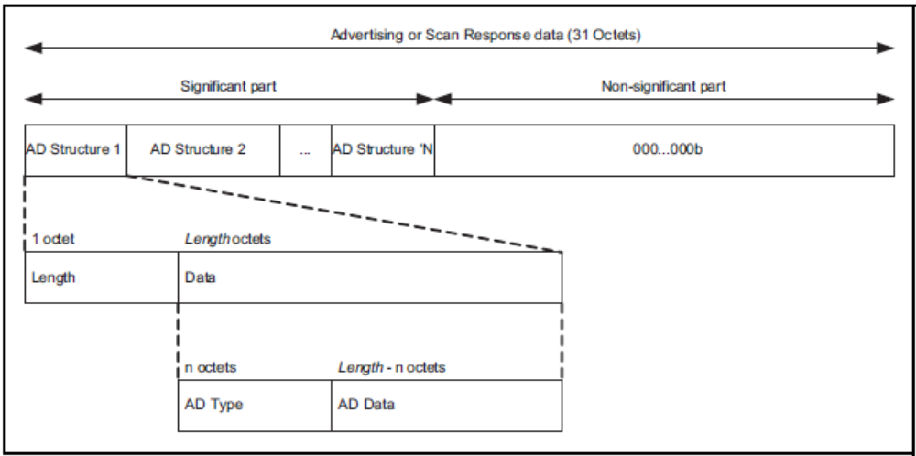
The content of the remaining Length - 1 octet in the Data field depends on the value of the AD type field and is called the AD data. The non-significant part extends the Advertising and Scan Response data to 31 octets and shall contain all-zero octets.
Figure 11.1: Advertising and Scan Response data format
If the Length field is set to zero, then the Data field has zero octets. This shall only occur to allow an early termination of the Advertising or Scan Response data.
Only the significant part of the Advertising or Scan Response data needs to be sent over the air.
The Advertising and Scan Response data is sent in advertising events. The Advertising Data is placed in the AdvData field of ADV_IND, ADV_NONCONN_IND, and ADV_SCAN_IND, AUX_ADV_IND, AUX_CHAIN_IND, and AUX_SYNC_IND packets. The Scan Response data is sent in the ScanRspData field of SCAN_RSP packets or the AdvData field of the AUX_SCAN_RSP packet. If the complete Advertising or Scan Response data cannot fit in the AUX_ADV_IND or AUX_SCAN_RSP packets, AUX_CHAIN_IND packets are used to send the remaining fragments of the data.
The AD type data formats and meanings are defined in [Core Specification Supplement], Part A. The AD type identifier values are defined in the Assigned Numbers document.

[Modified Section] Appendix A (Normative): Timers and Constants
APPENDIX A (NORMATIVE): TIMERS AND CONSTANTS
[NOTE TO EDITOR: Append the following timers to Table A.1]
Timer name | Value | Description | Requirement or Recommendation
T_{GAP}(gen_disc_scan_min_coded) | 30.72 s | Minimum time to perform scanning when performing the general discovery procedure | Recommended value
T_{GAP}(lim_disc_scan_min_coded) | 30.72 s | Minimum time to perform scanning when performing the limited discovery procedure | Recommended value
T_{GAP}(lim_disc_scan_int_coded) | 33.75 ms | Scan interval used in the limited discovery procedure | Recommended value
T_{GAP}(scan_fast_interval_coded) | 90 ms to 180 ms | Scan interval in any discovery or connection establishment procedure when user initiated | Recommended value
T_{GAP}(scan_fast_window_coded) | 90 ms | Scan window in any discovery or connection establishment procedure when user initiated | Recommended value
T_{GAP}(scan_slow_interval1_coded) | 3.84 s | Scan interval in any discovery or connection establishment procedure when background scanning | Recommended value
T_{GAP}(scan_slow_window1_coded) | 33.75 ms | Scan window in any discovery or connection establishment procedure when background scanning | Recommended value
T_{GAP}(scan_slow_interval2_coded) | 7.68 s | Scan interval in any discovery or connection establishment procedure when background scanning | Recommended value
T_{GAP}(scan_slow_window2_coded) | 67.5 ms | Scan window in any discovery or connection establishment procedure when background scanning | Recommended value
T_{GAP}(adv_fast_interval1_coded) | 90 ms to 180 ms | Minimum to maximum advertising interval in the following GAP Modes when user initiated:  1. Undirected Connectable Mode  2. Limited Discoverable Mode and sending connectable undirected advertising events  3. General Discoverable Mode and sending connectable undirected advertising events  4. Directed Connectable Mode and sending low duty cycle connectable directed advertising events | Recommended value
T_{GAP}(adv_fast_interval2_coded) | 300 ms to 450 ms | Minimum to maximum advertising interval in the following GAP Modes when user initiated and sending non-connectable advertising events:  1. Non-Discoverable Mode  2. Non-Connectable Mode  3. Limited Discoverable Mode  4. General Discoverable Mode | Recommended value
T_{GAP}(adv_slow_interval_coded) | 3 s to 3.6 s | Minimum to maximum advertisement interval in any discoverable or connectable mode when background advertising | Recommended value
T_{GAP}(initial_conn_interval_coded) | 90 ms to 150 ms | Minimum to maximum connection interval upon any connection establishment | Recommended value

Volume 6, Part B: Link Layer Specification

[Modified Section] 1.4.1 Advertising and Data Channel Indices
1.4.1 Advertising and Data Channel Indices
Table 1.2 shows the mapping from RF Channel to Data Channel Index and Advertising Channel IndexChannel Type. It also shows the allocation of channel type to each RF Channel. An ‘●’ in the table below indicates the PHY channel and index are used by the specified channel type.
PHY Channel | RF Center Frequency |  | Channel Type
PHY Channel | RF Center Frequency | Channel Index | Data | Primary Advertising | Secondary Advertising
0 | 2402 MHz | 37 |  | ●
1 | 2404 MHz | 0 | ● |  | ●
2 | 2406 MHz | 1 | ● |  | ●
… | … | … | … | … | …
11 | 2424 MHz | 10 | ● |  | ●
12 | 2426 MHz | 38 |  | ●
13 | 2428 MHz | 11 | ● |  | ●
14 | 2430 MHz | 12 | ● |  | ●
… | … | … | … | … | …
38 | 2478 MHz | 36 | ● |  | ●
39 | 2480 MHz | 39 |  | ●

Table 1.2: Mapping of RF Channel to Data Channel Index, and Advertising Channel IndexChannel Type

[Modified Section] 2.1: Packet Format
2.1: PACKET FORMAT FOR LE UNCODED PHYS
[Note to editor: Orange text is condition on AoD/AoA CR being included in 5.0]
The following packet format is defined for the LE Uncoded PHYs (LE 1M and LE 2M) and is used for both advertising channel packets and data channel packets.

This packet format is shown in Figure 2.1. Each packet consists of four mandatory fields and one optional field.: the preamble, the Access Address, the PDU, and the CRC., The mandatory fields are Preamble, Access Address, PDU, and CRC. The optional field is Supplemental.

LSB MSB
Preamble  (1 or 2 octets) | Access Address  (4 Octets) | PDU  (2-257 Octets) | CRC  (3 Octets) | Supplemental  (16 to 160 microseconds)
Figure 2.1: Link Layer packet format for LE Uncoded PHYs

The preamble is 1 octet when transmitting or receiving on the LE 1M PHY and 2 octets when transmitting or receiving on the LE 2M PHY. The Access Address is 4 octets. The PDU range is from 2 to 257 octets. The CRC is 3 octets.

The Preamble is transmitted first, followed by the Access Address, followed by the PDU followed by the CRC. The entire packet is transmitted at the same symbol rate (either 1Ms/s or 2Ms/s modulation).

Packets, not including the Supplemental, take between 44 and 2120 µs to transmit.

When the Supplemental is present, the Supplemental duration is between 16 and 160 microseconds, as shown in Figure 2.1.

[Modified Section] 2.1.2: Access Address
2.1.2: Access Address
The Access Address for all advertising channel packets, except those containing an AUX_SYNC_IND and certain AUX_CHAIN_IND, shall be 10001110100010011011111011010110b (0x8E89BED6), also known as the advertising access address.

The AUX_SYNC_IND PDU shall use the Access Address (AA) value set in the SyncInfo field (see Section 2.3.X.6) contained within the AUX_ADV_IND PDU that describes the periodic advertising.

When an AUX_SYNC_IND PDU points to an AUX_CHAIN_IND PDU using the AuxPtr field, the AUX_CHAIN_IND packet shall use the same Access Address used by the AUX_SYNC_IND that points to it. All other times, the AUX_CHAIN_IND packet shall use the advertising access address.

[Modified Section] 2.1.3: PDU
2.1.3: PDU
The preamble and Access Address are followed by a PDU. When a packet is transmitted in an on either the primary or secondary advertising physical channel, the PDU shall be the Advertising Channel PDU as defined in Section 2.3. When a packet is transmitted in a on the data physical channel, the PDU shall be the Data Channel PDU as defined in Section 2.4.

[…]

[New Section] 2.1.X Supplemental
2.1.X Supplemental
[Note to Editor: This section should follow 2.1.4 CRC]
TBD (supplied by the AoA/AoD feature)

[Modified Section] 2.3 Advertising Channel PDU
2.3 Advertising Channel PDU
The advertising channel PDU has a 16-bit header and a variable size payload. Its format is as shown in Figure 2.2. The 16-bit Header field of the advertising channel PDU is as shown in Figure 2.3.

LSB | MSB
Header  (16 bits) | Payload  (as per the Length field in the Header1 – 255 octets)
Figure 2.2: Advertising channel PDU
LSB |  |  |  |  | MSB
PDU Type  (4 bits) | RFU  (2 bits) | TxAdd  (1 bit) | RxAdd  (1 bit) | Length  (86 bits) | RFU  (2 bits)
Figure 2.3: Advertising channel PDU Header

The PDU Type field of the advertising channel PDU that is contained in the header indicates the PDU type as defined in Table 2.1. This table also shows which channel and which PHYs the packet may appear on.

PDU Type  b3b2b1b0 | PacketPDU Name | Channel | Permitted  PHYs
PDU Type  b3b2b1b0 | PacketPDU Name | Channel | LE 1M | LE 2M | LE Coded
0000b | ADV_IND | Primary Advertising | ●
0001b | ADV_DIRECT_IND | Primary Advertising | ●
0010b | ADV_NONCONN_IND | Primary Advertising | ●
0011b | SCAN_REQ | Primary Advertising | ●
0011b | AUX_SCAN_REQ | Secondary Advertising | ● | ● | ●
0100b | SCAN_RSP | Primary Advertising | ●
0101b | CONNECT_IND | Primary Advertising | ●
0101b | AUX_CONNECT_REQ | Secondary Advertising | ● | ● | ●
0110b | ADV_SCAN_IND | Primary Advertising | ●
0111b | ADV_EXT_IND | Primary Advertising | ● |  | ●
0111b | AUX_ADV_IND | Secondary Advertising | ● | ● | ●
0111b | AUX_SCAN_RSP | Secondary Advertising | ● | ● | ●
0111b | AUX_SYNC_IND | Secondary Advertising | ● | ● | ●
0111b | AUX_CHAIN_IND | Secondary Advertising | ● | ● | ●
1000b | AUX_CONNECT_RSP | Secondary Advertising | ● | ● | ●
All other values | Reserved for Future Use
Table 2.1: Advertising channel PDU Header’s PDU Type field encoding

Each PDU may only appear on those PHYs indicated with a bullet (●) and on the Advertising Channel shown in Table 2.1.

The TxAdd and RxAdd fields of the advertising channel PDU that are contained in the header contain information specific to the PDU type defined for each advertising channel PDU separately. If the TxAdd or RxAdd fields are not defined as used in a given PDU then they shall be considered Reserved for Future Use.

The Length field of the advertising channel PDU header indicates the payload field length in octets. The valid range of the Length field shall be 61 to 37 255 octets.

The Payload fields in the advertising channel PDUs are specific to the PDU Type and are defined in Section 2.3.1 through Section 2.3.3. The PDU Types marked as Reserved shall not be sent and shall be ignored upon receipt. Within advertising channel PDUs, Advertising Data from the Host may be included in the Payload in some PDU Types. The format of this data is defined in [Vol. 3] Part C, Section Appendix A.

[New Section] 2.3.X Common Extended Advertising Payload Format
2.3.X Common Extended Advertising Payload Format
The following extended Advertising Channel PDUs share the same Advertising Channel PDU payload format, referred to in this specification as the “Common Extended Advertising Payload Format”:
- ADV_EXT_IND
- AUX_ADV_IND
- AUX_SCAN_RSP
- AUX_SYNC_IND
- AUX_CHAIN_IND
- AUX_CONNECT_RSP

The common extended advertising payload format is shown in Figure 2.X
Payload
Extended Header Length  (6 bits) | AdvMode  (2 bits) | Extended Header  (0 – 63 octets) | AdvData  (0 – 254 octets)
Figure 2.X: Common Extended Advertising Payload Format

The Extended Header Length is a value between 0 and 63 and indicates the size of the variable length Extended Header field.
The AdvMode field indicates the mode of the advertisement. The value of the AdvMode field shall be set as defined in Table 2.X.
Value | Mode
00b | Non-connectable | Non-scannable
01b | Connectable | Non-scannable
10b | Non-connectable | Scannable
11b | Reserved
Table 2.X: AdvMode field encoding

AdvData may contain advertising data from the advertiser’s Host. The maximum size of AdvData depends on the size of the Extended Header. The size of the AdvData can be calculated by subtracting the length of the Extended Header plus one octet from the Length specified in the Advertising channel PDU Header.
The Extended Header field is a variable length header that is present if, and only if, the Extended Header Length field is non-zero. The format of the Extended Header is shown in Figure 2.X.
[Note to editor: Orange text is conditional on AoD/AoA CR inclusion in 5.0, otherwise replace “SuppInfo” with “RFU”]
Extended Header
Extended Header Flags  (1 octet) | AdvA  (6 octets) | TargetA  (6 octets) | Supp  Info  (1 octet) | AdvData Info  (ADI)  (2 octets) | AuxPtr  (3 octets) | SyncInfo  (18 octets) | TxPower  (1 octet) | ACAD  (varies)
Figure 2.X: Extended Header

The Extended Header Flags field is a bit field used to indicate the presence of the Extended Header fields. If no Extended Header fields are present, the Extended Header Flags field shall not be present.
The Extended Header Flags bit field definitions are shown in Table 2.X
Bit | Extended Header
0 | AdvA
1 | TargetA
2 | SuppInfo
3 | AdvDataInfo (ADI)
4 | AuxPtr
5 | SyncInfo
6 | TxPower
7 | Reserved
Table 2.X: Extended Header Flags
If a flag bit is set to 1, the corresponding Extended Header field is present; otherwise, the corresponding Extended Header field is not present. The Extended Header fields that are present are always in the same order as the flags in the Extended Header flags (i.e., the AdvA field is first if present, then the TargetA field if present, etc.).
Whether an Extended Header flag and corresponding Extended Header field is mandatory, optional, or reserved for future use is dependent on the Advertising Channel PDU in which the extended header is used.

[New Section] 2.3.X.1 AdvA field
2.3.X.1 AdvA field
When present, the AdvA field is six octets with the format shown in Figure 2.X.
AdvA
Advertising Address
(6 octets)
Figure 2.X: AdvA field
The Advertising Address field contains the advertiser’s device address. The TxAdd field of the Advertising Channel PDU Header applies to this value.

[New Section] 2.3.X.2 TargetA field
2.3.X.2 TargetA field
When present, the TargetA field is six octets with the format shown in Figure 2.X.
TargetA
Target Address
(6 octets)
Figure 2.X: TargetA field
The Target Address field contains the scanner’s or initiator’s device address to which the advertisement is directed. The RxAdd field of the Advertising Channel PDU Header applies to this value.

[New Section] 2.3.X.3 SuppInfo field
2.3.X.3 SuppInfo field
[Note to editor: Orange text is conditional on AoD/AoA CR inclusion in 5.0, this section will be removed if AoD/AoA CR not included in 5.0, in the case the text is removed, the section should remain with the title RFU and text indicating field and section reserved for a future feature.]

The presence of the SuppInfo field indicates that the packet includes a Supplemental. The SuppInfo field is defined in Section 2.X.2.
[Note to editor: 2.X.2 is a section in the AoD/AoA document and not this document.]

[New Section] 2.3.X.4 AdvDataInfo field
2.3.X.4 AdvDataInfo field
When present, the AdvDataInfo (ADI) field is two octets with the format shown in Figure 2.X.
AdvDataInfo
Advertising Data ID (DID)  (12 bits) | Advertising Set ID (SID)  (4 bits)
Figure 2.X: AdvDataInfo field
The Advertising Set ID (SID) is set by the advertiser to distinguish between different advertising sets transmitted by this device.
The Advertising Data ID (DID) is set by the advertiser to indicate to the scanner that the data contents in the AdvData are a duplicate of the previous AdvData sent in an earlier packet. Whenever the AdvData is changed by the host, the Advertising DID shall be updated to a randomly chosen value that is not the same as the previously used value. The scanner may use the Advertising SID and Advertising DID to determine whether the AdvData in the packet is a retransmission of data it has already received.

[New Section] 2.3.X.5 AuxPtr field
2.3.X.5 AuxPtr field
When present, the AuxPtr field is three octets with the format shown in Figure 2.X.
AuxPtr
LL Channel  (6 bits) | CA  (1 bits) | Offset Units  (1 bits) | Aux Offset  (13 bits) | Aux PHY  (3 bits)
Figure 2.X: AuxPtr Field
The presence of the AuxPtr field indicates that some or all of the advertisement data is in a subsequent auxiliary packet. The contents of the AuxPtr field describe this packet.
The LL Channel field contains the Link Layer data channel index used to transmit the auxiliary packet. The data channel index shall be one permitted on the secondary advertising channel (see Section 1.4.1).
The Offset Units field indicates the units used by the Aux Offset Field. The value of the Offset Units field shall be set as defined in Table 2.X.
Value | Units
0 | 30 µs
1 | 300 µs
Table 2.X: Offset Units field encoding
The Aux Offset field contains the time from the start of the packet containing the AuxPtr field to the approximate start of the auxiliary packet. The value of the AUX Offset field is in the unit of time indicated by the Offset Units field; the offset is determined by multiplying the value by the unit. The Aux Offset shall be at least the length of the packet plus T_MAFS (see Section 4.1.2). The auxiliary packet shall not start any earlier than the Aux Offset and shall start no later than the Aux Offset plus one Offset Unit. This allows the LL to round the Aux Offset to the Offset Unit.
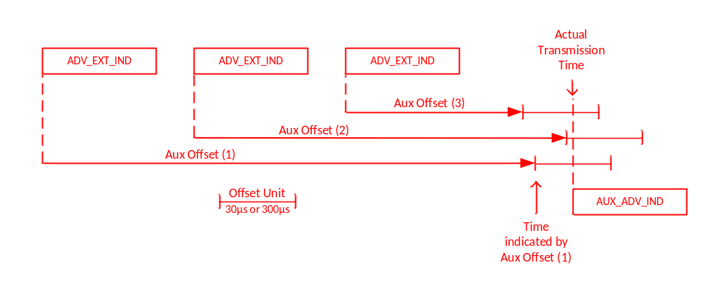Figure 2.X Aux Offset Transmission Window
The Aux PHY field indicates the PHY used to transmit the auxiliary packet. The value of the Aux PHY field shall be set as defined in Table 2.X.

Value | PHY used
000b | LE 1M
001b | LE 2M
010b | LE Coded
011b – 111b | Reserved
Table 2.X: Aux PHY field encoding
The CA field contains the clock accuracy of the advertiser that will be used between the packet containing this data and the auxiliary packet. The value of the CA field shall be set as defined in Table 2.2.

CA Value | Advertiser’s Clock Accuracy
0 | 51 ppm to 500 ppm
1 | 0 ppm to 50 ppm
Table 2.X: Clock Accuracy field encoding

[New Section] 2.3.X.6 SyncInfo field
2.3.X.6 SyncInfo field
When present, the SyncInfo field is 18 octets with the format shown in Figure 2.X.
SyncInfo
Sync Packet Offset  (13 bits) | Offset Units  (1 bit) | RFU  (2 bits) | Interval  (2 octets) | ChM  (37 bits) | SCA  (3 bits) | AA  (4 octets) | CRCInit  (3 octets) | Hop  (5 bits) | RFU  (3 bits) | Channel Index  (1 octet)
Figure 2.X: SyncInfo field
The presence of the SyncInfo field indicates the presence of a periodic advertisement (using AUX_SYNC_IND PDUs). The contents of the SyncInfo field describe this periodic advertisement.
The Offset Units field indicates the units used by the Sync Packet Offset field. The value of the Offset Units field shall be set as defined in Table 2.X.
Value | Units
0b | 30 µs
1b | 300 µs
Table 2.X: Offset Units field encoding
The Sync Packet Offset field contains the time from the start of the AUX_ADV_IND packet containing the SyncInfo field to the start of the AUX_SYNC_IND packet. The value of the Sync Packet Offset field is in the unit of time indicated by the Offset Units field; the actual offset is determined by multiplying the value by the unit.
The Interval field contains the time in 1.25 ms units from the start of one packet of the periodic advertisement to the start of the next packet.
The ChM field contains the channel map indicating Used and Unused secondary advertising channels. Every channel is represented with a bit positioned as per the data channel index as defined in Section 1.4.1. The LSB represents channel index 0 and the bit in position 36 represents channel index 36. A bit value of 0 indicates that the channel is Unused. A bit value of 1 indicates that the channel is Used.

The AA, CRCInit, Hop, and SCA fields have the same meaning as the corresponding fields in the CONNECT_IND PDU (see Section 2.3.3.1).
The Channel Index field is the secondary advertising channel index of the AUX_SYNC_IND packet.

[New Section] 2.3.X.7 TxPower field
2.3.X.7 TxPower field
When present, the TxPower is one octet with the format shown in Figure 2.X.
TxPower
Tx Power Level
(1 octet)
Figure 2.X: TxPower field
The Tx Power Level field is the same value defined for the Tx Power Advertising Data type defined in [3].

[New Section] 2.3.X.8 ACAD field
2.3.X.8 ACAD field
The remainder of the extended header forms the Additional Controller Advertising Data (ACAD) field. The length of this field is the Extended Header length minus the sum of the size of the extended header flags (1 octet) and those fields indicated by the flags as present. ACAD cannot be fragmented across multiple advertising data PDUs; it shall always fit inside a single advertising data PDU.
The ACAD field holds data from the advertiser’s Controller or intended to be used by the recipient’s Controller. It uses the same format as the AdvData field in various Advertising Channel PDUs. This format is described in [Vol 3] Part C, Section 11.
The ACAD type formats and meanings are defined in [Core Specification Supplement], Part X. The ACAD type identifier values are defined in the Assigned Numbers document.

[New Section] 2.3.X.9 Host Advertising Data
2.3.X.9 Host Advertising Data
The portion of the PDU after the extended header forms the AdvData field. The length of this field is specified in Section 2.3.X.
The AdvData field holds data from the advertiser’s Host. The format of this data is described in [Vol 3] Part C, Section 11.
The Controller shall support a minimum of 31 octets for Host Advertising Data without fragmentation. The Controller may support fragmentation of larger Host Advertising Data. When the Link Layer fragments the Host advertising data, the number of fragments and the size of each fragment are chosen by the Controller. The Controller should minimize the number of fragments to ensure more reliability in delivering the entire Host advertising data. The Host may indicate a preference whether the Controller should fragment the Host advertising data, but the Controller may support this preference or ignore the preference.
If the amount of advertising or scan response data to be sent in an extended advertising or scanning PDU plus the Extended Header Length, AdvMode, and Extended Header exceed the maximum Advertising Channel PDU payload (255 octets), the Link Layer shall fragment the Host advertising data. The Link Layer shall place the multiple fragments in the AdvData field of different PDUs. When Host advertising data is fragmented the first fragment shall be placed in the AUX_ADV_IND, AUX_SYNC_IND or AUX_SCAN_RSP PDU while subsequent fragments shall be placed in AUX_CHAIN_IND_PDUs. Each AUX_CHAIN_IND PDU is pointed to by the AuxPtr field in the PDU containing the previous fragment; the AUX_CHAIN_PDU holding the last fragment shall not have an AuxPtr field.

[Modified Section] 2.3.1 Advertising PDUs
2.3.1 Advertising PDUs
The following advertising channel PDU Types are called advertising PDUs and are used in the specified events:

• ADV_IND: connectable undirected advertising event
• ADV_DIRECT_IND: connectable directed advertising event
• ADV_NONCONN_IND: non-connectable undirected advertising event
• ADV_SCAN_IND: scannable undirected advertising event
- ADV_EXT_IND
- AUX_ADV_IND
- AUX_SYNC_IND
- AUX_CHAIN_IND
These PDUs are sent by the Link Layer in the Advertising State and received by a Link Layer in the Scanning State or Initiating State. The ADV_IND, ADV_DIRECT_IND, ADV_NONCONN_IND and ADV_SCAN_IND are called “legacy advertising PDUs”. ADV_EXT_IND, AUX_ADV_IND, AUX_SYNC_IND and AUX_CHAIN_IND are considered called “extended advertising PDUs”. Advertising events using legacy advertising PDUs are called “legacy advertising events”.

[Modified Section] 2.3.1.4 ADV_SCAN_IND
2.3.1.4 ADV_SCAN_IND¹
[NOTE to editor: Remove footnote]

[New Section] 2.3.1.X ADV_EXT_IND
2.3.1.X ADV_EXT_IND
The ADV_EXT_IND PDU uses the Common Extended Advertising Payload Format described in Section 2.3.X. The PDU may be used in all advertising events (except connectable and scannable undirected) as indicated by the AdvMode field value. An advertising event using an ADV_EXT_IND PDU is directed if, and only if, either the TargetA field is present or the AuxPtr field is present and points to a PDU where the TargetA field is present.
The Common Extended Advertising Payload Format fields permitted in the ADV_EXT_IND PDU are shown in Table 2.X. The AdvA and TargetA fields shall not be present when this PDU is used on the LE Coded PHY.
[Note to Editor: The “Supp Info” column is conditional and shall not be present if AoD/AoA feature is not part of Shanghai]
Event Type | Common Extended Advertising Payload Format fields
Event Type | AdvMode | AdvA | TargetA | Supp  Info | ADI | Aux  Ptr | Sync  Info | Tx Power | ACAD | AdvData
Non-Connectable Undirected | 00b | Present | X | X | C2 | O | X | O | X | X
Non-Connectable Undirected | 00b | Not Present | X | X | M | M | X | C1 | X | X
Non-Connectable Directed | 00b | Present | M | X | C2 | O | X | O | X | X
Non-Connectable Directed | 00b | Not Present | X | X | M | M | X | C1 | X | X
Connectable Undirected | 01b | X | X | X | M | M | X | C1 | X | X
Connectable Directed | 01b | X | X | X | M | M | X | C1 | X | X
Scannable Undirected | 10b | X | X | X | M | M | X | C1 | X | X
Scannable Directed | 10b | X | X | X | M | M | X | C1 | X | X

Table 2.X: Common Extended Advertising Payload Format fields permitted in the ADV_EXT_IND PDU
In all tables describing permitted Common Extended Advertising Payload Format Fields:
M | This field is mandatory
O | This field is optional
X | This field is reserved for future use
C1 | This field is optional on the LE 1M PHY and reserved for future use on the LE Coded PHY
C2 | This field is mandatory if AuxPtr is present, otherwise the field is optional.

Reserved fields shall not be present when the packet is sent and shall be ignored when received.
The AuxPtr field, when present, shall point to an AUX_ADV_IND packet with the same AdvMode as the ADV_EXT_IND packet.

[New Section] 2.3.1.X AUX_ADV_IND
2.3.1.X AUX_ADV_IND
The AUX_ADV_IND PDU uses the Common Extended Advertising Payload Format described in Section 2.3.X. The PDU may be used in all advertising events (except connectable and scannable undirected) as indicated by the AdvMode field value.
The AdvMode field indicates the type of advertising event the AUX_ADV_IND packet is being used for.
The Common Extended Advertising Payload Format fields permitted in the AUX_ADV_IND PDU are shown in Table 2.X.
The PHY used for the AUX_ADV_IND shall be specified in the AuxPtr field of the PDU that points to this PDU. The PHY specified in any AuxPtr field in an AUX_ADV_IND PDU shall be the same as the PHY the PDU was sent on.
The ADI field, when present, shall have the same value as the field in the PDU pointing to this PDU. Note: The ADI field can be used to detect collisions.
The AuxPtr field, when present, shall point to an AUX_CHAIN_IND PDU.
The SyncInfo field, when present, shall point to an AUX_SYNC_IND PDU.
Adv Mode | Event Type | Common Extended Advertising Payload Format fields
Adv Mode | Event Type | AdvA | TargetA | Supp  Info | ADI | Aux  Ptr | Sync  Info | Tx Power | ACAD | AdvData
00b | Non-Connectable  Undirected | O | X | X | C1 | O | O | O | O | O
00b | Non-Connectable Directed | O | C1 | X | C1 | O | O | O | O | O
01b | Connectable Undirected | M | X | X | C1 | X | X | O | O | O
01b | Connectable Directed | M | M | X | C1 | X | X | O | O | O
10b | Scannable Undirected | M | X | X | C1 | X | X | O | O | X
10b | Scannable Directed | M | M | X | C1 | X | X | O | O | X
11b | Reserved
Table 2.X: Common Extended Advertising Payload Format fields permitted in the AUX_ADV_IND PDU
C1 | This field is mandatory if the corresponding field in the ADV_EXT_IND PDU is present, otherwise it is reserved for future use.

[New Section] 2.3.1.X AUX_SYNC_IND
2.3.1.X AUX_SYNC_IND
The AUX_SYNC_IND PDU uses the Common Extended Advertising Payload Format described in Section 2.3.X. The PDU is used in periodic advertising.
The AdvMode field shall be set to 00b.
The Common Extended Advertising Payload Format fields permitted in the AUX_SYNC_IND PDU are shown in Table 2.X.
The PHY used for the AUX_SYNC_IND PDU shall be the same as the PHY used for the AUX_ADV_IND that contains the SyncInfo field.
The AuxPtr field, when present, shall point to an AUX_CHAIN_IND PDU.
Adv Mode | Event Type | Common Extended Advertising Payload Format fields
Adv Mode | Event Type | AdvA | TargetA | Supp  Info | ADI | Aux  Ptr | Sync  Info | Tx Power | ACAD | AdvData
00b | Non-Connectable  undirected or directed | X | X | O | X | O | X | O | O | O
01b – 11b | Reserved

Table 2.X: Common Extended Advertising Payload Format fields permitted in the AUX_SYNC_IND PDU

[New Section] 2.3.1.X AUX_CHAIN_IND
2.3.1.X AUX_CHAIN_IND
The AUX_CHAIN_IND PDU uses the Common Extended Advertising Payload Format described in Section 2.3.X. The PDU is used to hold additional AdvData. It is pointed to by the AuxPtr field in an AUX_ADV_IND, AUX_SYNC_IND, AUX_SCAN_RSP or AUX_CHAIN_IND PDU.
The AdvMode field shall be set to 00b.
The Common Extended Advertising Payload Format fields permitted in the AUX_CHAIN_IND PDU are shown in Table 2.X.
The PHY used for the AUX_CHAIN_IND PDU, and specified in the AuxPtr field if present, shall be the same as the PHY used in the PDU that points to the AUX_CHAIN_IND.
The ADI field, when present, shall have the same value as the field in the PDU pointing to this PDU. Note: The ADI field can be used to detect collisions.
The AuxPtr field, when present, shall point to another AUX_CHAIN_IND PDU
Adv Mode | PDU Type | Common Extended Advertising Payload Format fields
Adv Mode | PDU Type | AdvA | TargetA | Supp  Info | ADI | Aux  Ptr | Sync  Info | Tx Power | ACAD | AdvData
00b | Chained data | X | X | X | C1 | O | X | O | O | O
01b – 11b | Reserved

Table 2.X: Common Extended Advertising Payload Format fields permitted in the AUX_CHAIN_IND PDU
C1 | This field is mandatory if the corresponding field in the ADV_EXT_IND PDU is present, otherwise it is reserved for future use.

[Modified Section] 2.3.2 Scanning PDUs
2.3.2 Scanning PDUs

The following advertising channel PDU Types are called scanning PDUs. They are used in the following states:

- SCAN_REQ: sent by the Link Layer in the Scanning State, received by a
Link Layer in the Advertising State
- SCAN_RSP: sent by the Link Layer in the Advertising State, received by a
Link Layer in the Scanning State
- AUX_SCAN_REQ
- AUX_SCAN_RSP
Where these PDUs are used to reply to a scannable advertisement, the PHY used for them shall be the same as the PHY used for the PDU that they reply to.

[Modified Section] 2.3.2.1 SCAN_REQ and AUX_SCAN_REQ
2.3.2.1 SCAN_REQ and AUX_SCAN_REQ
The SCAN_REQ and AUX_SCAN_REQ PDUs hashave the Payload as shown in Figure 2.8. The TxAdd in the advertising channel PDU header indicates whether the scanner’s address in the ScanA field is public (TxAdd = 0) or random (TxAdd = 1). The RxAdd in the advertising channel PDU header indicates whether the advertiser’s address in the AdvA field is public (RxAdd = 0) or random (RxAdd = 1).

Payload
ScanA  (6 octets) | AdvA  (6 octets)
Figure 2.8: SCAN_REQ PDU payload
The Payload field consists of ScanA and AdvA fields. The ScanA field shall contain the scanner’s public or random device address as indicated by TxAdd. The AdvA field is the address of the device to which this PDU is addressed. The AdvA field shall contain the advertiser’s public or random device address as indicated by RxAdd.

Note: This packet These PDUs does not contain any Host Data.

[New Section] 2.3.2.X AUX_SCAN_RSP
2.3.2.X AUX_SCAN_RSP
The AUX_SCAN_RSP PDU uses the Common Extended Advertising Payload Format described in Section 2.3.X.
The AdvMode field shall be set to 00b.
The Common Extended Advertising Payload Format fields permitted in the AUX_SCAN_RSP PDU are shown in Table 2.X.
The SyncInfo field, when present, shall point to an AUX_SYNC_IND PDU.
The AuxPtr field, when present, shall point to an AUX_CHAIN_IND PDU. The PHY specified in the AuxPtr field shall be the same as the PHY the PDU was sent on.

Adv Mode | PDU Type | Common Extended Advertising Payload Format fields
Adv Mode | PDU Type | AdvA | TargetA | Supp  Info | ADI | Aux  Ptr | Sync  Info | Tx Power | AddCtrlr AdvData | AdvData
00b | Scan response | M | X | X | X | O | O | O | O | M
01b – 11b | Reserved
Table 2.X: Common Extended Advertising Payload Format fields permitted in the AUX_SCAN_RSP PDU

[Modified Section] 2.3.3 Initiating PDUs
2.3.3 Initiating PDUs

The following advertising channel PDU Types isare called the initiating PDUs:

- CONNECT_IND
- AUX_CONNECT_REQ
- AUX_CONNECT_RSP

Thisese PDUs isare sent by the Link Layer in the Initiating State and received by the Link Layer in the Advertising State.

The PHY used for these PDUs shall be the same as the PHY used for the PDU that they reply to.

[Modified Section] 2.3.3.1 CONNECT_IND and AUX_CONNECT_REQ
2.3.3.1 CONNECT_IND and AUX_CONNECT_REQ
The CONNECT_IND and AUX_CONNECT_REQ PDUs hashave the Payload as shown in Figure 2.10. TxAdd in the advertising channel PDU header indicates whether the initiator’s device address in the InitA field is public (TxAdd = 0) or random (TxAdd = 1). The RxAdd in the advertising channel PDU header indicates whether the advertiser’s device address in the AdvA field is public (RxAdd = 0) or random (RxAdd = 1).

Payload
InitA  (6 octets) | AdvA  (6 octets) | LL Data  (22 octets)
Figure 2.10:CONNECT_IND and AUX_CONNECT_REQ PDU payload

[New Section] 2.3.3.X AUX_CONNECT_RSP
2.3.3.X AUX_CONNECT_RSP
The AUX_CONNECT_RSP PDU uses the Common Extended Advertising Payload Format described in Section 2.3.X.
The AdvMode field shall be set to 00b.
The Common Extended Advertising Payload Format fields permitted in the AUX_CONNECT_RSP PDU are shown in Table 2.X.
Adv Mode | PDU Type | Common Extended Advertising Payload Format fields
Adv Mode | PDU Type | AdvA | TargetA | Supp  Info | ADI | Aux  Ptr | Sync  Info | Tx Power | AddCtrlr AdvData | AdvData
00b | Connection response | M | M | X | X | X | X | X | X | X
01b – 11b | Reserved
Table 2.X: Common Extended Advertising Payload Format fields permitted in the AUX_CONNECT_RSP PDU

[Modified Section] 3.1.1 CRC Generation
3.1.1 CRC Generation
The CRC shall be calculated on the PDU field in all Link Layer packets. If the PDU is encrypted, then the CRC shall be calculated after encryption of the PDU has been performed.
The CRC polynomial is a 24-bit CRC and all bits in the PDU shall be processed in transmitted order starting from the least significant bit. The polynomial has the form of x24 + x10 + x9 + x6 + x4 + x3 + x + 1. For every Data Channel PDU, the shift register shall be preset with the CRC initialization value set for the Link Layer connection and communicated in the CONNECT_IND PDU. For the AUX_SYNC_IND PDU and any AUX_CHAIN_IND PDUs connected to it, the shift register shall be preset with the CRCInit value set in the SyncInfo field (see Section 2.3.X.6) contained in the AUX_ADV_IND PDU that describes the periodic advertising. For everyall other Advertising Channel PDUs, the shift register shall be preset with 0x555555.
Position 0 shall be set as the least significant bit and position 23 shall be set as the most significant bit of the initialization value. The CRC is transmitted most significant bit first, i.e. from position 23 to position 0 (see Section 1.2).
Figure 3.2 shows an example linear feedback shift register (LFSR) to generate the CRC.
[Figure omitted from this document.]

[New Section] 4.1 Frame Space
4.1 FRAME SPACE

[Modified Section] 4.1.1 Inter Frame Space
4.1.1 INTER FRAME SPACE
The time interval between two consecutive packets on the same channel index
is called the Inter Frame Space. It is defined as the time from the end of the last
bit of the previous packet to the start of the first bit of the subsequent packet.
The Inter Frame Space is designated “T_IFS” and shall be 150 μs.

[New Section] 4.1.2 Minimum AUX Frame Space
4.1.2 MINIMUM AUX FRAME SPACE
The minimum time interval between a packet containing an AuxPtr and the packet indicated by the AuxPtr is called the Minimum AUX Frame Space. It is defined as the minimum time from the end of the last bit of the packet containing the AuxPtr to the start of the packet indicated by the AuxPtr. The Minimum AUX Frame Space is designated “T_MAFS” and shall be 300 µs.
Figure 4.X illustrates an example where the Minimum AUX Frame Space applies.
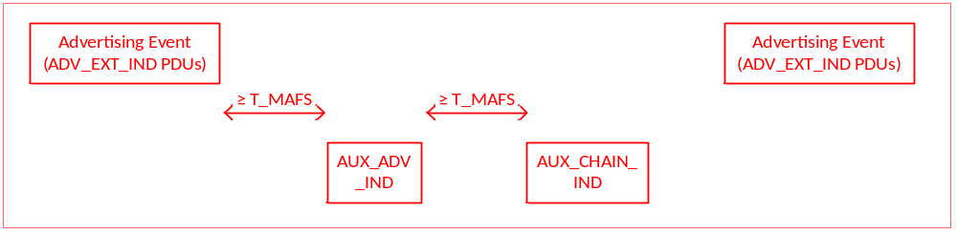
Figure 4.X: Example where the Minimum AUX Frame Space applies

[Modified Section] 4.4.2 Advertising State
4.4.2 Advertising State
The Link Layer shall enter the Advertising State when directed by the Host. When placed in the Advertising State, the Link Layer shall send advertising PDUs (see Section 2.3.1) in advertising events.

Each advertising event is composed of one or more advertising PDUs sent on used primary advertising channel indices. The advertising event shall be closed after one advertising PDU has been sent on each of the used primary advertising channel indices (see Section 4.4.2.1) or the advertiser may close an advertising event earlier to accommodate other functionality.

The time between two consecutive advertising events is defined in Section
4.4.2.2.

An advertising event can be one of the following types:

- a connectable and scannable undirected event
- a connectable undirected event
- a connectable directed event
- a non-connectable undirected event
- a non-connectable directed event
- a scannable undirected event
- a scannable directed event

The first PDU of each advertising event shall be transmitted in the used primary advertising channel with the lowest advertising channel index.

The advertising event type determines the allowable response PDUs. The table below specifies the allowable responses for each advertising event.

Connectable and scannable undirected, connectable undirected, and connectable directed events are collectively referred to as connectable events; the remaining events (non-connectable undirected, non-connectable directed, scannable undirected, and scannable directed) are collectively referred to as non-connectable events. Connectable and scannable undirected, scannable undirected, and scannable directed events are collectively referred to as scannable events; the remaining events (non-connectable undirected, non-connected directed, connectable undirected, and connectable directed) are collectively referred to as non-scannable events.

Advertising Event Type | Type of PDU being responded to | Allowable response PDUs
Advertising Event Type | Type of PDU being responded to | SCAN_REQ³ | CONNECT_IND³ | AUX_SCAN_REQ | AUX_CONNECT_REQ
Connectable and Scannable Undirected Event | ADV_IND | YES | YES | NO | NO
Connectable Undirected Event | ADV_EXT_IND | NO | NO | NO | NO
Connectable Undirected Event | AUX_ADV_IND | NO | NO | NO | YES
Connectable Directed Event | ADV_DIRECT_IND | NO | YES*¹ | NO | NO
Connectable Directed Event | ADV_EXT_IND | NO | NO | NO | NO
Connectable Directed Event | AUX_ADV_IND | NO | NO | NO | YES¹
Non-connectable Undirected Event | ADV_NONCONN_IND | NO | NO | NO | NO
Non-connectable Undirected Event | ADV_EXT_IND | NO | NO | NO | NO
Non-connectable Directed Event | ADV_EXT_IND | NO | NO | NO | NO
Scannable Undirected Event | ADV_SCAN_IND | YES | NO | NO | NO
Scannable Undirected Event | ADV_EXT_IND | YES | NO | NO | NO
Scannable Undirected Event | AUX_ADV_IND | NO | NO | YES | NO
Scannable Directed Event | ADV_EXT_IND | YES² | NO | NO | NO
Scannable Directed Event | AUX_ADV_IND | NO | NO | YES² | NO
All other event types | All other PDU types | NO | NO | NO | NO
Table 4.1: Advertising event types, PDUs used and allowable response PDUs

*¹ Only the correctly addressed initiator may respond.Initiators other than the correctly addressed initiator shall not respond.
² Scanners other than the correctly addressed scanner shall not respond.
³ Not permitted on the LE Coded PHY

If the advertiser receives a PDU for the advertising event that is not explicitly allowed it shall be ignored. If no PDU is received or the received PDU was ignored, the advertiser shall either send an advertising PDU on the next used primary advertising channel index or close the advertising event.

[Modified Section] 4.4.2.1 Advertising Channel Index Selection
4.4.2.1 Advertising Channel Index Selection

Advertising events use three predefined primary advertising channels. Primary Aadvertising channel indices are either used or unused.

For AUX_ADV_IND, AUX_CHAIN_IND and initial AUX_SYNC_IND PDUs on the secondary channel, the secondary advertising channel index used in the Channel Index subfield of the AuxPtr or SyncInfo fields is implementation specific. It is recommended that sufficient channel diversity is used to avoid collisions.

Subsequent AUX_SYNC_IND PDUs shall use the same channel selection algorithm used by the Connection State defined in Section 4.5.8.2. The lastUnmappedChannel shall be the current AUX_SYNC_IND PDU secondary advertising channel index and hopIncrement shall be the hop subfield in the SyncInfo field in the AUX_SYNC_IND PDU.

The Link Layer shall use the primary and secondary advertising channel indices as specified by the Host, and the used primary and secondary advertising channel indices shall take effect when the Advertising State is entered.

[Modified Section] 4.4.2.2 Advertising Events
4.4.2.2 Advertising Interval Events

Advertising events are defined as one or more advertising PDUs sent on the primary advertising channel beginning with the first used advertising channel index and ending with the last used advertising channel index. The advertising event can be closed early after a CONNECT_IND is received or when a SCAN_RSP is sent. The time between advertising events is the advertising interval. Advertising packets sent on the secondary advertising channel are not part of the advertising event. Advertising events that use the ADV_EXT_IND PDU may also be part of an extended advertising event.

[Note to editor: Existing text in this section is moved to a new section 4.4.2.2.1]

[New Section] 4.4.2.2.1 Advertising Interval
4.4.2.2.1 Advertising Interval

For all undirected advertising events or connectable directed advertising events used in a low duty cycle mode, the time between the start of two consecutive advertising events (T_advEvent) is computed as follows for each advertising event:

T_advEvent = advInterval + advDelay

The advInterval shall be an integer multiple of 0.625 ms in the range of 20 ms to 10.24s. If the advertising event type is either a scannable undirected event type or a non-connectable undirected event type, the advInterval shall not be less than 100 ms. If the advertising event type is a connectable undirected event type or connectable directedconnectable event type used in a low duty cycle mode, the advInterval can be 20 ms or greater.

The advDelay is a pseudo-random value with a range of 0 ms to 10 ms generated by the Link Layer for each advertising event.

As illustrated in Figure 4.1, the advertising events are perturbed in time using the advDelay.
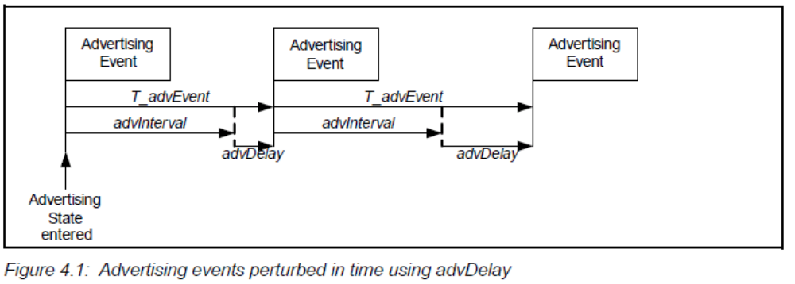

[New Section] 4.4.2.2.2 Extended Advertising Event
4.4.2.2.2 Extended Advertising Event

An extended advertising event begins at the start of an advertising event containing an ADV_EXT_IND PDU on the primary advertising channel and ends with the last PDU associated with the ADV_EXT_IND PDU sent on either the primary or secondary advertising channel. All ADV_EXT_IND PDUs containing an AuxPtr field in the same advertising event shall point to the same AUX_ADV_IND packet.

Multiple extended advertising events may overlap with each other. This can occur when ADV_EXT_IND PDUs containing an AuxPtr field in multiple advertising events point to the same AUX_ADV_IND packet, or when a different advertising event is interposed between the ADV_EXT_IND PDUs and the AUX_ADV_IND PDU.

advDelay is not used between extended advertising events.

T_advEvent, advInterval and advDelay have the same meaning as in Section 4.4.2.2.1.

Figure 4.X illustrates an example of overlapping extended advertising events.

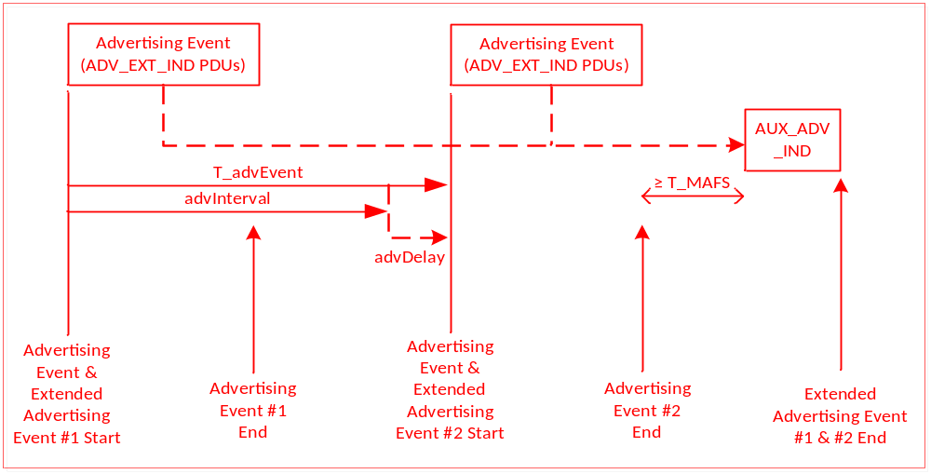
Figure 4.X: Example of Overlapping Extended Advertising Events

[Modified Section] 4.4.2.3 Connectable and Scannable Undirected Event Type
4.4.2.3 Connectable and Scannable Undirected Event Type

When the connectable and scannable undirected advertising event type is used, advertising indications (ADV_IND PDUs) are sent by the Link Layer.

The connectable and scannable undirected advertising event type allows a scanner or initiator to respond with either a scan request or connect request. A scanner may send a scan request (SCAN_REQ PDU) to request additional information about the advertiser. An initiator may send a connect request (CONNECT_IND PDU) to request the Link Layer to enter the Connection State.

The Link Layer shall listen on the same primary advertising channel index for requests from scanners or initiators.

If the advertiser receives a SCAN_REQ PDU that contains its device address from a scanner allowed by the advertising filter policy, it shall reply with a SCAN_RSP PDU on the same primary advertising channel index. After the SCAN_RSP PDU is sent, or if the advertising filter policy prohibited processing the SCAN_REQ PDU, the advertiser shall either move to the next used primary advertising channel index to send another ADV_IND PDU, or close the advertising event.

If the advertiser receives a CONNECT_IND PDU that contains its device address, from an initiator allowed by the advertising filter policy, the Link Layer shall exit the Advertising State and transition to the Connection State in the Slave Role as defined in Section 4.5.5. If the advertising filter policy prohibited processing the received CONNECT_IND PDU, the advertiser shall either move to the next used primary advertising channel index to send another ADV_IND PDU, or close the advertising event.

The time between the beginning of two consecutive ADV_IND PDUs within an
advertising event shall be less than or equal to 10 ms. The advertising event shall be closed within the advertising interval.

An illustration of an advertising event using all the primary advertising channel indices and in which no SCAN_REQ or CONNECT_IND PDUs are received is shown in Figure 4.2.

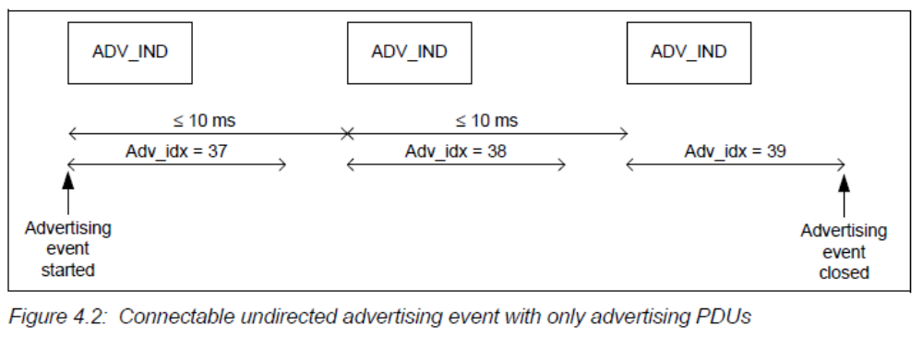
[Note to editor: Change caption to read: “Connectable and scannable undirected advertising event with only advertising PDUs”]

Two illustrations of advertising events using all the primary advertising channel indices
during which a SCAN_REQ PDU is received and a SCAN_RSP PDU is sent
are shown in Figure 4.3 and in Figure 4.4.

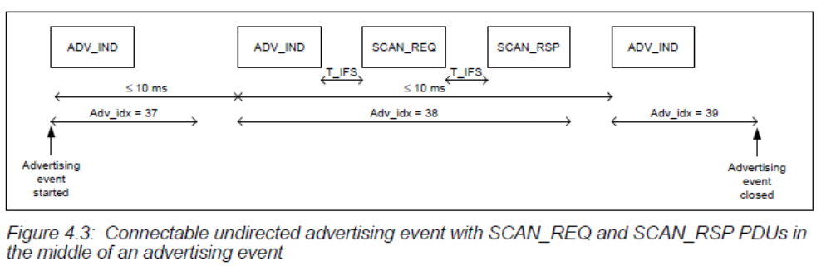
[Note to editor: Change caption to read: “Connectable and scannable undirected advertising event with SCAN_REQ and SCAN_RSP PDUs in the middle of an advertising event”]

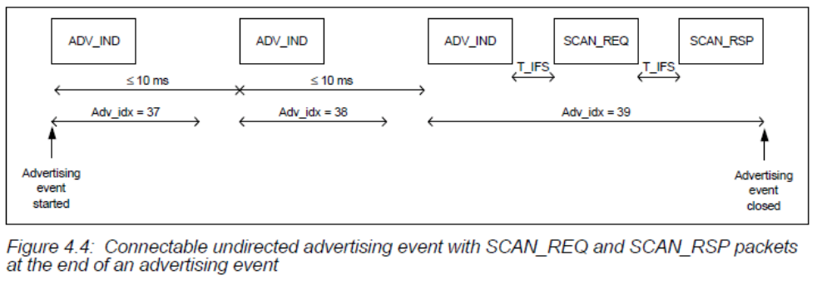
[Note to editor: Change caption to read: “Connectable and scannable undirected advertising event with SCAN_REQ and SCAN_RSP PDUs at the end of an advertising event”]

Figure 4.5 illustrates an advertising event during which a CONNECT_IND PDU is received on the second primary advertising channel index.
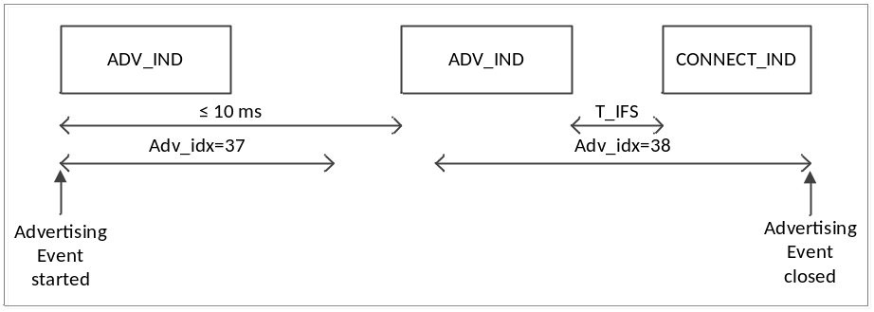
Figure 4.5: Connectable and scannable undirected advertising event during which when a CONNECT_IND PDU is received

[Modified Section] 4.4.2.4 Connectable Directed Event Type
4.4.2.4 Connectable Directed Event Type
When the connectable directed advertising event type is used, directed advertising indications (ADV_DIRECT_IND PDUs) are sent by the Link Layer.
The connectable directed advertising event type allows an initiator to respond so that both the advertiser and scanner will with a connect request. An initiator may send a connect request (CONNECT_IND PDU) to request the Link Layer to enter the Connection State.
The connectable directed advertising event type may use either the ADV_DIRECT_IND PDU (see Sections 4.4.2.4.1 to 4.4.2.4.3) or the ADV_EXT_IND PDU (see Section 4.4.2.4.4). A single connectable directed advertising event shall only use one of these two PDU types.
[Note to Editor: The remaining paragraphs of 4.4.2.4 were moved to a new section 4.4.2.4.1]

[New Section] 4.4.2.4.1 Connectable Directed Event Type using ADV_DIRECT_IND
4.4.2.4.1 Connectable Directed Event Type using ADV_DIRECT_IND

This procedure shall not be used when the connectable directed event type is used on the LE Coded PHY.
The connectable directed advertising event type using ADV_DIRECT_IND allows an initiator to respond with a connect request on the primary advertising channel to establish a Link Layer connection.

[Note to Editor: The following paragraphs were moved from 4.4.2.4]

The ADV_DIRECT_IND PDU contains both the initiator’s device address and the advertiser’s device address. Only the addressed initiator may initiate a Link Layer connection with the advertiser by sending a CONNECT_IND PDU to the advertiser.

After every ADV_DIRECT_IND PDU sent by the advertiser, the advertiser shall listen for CONNECT_IND PDUs on the same primary advertising channel index. Any SCAN_REQ PDUs received shall be ignored.

If the advertiser receives a CONNECT_IND PDU that contains its device address and the initiator device address is contained in the ADV_DIRECT_IND PDU, the Link Layer shall exit the Advertising State and transition to the Connection State in the Slave Role as defined in Section 4.5.5.

Otherwise, the advertiser shall either move to the next used primary advertising channel index to send another ADV_DIRECT_IND PDU, or close the advertising event.

Connectable directed advertising may be either used in a low duty cycle or high duty cycle mode; these are described in the next two sub-sections. Connectable lLow duty cycle connectable directed advertising is designed for cases where reconnection with a specific device is required, but time is not of the essence or it is not known if the central device is in range or not. High duty cycle connectable directed advertising is designed for cases in which fast Link Layer connection setup is essential (for example, a reconnection). Note that high duty cycle connectable directed advertising is a power and bandwidth intensive advertising scheme that should only be used when fast connection setup is required.

[Modified Section] 4.4.2.4.2 Low Duty Cycle Connectable Directed Advertising
4.4.2.4.12 Low Duty Cycle Connectable Directed Advertising
In low duty cycle connectable directed advertising mode, the time between the start of two consecutive ADV_DIRECT_IND PDUs within an advertising event shall be less than or equal to 10 ms. The advertising event shall be closed within the advertising interval.

An illustration of an advertising event using all primary advertising channel indices and in which no CONNECT_IND PDUs are received is shown in Figure 4.6.

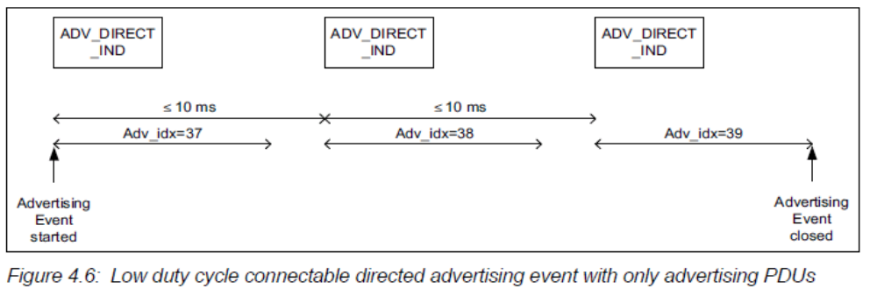

Figure 4.7 illustrates an advertising event using ADV_DIRECT_IND advertising PDUs during which a CONNECT_IND PDU is received on the second primary advertising channel index.
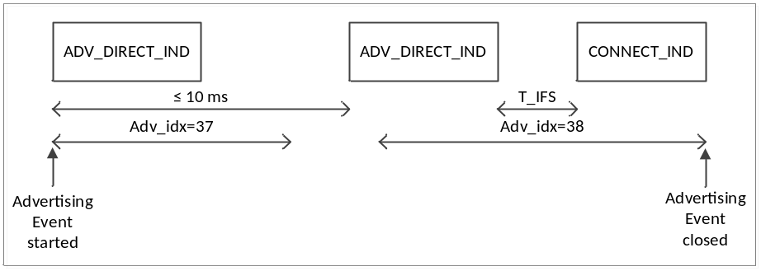
Figure 4.7: Low duty cycle connectable directed advertising event during which when a CONNECT_IND PDU is received

[Modified Section] 4.4.2.4.3 High Duty Cycle Connectable Directed Advertising
4.4.2.4.23 High Duty Cycle Connectable Directed Advertising

In high duty cycle connectable directed advertising mode, the time between the start of two consecutive ADV_DIRECT_IND PDUs sent on the same advertising channel index shall be less than or equal to 3.75 ms.

The Link Layer shall exit the Advertising State no later than 1.28 s after the Advertising State was entered.

A sequence of five ADV_DIRECT_IND PDUs in two advertising events without CONNECT_IND PDUs is shown in Figure 4.8 for the case in which all the primary advertising channels are used.

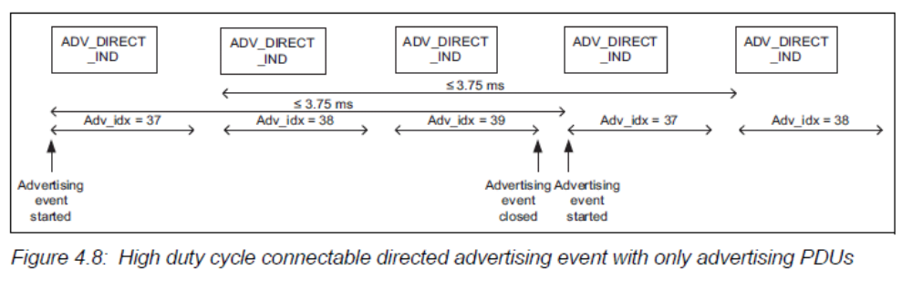

[New Section] 4.4.2.4.4 Connectable Directed Event Type using ADV_EXT_IND
4.4.2.4.4 Connectable Directed Event Type using ADV_EXT_IND

This procedure shall be used when the connectable directed event type is used on the LE Coded PHY.

The connectable directed advertising event type using ADV_EXT_IND allows an initiator to respond with a connect request on the secondary advertising channel to establish a Link Layer connection.

The AdvMode field in the ADV_EXT_IND PDU shall be set to connectable.

The ADV_EXT_IND PDU shall not contain the AdvA and TargetA fields. The ADV_EXT_IND PDU’s AuxPtr field shall point to an AUX_ADV_IND PDU with the AdvMode field set to connectable and the AdvA and TargetA fields both present.

After every AUX_ADV_IND PDU related to this event it sends, the advertiser shall listen for AUX_CONNECT_REQ PDUs on the same secondary advertising channel index. Any AUX_SCAN_REQ PDUs received shall be ignored.

If the advertiser receives an AUX_CONNECT_REQ PDU that contains its device address and the initiator’s device address was contained in the AUX_ADV_IND PDU, it shall reply with an AUX_CONNECT_RSP PDU that contains those addresses on the same secondary advertising channel index. After the AUX_CONNECT_RSP PDU is sent the Link Layer shall exit the Advertising State and transition to the Connection State in the Slave Role as defined in Section 4.5.5. Any AUX_SCAN_REQ PDUs received on the secondary advertising channel shall be ignored.

The time between the start of two consecutive connectable directed ADV_EXT_IND PDUs within an advertising event shall be less than or equal to 10 ms. The advertising event shall be closed within the advertising interval.

The channel index on the secondary channel, SAdv_idx, is contained in the AuxPtr field of the ADV_EXT_IND PDU.

Figure 4.X shows an advertising event in which no AUX_CONNECT_REQ PDU is received.

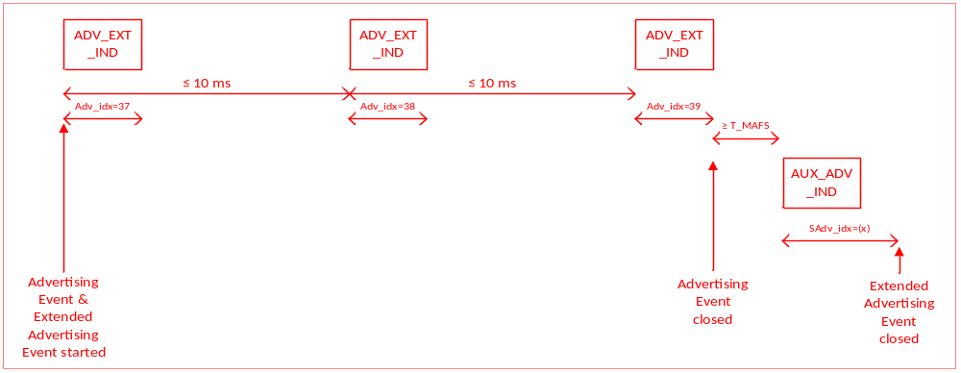
Figure 4.X: Connectable directed advertising event using the ADV_EXT_IND PDUs and AUX_ADV_IND PDU containing advertising data

Figure 4.X illustrates an advertising event using connectable directed EXT_ADV_IND advertising PDUs during which an AUX_CONNECT_REQ PDU is received on the second secondary advertising channel index.

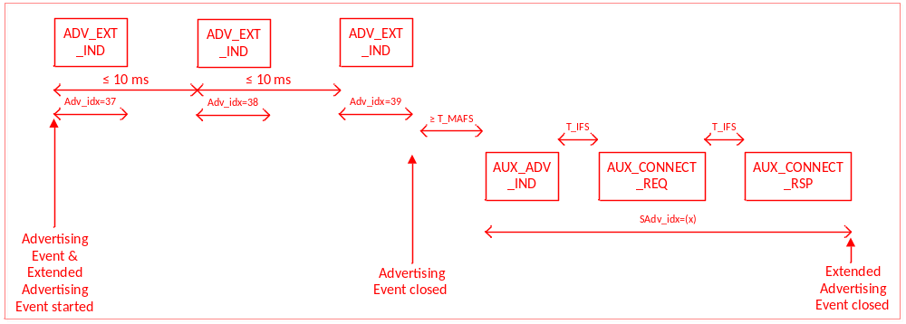
Figure 4.X: Connectable directed advertising event using ADV_EXT_IND PDUs and AUX_ADV_IND PDUs containing advertising data with an AUX_CONNECT_REQ PDU

[Modified Section] 4.4.2.5 Scannable Undirected Event Type
4.4.2.5 Scannable Undirected Event Type¹
[NOTE TO EDITOR: remove footnote “1. Discoverable Undirected Event Type was renamed to Scannable Undirected Event Type” ]

When the scannable undirected advertising event type is used, scannable undirected advertising indications (ADV_SCAN_IND or scannable undirected ADV_EXT_IND PDUs) are sent by the Link Layer.

A scannable undirected advertising event shall use either ADV_SCAN_IND or scannable undirected ADV_EXT_IND PDUs but not both.

[New Section] 4.4.2.5.1 Scannable Undirected Event Type using ADV_SCAN_IND
4.4.2.5.1 Scannable Undirected Event Type using ADV_SCAN_IND
When the scannable undirected advertising event type is used, scannable advertising indications (ADV_SCAN_IND PDUs) are sent by the Link Layer.

The scannable undirected event type allows a scanner to respond with a scan request (SCAN_REQ PDU) to request additional information about the advertiser.

The Link Layer shall listen on the same primary advertising channel index for requests from scanners. Any CONNECT_IND PDUs received shall be ignored.

If the advertiser receives a SCAN_REQ PDU that contains its device address from a scanner allowed by the advertising filter policy it shall reply with a SCAN_RSP PDU on the same advertising channel index. After the SCAN_RSP PDU is sent or if the advertising filter policy prohibited processing the SCAN_REQ PDU the advertiser shall either move to the next used primary advertising channel index to send another ADV_SCAN_IND PDU, or close the advertising event.

The time between the beginning of two consecutive ADV_SCAN_IND PDUs within an advertising event shall be less than or equal to 10 ms. The advertising event shall be closed within the advertising interval.

The structure of an advertising event in which no SCAN_REQ PDU was received is shown in Figure 4.9 for the case in which all the primary advertising channels are used.

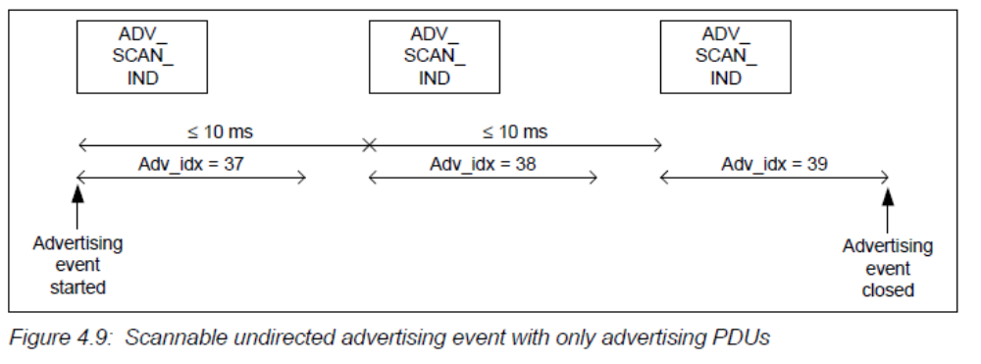

Two example advertising events during which a SCAN_REQ PDU is received and a SCAN_RSP PDU is sent are shown in Figure 4.10 and in Figure 4.11 for the case in which all the primary advertising channels are used.

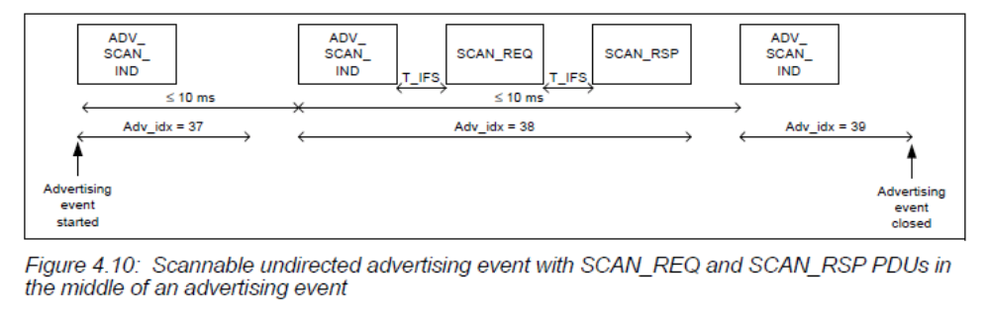
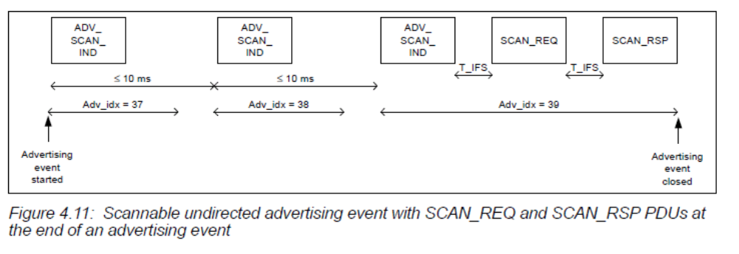

[New Section] 4.4.2.5.2 Scannable Undirected Event Type using ADV_EXT_IND
4.4.2.5.2 Scannable Undirected Event Type using ADV_EXT_IND

The scannable undirected event type using the ADV_EXT_IND PDU allows any scanner to respond with a scan request to receive scan response data on the secondary advertising channel.

The AdvMode field in the ADV_EXT_IND PDU shall be set to scannable.

The ADV_EXT_IND PDU shall not contain the AdvA field. A scanner may send a scan request using the AUX_SCAN_REQ PDU on the same secondary advertising channel index as the received AUX_ADV_IND PDU pointed to by the ADV_EXT_IND PDU.

After every AUX_ADV_IND PDU sent by the advertiser, the advertiser shall listen for AUX_SCAN_REQ PDUs on the same secondary advertising channel index from scanners. Any AUX_CONNECT_REQ PDUs received shall be ignored.

If the advertiser receives an AUX_SCAN_REQ PDU that contains its device address from a scanner allowed by the advertising filter policy, it shall reply with an AUX_SCAN_RSP PDU on the same secondary advertising channel index prior to the start of the next advertising event. After the AUX_SCAN_RSP PDU is sent or if the advertising filter policy prohibits processing the AUX_SCAN_REQ PDU. Any AUX_CONNECT_REQ PDUs on the secondary advertising channel shall be ignored.
The time between the beginning of two consecutive ADV_EXT_IND PDUs within an advertising event shall be less than or equal to 10 ms. The advertising event shall be closed within the advertising interval.

Figure 4.X shows an advertising event in which no AUX_SCAN_REQ PDU is received.

Figure 4.X: Scannable undirected advertising event using the ADV_EXT_IND PDUs and AUX_ADV_IND PDU containing advertising data
An example advertising event during which an AUX_SCAN_REQ PDU is received and an AUX_SCAN_RSP PDU is sent on the secondary advertising channel is shown in Figure 4.X.

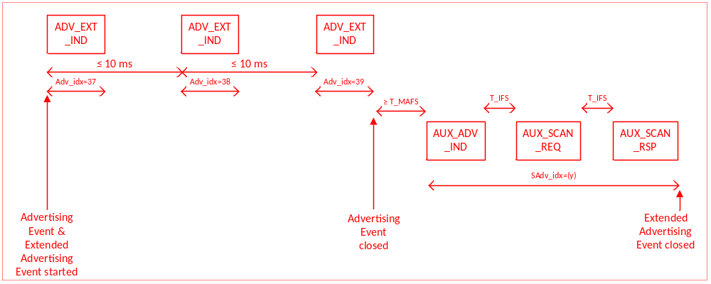
Figure 4.X: Scannable undirected advertising event with ADV_EXT_IND and AUX_ADV_IND PDUs with AUX_SCAN_REQ and AUX_SCAN_RSP PDUs on the secondary advertising channel

[Modified Section] 4.4.2.6 Non-connectable Undirected Event Type
4.4.2.6 Non-connectable Undirected Event Type

When the non-connectable undirected advertising event type is used, non-connectable undirected advertising indications (ADV_NONCONN_IND or non-connectable undirected ADV_EXT_IND PDUs) are sent by the Link Layer. The non-connectable undirected advertising event shall use either ADV_NONCONN_IND or non-connectable undirected ADV_EXT_IND PDUs but not both. The ADV_NONCONN_IND PDU shall not be used on the LE Coded PHY.

The non-connectable undirected event type allows a scanner to receive information contained in the ADV_NONCONN_IND or ADV_EXT_IND PDU from the advertiser.

The advertiser shall either move to the next used primary advertising channel index or close the advertising event after each ADV_NONCONN_IND or ADV_EXT_IND PDU that is sent. The Link Layer does not listen, and therefore cannot receive any requests from scanners or initiators.

The time between the beginning of two consecutive ADV_NONCONN_IND or ADV_EXT_IND PDUs within an advertising event shall be less than or equal to 10 ms. The advertising event shall be closed within the advertising interval.
If an ADV_EXT_IND PDU is used and it does not contain an AuxPtr field, the AdvA field shall be present. If it does contain an AuxPtr field, either the ADV_EXT_IND PDU or the AUX_ADV_IND that it points to, but not both, shall contain the AdvA field. On the LE Coded PHY, the AUX_ADV_IND PDU shall contain the AdvA field. The TargetA field shall not be present in either PDU.
An illustration of a non-connectable undirected advertising event is shown in Figure 4.12 for the case in which all the primary advertising channels are used.
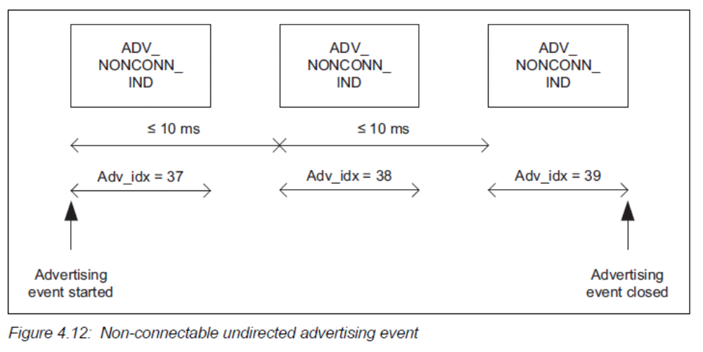
[NOTE TO EDITOR: Change caption to “Non-connectable undirected advertising event using ADV_NONCONN_IND PDUs”]

Figure 4.X shows an example of a non-connectable undirected ADV_EXT_IND PDU.

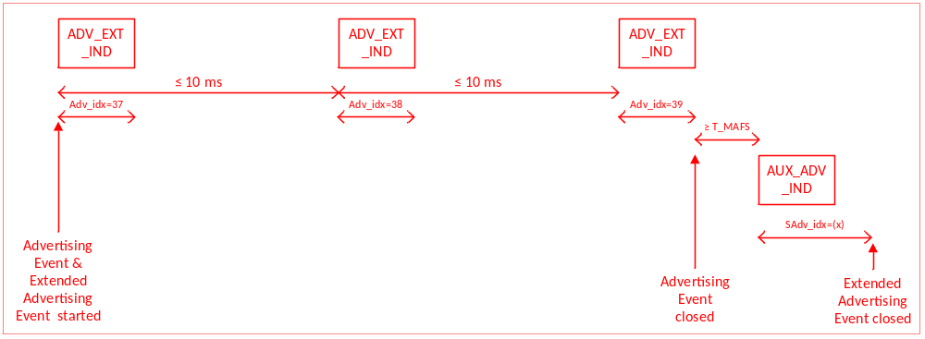
Figure 4.X: Non-connectable undirected advertising event using the ADV_EXT_IND PDU

Figure 4.X shows an example of a non-connectable undirected ADV_EXT_IND PDU where the Host advertising data is fragmented using the AUX_CHAIN_IND PDU.
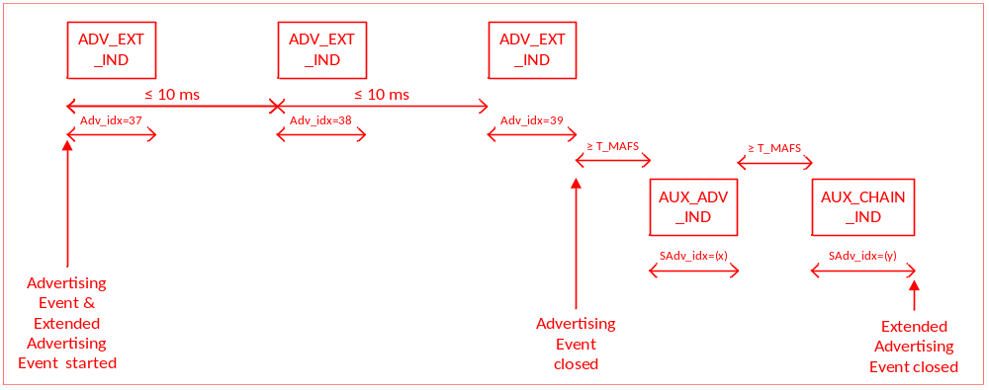Figure 4.X: Non-connectable undirected advertising event using the ADV_EXT_IND PDU with fragmented Host advertising data

[New Section] 4.4.2.7 Connectable Undirected Event Type
4.4.2.7 Connectable Undirected Event Type

The connectable undirected advertising event type using the ADV_EXT_IND PDU allows an initiator to respond with a connect request to establish a link layer connection on the secondary advertising channel.

The AdvMode field in the ADV_EXT_IND PDU shall be set to connectable. The ADV_EXT_IND PDU shall not contain the AdvA field and Target fields. The ADV_EXT_IND PDU’s AuxPtr field shall point to an AUX_ADV_IND PDU with the AdvA field present.

An initiator may send a connect request using the AUX_CONNECT_REQ PDU on the same secondary advertising channel as the AUX_ADV_IND PDU to request the Link Layer to enter the Connection State.

After every AUX_ADV_IND PDU sent related to this event by the advertiser, the advertiser shall listen for AUX_CONNECT_REQ PDUs on the same secondary advertising channel index. Any AUX_SCAN_REQ PDUs received shall be ignored.

If the advertiser receives an AUX_CONNECT_REQ PDU that contains its device address from an initiator allowed by the advertising filter policy it shall reply with an AUX_CONNECT_RSP PDU on the same secondary advertising channel index. After the AUX_CONNECT_RSP PDU is sent the Link Layer shall exit the Advertising State and transition to the Connection State in the Slave Role as defined in Section 4.5.5.

The time between the beginning of two consecutive ADV_EXT_IND PDUs within an advertising event shall be less than or equal to 10 ms. The advertising event shall be closed within the advertising interval.

Figure 4.X shows an advertising event in which no AUX_CONNECT_REQ PDU is received.

Figure 4.X: Connectable undirected advertising event using the ADV_EXT_IND PDUs and AUX_ADV_IND PDU containing advertising data

Figure 4.X illustrates an advertising event during which an AUX_CONNECT_REQ PDU is received and an AUX_CONNECT_RSP PDU is sent on the secondary advertising channel index.

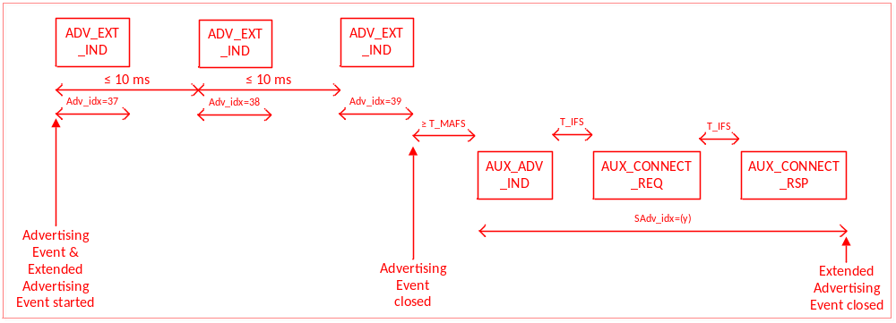Figure 4.X: Connectable undirected advertising using ADV_EXT_IND PDUs when an AUX_CONNECT_REQ PDU is received

[New Section] 4.4.2.9 Scannable Directed Event Type
4.4.2.9 Scannable Directed Event Type

The scannable directed advertising event type using the ADV_EXT_IND PDU allows a specific scanner to respond with a scan request to receive scan response data on the secondary advertising channel.

The AdvMode field in the ADV_EXT_IND PDU shall be set to scannable.

The ADV_EXT_IND PDU shall not contain the AdvA and TargetA fields. The ADV_EXT_IND PDU’s AuxPtr field shall point to an AUX_ADV_IND PDU with the AdvA and TargetA fields both present.

After every AUX_ADV_IND PDU sent, the advertiser shall listen for an AUX_SCAN_REQ PDU on the same secondary advertising channel index from the targeted scanner.

If the advertiser receives an AUX_SCAN_REQ PDU that contains its device address and the scanner’s device address is contained in the AUX_ADV_IND PDU, it shall reply with an AUX_SCAN_RSP PDU on the same secondary advertising channel index prior to the next advertising event. The AUX_SCAN_RSP PDU shall contain the scan response data. AUX_SCAN_REQ PDUs from any other scanner or any AUX_CONNECT_REQ PDUs received shall be ignored.

The time between the beginning of two consecutive ADV_EXT_IND PDUs within an advertising event shall be less than or equal to 10 ms. The advertising event shall be closed within the advertising interval.

See Section 4.4.2.5.2.2 for a description on how the AUX_SCAN_REQ packet is used in conjunction with the AUX_SCAN_RSP packets on the secondary advertising channel.

[New Section] 4.4.2.10 Non-Connectable Directed Event Type
4.4.2.10 Non-Connectable Directed Event Type

The non-connectable directed advertising event type using the ADV_EXT_IND PDU allows an advertiser to send non-connectable directed ADV_EXT_IND PDUs on the primary advertising channel with any advertising data sent on the secondary advertising channel targeted for a specific scanner.

The AdvMode field in the ADV_EXT_IND PDU shall be set to non-connectable.

Either the ADV_EXT_IND PDU or the AUX_ADV_IND PDU it points to, but not both, shall contain the AdvA and TargetA fields. On the LE Coded PHY they shall be present in the AUX_ADV_IND PDU.
The Link Layer does not listen, and therefore cannot receive any requests from scanners or initiators.

[New Section] 4.4.2.11 Advertising Data Sets
4.4.2.11 Advertising Data Sets

The advertiser’s Host may instruct the Link Layer to interleave advertising events. Advertising data belonging together is called an advertising data set. The Link Layer may support multiple advertising data sets, with each set having different advertising parameters such as advertising PDU type, advertising interval, and PHY.

When advertising with the ADV_EXT_IND, AUX_ADV_IND, or AUX_SYNC_IND PDUs, the advertising data set is identified by the Advertising SID subfield of the ADI field. The Link Layer shall set the Advertising SID subfield as directed by the Host.

The scanner may filter advertisements based on the Advertising SID.

The advertising events for each Advertising Data Set are considered a separate instance of the Advertising State.

Figure 4.X illustrates an example of advertising using multiple advertising sets.
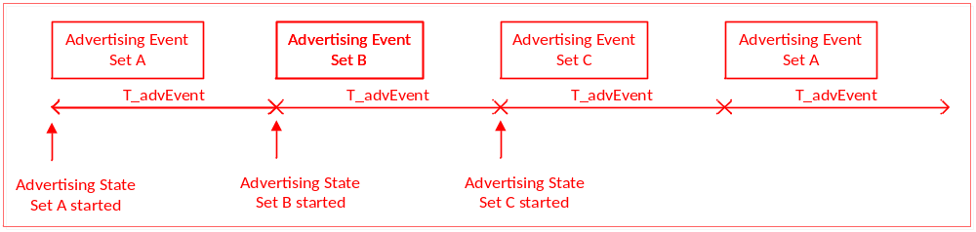
Figure 4.X: Multiple advertising data sets example
On reset, the advertising parameters and advertising data for all advertising sets are cleared.

[New Section] 4.4.2.12 Using AdvDataInfo (ADI)
4.4.2.12 Using AdvDataInfo (ADI)

The AdvDataInfo (ADI) field is used to identify advertising sets and duplicate AdvData in either the AUX_ADV_IND or AUX_SCAN_RSP PDUs. For scannable ADV_EXT_IND, AdvData is not permitted in the AUX_ADV_IND PDU so ADI only refers to the AdvData contained in the AUX_SCAN_RSP PDU.

The ADI field contains two fields: Advertising SID field and Advertising DID field.

The following rules apply to PDUs containing the ADI field. No PDU is required to contain an ADI field.

If consecutive ADV_EXT_IND PDUs with the same Advertising SID field are sent (whether or not separated by other ADV_EXT_IND PDUs containing a different Advertising SID field), then the Advertising DID fields shall be the same in each of the ADV_EXT_IND PDUs if and only if the AUX_ADV_IND PDUs indicated by the AuxPtr fields (plus any AUX_CHAIN_IND PDUs that these refer to) or an AUX_SCAN_RSP resulting from a AUX_SCAN_REQ contain the same AdvData. For this purpose, an ADV_EXT_IND PDU not containing an AuxPtr field shall be equivalent to one pointing to an AUX_ADV_IND PDU with no advertising data.
Note: The Controller should choose Advertising DID field values randomly to reduce the possibility of PDUs from different advertisers containing the same ADI field value.

[New Section] 4.4.2.13 Periodic Advertising
4.4.2.13 Periodic Advertising

When advertising data is required to be sent regularly at a fixed interval, periodic advertising is used. Periodic advertising consists of advertisements sent at a fixed interval with the advertisement data changing from time to time.

When periodic advertising data is used, the Periodic Advertising is identified by the AdvDataInfo field of the ADV_EXT_IND PDUs on the primary advertising channel that point to the AUX_ADV_IND PDUs containing the SyncInfo field used to describe the AUX_SUNC_IND PDUs. The advertiser shall send the AUX_SYNC_IND PDUs sent at regular intervals described in the AUX_ADV_IND PDU’s SyncInfo field on the secondary advertising channel. The AUX_SYNC_IND PDUs shall be sent on the same PHY as that used for the PDUs that point to them.

The Host may send periodic advertising data to the Link Layer. This advertising data is placed by the Link Layer in the periodic AUX_SYNC_IND PDUs. The Link Layer shall repeat the last advertising data sent by the Host until it receives new advertising data. The AUX_SYNC_IND PDUs are continuously sent out until the Host directs the Link Layer to terminate the periodic advertising.
Periodic advertising may be sent autonomously or on demand.

[New Section] 4.4.2.13.1 Autonomous Periodic Advertising
4.4.2.13.1 Autonomous Periodic Advertising

A link layer can choose to supply periodic advertising data autonomously. To do so, the advertiser shall send ADV_EXT_IND PDUs on the primary advertising channel that contain an AuxPtr field pointing to AUX_ADV_IND PDUs sent on the secondary advertising channel. The AdvA field shall be present in either the ADV_EXT_IND PDU or the AUX_ADV_IND PDU but not both. If periodic advertising is used on the LE Coded PHY, the AdvA field shall not be present in the ADV_EXT_IND PDU. The AUX_ADV_IND PDUs shall contain a SyncInfo field.
Figure 4.X illustrates an example of autonomous periodic advertising.
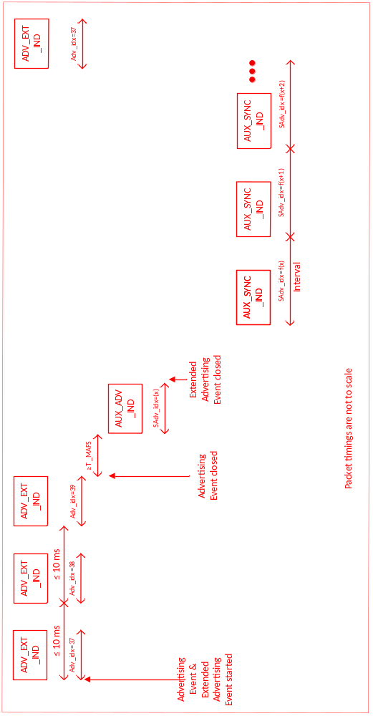

[New Section] 4.4.2.13.2 On-Demand Periodic Advertising
4.4.2.13.2 On-Demand Periodic Advertising

A link layer can choose to supply periodic advertising data only when requested by a scanning device; this is called “on-demand” periodic advertising. To do so, when the advertiser transmits an AUX_SCAN_RSP PDU to the scanner, the PDU shall contain a SyncInfo field.

[Modified Section] 4.4.3 Scanning State
4.4.3 Scanning State

The Link Layer shall enter the Scanning State when directed by the Host. When scanning, the Link Layer shall listen on the primary advertising channel indices. There are two types of scanning, determined by the Host: passive and active.

There are no strict timing or advertising channel index selection rules for scanning.

During scanning, the Link Layer listens on an primary advertising channel index for the duration of the scan window, scanWindow. The scan interval, scanInterval, is defined as the interval between the start of two consecutive scan windows.

The Link Layer should listen for the complete scanWindow every scanInterval as directed by the Host unless there is a scheduling conflict. In each scan window, the Link Layer should scan on a different advertising channel index. The Link Layer shall use all the advertising channel indices.

The scanWindow and scanInterval parameters shall be less than or equal to 40.96 s. The scanWindow shall be less than or equal to the scanInterval. If the scanWindow and the scanInterval parameters are set to the same value by the Host, the Link Layer should scan continuously.

The scanner filter policy shall apply when receiving an advertising PDU when scanning.

On receiving a PDU with the AuxPtr field present, the scanner should also listen for the PDU it points to (provided that it supports the PHY specified in the AuxPtr field).

For each non-duplicate ADV_IND, ADV_SCAN_IND, ADV_NONCONN_IND, ADV_DIRECT_IND, or SCAN_RSP PDU from an advertiser, the Link Layer shall send an advertising report to the Host. The advertising report shall contain at least the advertiser's device address and advertising data or scan response data if present. Duplicate advertising reports are not required to be sent to the Host. A duplicate advertising report is an advertising report for the same device address while the Link Layer stays in the Scanning State. The advertising data may change; advertising data or scan response data is not considered significant when determining duplicate advertising reports.
[Moved to new section 4.4.3.3]

[Modified Section] 4.4.3.2 Active Scanning
4.4.3.2 Active Scanning

In active scanning, the Link Layer shall listen for advertising PDUs and depending on the advertising PDU type it may request an advertiser to send additional information.

The Link Layer shall not only send a SCAN_REQ PDU to an advertiser from which an ADV_DIRECT_IND PDU or ADV_NONCONN_IND ADV_IND PDU or ADV_SCAN_IND PDU, is received. The Link Layer shall only send an AUX_SCAN_REQ PDU to an advertiser from which a scannable AUX_ADV_IND is received.

The Link Layer shall send at least one SCAN_REQ PDU after entering the Scanning State to all advertisers that are allowed by the scanner filter policy from which ADV_IND PDUs,or ADV_SCAN_IND PDUs are received. The Link Layer should interleave SCAN_REQ PDUs to multiple advertisers. The Link Layer shall ignore the scannable ADV_EXT_IND PDU if the TargetA field is present and it does not match the Link Layer’s device address.

If the Link Layer has not already sent at least one SCAN_REQ PDU after entering the Scanning State to all advertisers that are allowed by the scanner filter policy, the Link Layer shall send at least one AUX_SCAN_REQ PDU after entering the Scanning State to all advertisers that are allowed by the scanner filter policy from which scannable AUX_ADV_IND PDUs are received. The Link Layer shall ignore the scannable AUX_ADV_IND PDU if the TargetA field is present and it does not match the Link Layer’s device address.

The Link Layer shall continue to send SCAN_REQ or AUX_SCAN_REQ PDUs to an advertiser that is allowed by the advertiser filter policy until it has received at least one SCAN_RSP PDU from that advertiser. A scanner should not send multiple AUX_SCAN_REQ PDUs to an advertiser if the ADI field in the AUX_ADV_IND PDUs does not change.

The scanner shall run a backoff procedure to minimize collisions of SCAN_REQ or AUX_SCAN_REQ PDUs from multiple scanners.

The backoff procedure uses two parameters, backoffCount and upperLimit to restrict the number of SCAN_REQ PDUs sent when collisions occur on SCAN_RSP PDUs.

Upon entering the Scanning State, the upperLimit shall be set to one and the
backoffCount shall be set to one.

On every received ADV_IND PDU, or ADV_SCAN_IND PDU, or scannable AUX_ADV_IND PDU that is allowed by the scanner filter policy and for which a SCAN_REQ or AUX_SCAN_REQ PDU is to be sent, the backoffCount shall be decremented by one until it reaches the value of zero. The SCAN_REQ or AUX_SCAN_REQ PDU shall only be sent when backoffCount becomes zero.

After sending a SCAN_REQ or AUX_SCAN_REQ PDU the Link Layer shall listen for a SCAN_RSP or AUX_SCAN_RSP PDU from that advertiser. If the SCAN_RSP or AUX_SCAN_RSP PDU was not received from that advertiser, it is considered a failure otherwise it is considered a success. On every two consecutive failures, the upperLimit shall be doubled until it reaches the value of 256. On every two consecutive successes, the upperLimit shall be halved until it reaches the value of one. After success or failure of receiving the SCAN_RSP or AUX_SCAN_RSP PDU, the Link Layer shall set backoffCount to a new pseudorandom integer between one and upperLimit inclusive.

Two illustrations of advertising events using all the advertising channel indices during which a SCAN_REQ PDU is received and a SCAN_RSP PDU is sent are shown in Figure 4.3 and in Figure 4.4.

[New Section] 4.4.3.3 Advertising Data Sets
4.4.3.3 Advertising Data Sets

When an advertiser is advertising multiple data sets, the Host may only be interested in receiving specific advertising data sets. The Host can configure the Link Layer to only report specified advertising data sets.

The ADV_EXT_IND PDU may contain an ADI field. When the ADI field is present, it can be used to identify advertisement data that belong to the same set. This is specified in the Advertising SID subfield in the ADI. The Advertising SID is set by the Host of the advertiser. The Host on the scanner may configure the Link Layer to only report specific advertising data sets; if so, the Link Layer shall only send advertising reports for advertising data sets specified by the Host. If the Host does not configure the Link Layer to only return advertising reports for specific advertising data sets, the Link Layer shall report all advertising data sets.

[New Section] 4.4.3.4 Periodic Advertisements
4.4.3.4 Periodic Advertisements

For an AUX_ADV_IND PDU where the SyncInfo field is present the scanner should, when instructed by the Host, listen for the AUX_SYNC_IND PDU specified in the SyncInfo field.

The next channel to listen for the AUX_SYNC_IND PDU is determined by the Hop and Channel Index subfields in the SyncInfo field.

Because of sleep clock accuracies (see Section 4.2.2), the scanner should perform the window widening specified in Section 4.5.7, with connection events replaced by packets containing AUX_SYNC_IND PDUs.
The Link Layer on the scanner shall report the advertising data received in the periodic advertisements to the Host.

[New Section] 4.4.3.5 Duplicate Advertisement Report Filtering
4.4.3.5 Duplicate Advertisement Report Filtering
[Editor Note: the following paragraph was moved from the last paragraph in 4.4.3 to create this new sub-section]
For each non-duplicate ADV_IND, ADV_SCAN_IND, ADV_NONCONN_IND, ADV_DIRECT_IND, or SCAN_RSP advertising, SCAN_RSP or AUX_SCAN_RSP PDU, from an advertiser, the Link Layer shall send an advertising report to the Host. The advertising report shall contain at least the advertiser's device address and advertising data or scan response data if present. The Host may request that duplicate advertising reports are filtered.

Where the ADV_EXT_IND PDU contains an ADI field, a duplicate advertising report is an advertising report for the same device address where the previous report that contained an ADI value with the same Advertising SID also had the same Advertising DID.

Where the ADV_EXT_IND PDU does not contain an ADI field, aA duplicate advertising report is an advertising report for the same device address while the Link Layer stays in the Scanning State.

In either case tThe actual advertising data may change; advertising data or scan response data is not considered significant when determining duplicate advertising reports.

[Modified Section] 4.4.4 Initiating State
4.4.4 Initiating State

The Link Layer shall enter the Initiating State when directed by the Host. When initiating, the Link Layer shall listen on the advertising channel indices.

There are no strict timing or advertising channel index selection rules for initiators.

During initiating, the Link Layer listens on an advertising channel index for the duration of the scan window, scanWindow. The scan interval, scanInterval, is defined as the interval between the start of two consecutive scan windows.

The Link Layer should listen for the complete scanWindow every scanInterval as directed by the Host unless there is a scheduling conflict. In each scan window, the Link Layer should listen on a different advertising channel index. The Link Layer shall use all the advertising channel indices.

The scanWindow and scanInterval parameters shall be less than or equal to 10.24 s. The scanWindow shall be less than or equal to the scanInterval. If the scanWindow and the scanInterval parameters are set to the same value by the Host, the Link Layer should listen continuously.

Connection indications or requests in response to a connectable advertisment shall be sent on either the primary or secondary advertising channel depending on which advertising PDU contains an AdvA field. The following sub-sections describe the two procedures.

If Link Layer Privacy has been enabled, then the requirements in Section 6.4 shall also be followed.

[New Section] 4.4.4.1 Connect Requests on the Primary Advertising Channel
4.4.4.1 Connect Requests on the Primary Advertising Channel

This procedure shall not be used when establishing a connection on the LE Coded PHY.

[Editor Note: The following text was taken from 4.4.4, modified and placed in this subsection]

If an ADV_IND PDU is received that is allowed by the initiator filter policy, the initiator shall send a CONNECT_IND PDU to the advertiser. If an ADV_DIRECT_IND PDU with this Link Layer’s device address is received and that is allowed by the initiator filter policy is received, the initiator shall send a CONNECT_IND PDU to the advertiser; otherwise it shall be ignored.

After sending the CONNECT_IND PDU, the Link Layer shall exit the Initiating State, and shall transition to the Connection State in the Master Role as defined in Section 4.5.4.

[New Section] 4.4.4.2 Connect Requests on the Secondary Advertising Channel
4.4.4.2 Connect Requests on the Secondary Advertising Channel

This procedure shall be used when establishing a connection on the LE Coded PHY.

If a connectable ADV_EXT_IND PDU is received, the initiator shall listen for the connectable AUX_ADV_IND on the secondary advertising channel. If a connectable undirected AUX_ADV_IND PDU, or a connectable directed AUX_ADV_IND PDU with this Link Layer’s device address, is received and is allowed by the initiator filter policy, the initiator shall send an AUX_CONNECT_REQ PDU to the advertiser; otherwise, it shall be ignored.

After sending the AUX_CONNECT_REQ PDU, the initiator shall wait for the advertiser to send an AUX_CONNECT_RSP PDU. Once an AUX_CONNECT_RSP PDU is received, the Link Layer shall exit the Initiating State and shall transition to the Connection State in the Master Role as defined in Section 4.5.4. If the initiator does not receive an AUX_CONNECT_RSP PDU from the advertiser, it shall use the back-off algorithm described for SCAN_REQ in Section 4.4.3.2 before responding to the next connectable AUX_ADV_IND PDU.

[Modified Section] 4.5 Connection State
4.5 CONNECTION STATE
The Link Layer enters the Connection State when an initiator sends a CONNECT_IND PDU on the primary channel to an advertiser, or an advertiser receives a CONNECT_IND PDU on the primary advertising channel from an initiator, an advertiser sends an AUX_CONNECT_RSP PDU on the secondary advertising channel to an initiator, or an initiator receives an AUX_CONNECT_RSP PDU on the secondary advertising channel from an advertiser.

After entering the Connection State, the connection is considered to be created. The connection is not considered to be established at this point. A connection is only considered to be established once a data channel packet has been received from the peer device. The only difference between a connection that is created and a connection that is established is the Link Layer connection supervision timeout value that is used (see Section 4.5.2).

When If the connection is first created using the CONNECT_IND PDU on the primary advertising channel, it shall use the same LE 1M PHY in both directions as was used for the CONNECT_IND PDU. If the connection is first created on the secondary channel using the AUX_CONNECT_REQ and AUX_CONNECT_RSP PDUs, it shall use the same PHY in both directions as was used for the AUX_CONNECT_REQ and AUX_CONNECT RSP PDU. Either PHY may be changed subsequently using the PHY Update Procedure (Section 5.1.10). When the LE Coded PHY is in use, the coding of each packet is determined by the CI field as defined in Section 2.5.3 and may be different in each direction and in adjacent packets in a given direction.

When two devices are in a connection, the two devices act in different roles. A Link Layer in the Master Role is called a master. A Link Layer in the Slave Role is called a slave. The master controls the timing of a connection event. A connection event is a point of synchronization between the master and the slave. There shall be only one connection between two LE device addresses. An initiator shall not send a connection request to an advertiser it is already connected to.

If an advertiser receives a connection request from an initiator it is already connected to, it shall ignore that request.

[Modified Section] 4.5.3 Connection Event Transmission Window
4.5.3 Connection Event Transmit Window
To allow the master to efficiently schedule connection events for multiple connections or other activities it may be involved in, the master has the flexibility to schedule the first connection event anchor point at a time of its choosing. The CONNECT_IND PDU includes parameters to determine when the master can send its first packet in the Connection State to set the anchor point and when the slave must listen.

The CONNECT_IND and AUX_CONNECT_REQ PDUs includes three parameters used to determine the transmit window. The transmit window starts at transmitWindowDelay + transmitWindowOffset + 1.25 ms after the end of the packet containing the CONNECT_IND PDU or AUX_CONNECT_REQ PDU, and the transmitWindowSize parameter shall define the size of the transmit window. The connInterval is used in the calculation of the maximum offset and size of the transmit window. The transmitWindowOffset and transmitWindowSize parameters are determined by the Link Layer.

The transmitWindowOffset shall be a multiple of 1.25 ms in the range of 0 ms to connInterval. The transmitWindowSize shall be a multiple of 1.25 ms in the range of 1.25 ms to the lesser of 10 ms and (connInterval - 1.25 ms).

Therefore the start of the first packet will be no earlier than transmitWindowDelay1.25 ms + transmitWindowOffset and no later than transmitWindowDelay1.25 ms + transmitWindowOffset + transmitWindowSize after the end of the packet containing the CONNECT_IND PDU transmitted in the advertising channel or AUX_CONNECT_REQ PDU.

The value of transmitWindowDelay shall be 1.25 ms when a CONNECT_IND PDU is used, 2.5 ms when an AUX_CONNECT_REQPDU is used on an LE Uncoded PHY, and 3.75 ms when an AUX_CONNECT_REQ PDU is used on the LE Coded PHY.

[Modified Section] 4.5.4 Connection Setup – Master Role
4.5.4 Connection Setup – Master Role

After the initiator sends thea CONNECT_IND PDU on the primary advertising channel or receives an AUX_CONNECT_RSP PDU on the secondary advertising channel, the Link Layer is in the Connection State in the Master Role. The master shall reset the Link Layer connection supervision timer TLLconnSupervision. The Link Layer shall notify the Host that the connection has been created. The first connection event shall use the data channel index as specified in Section 1.4.1.
[…]

Two examples of the LL connection setup procedure timing from the master’s perspective are shown in Figure 4.14, and in Figure 4.15 and in Figure 4.X.

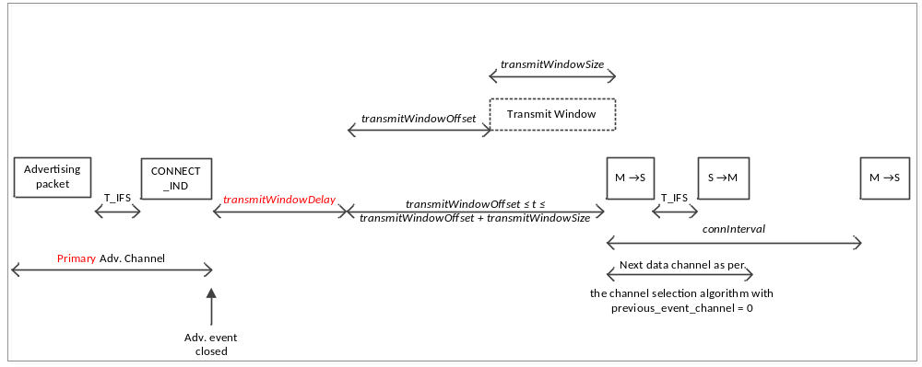
Figure 4.14: Master’s view on LL connection setup with a non-zero transmitWindowOffsetCONNECT_IND

[Note to editor: Remove Figure 4.15]

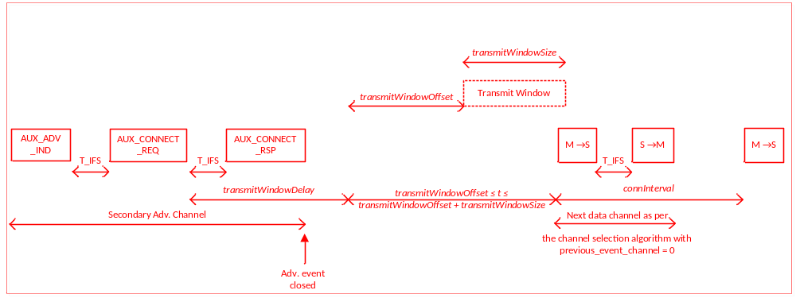Figure 4.X: Master’s view on LL connection setup with AUX_CONNECT_REQ

[Modified Section] 4.5.5 Connection Setup – Slave Role
4.5.5 Connection Setup – Slave Role

After the advertiser receives a CONNECT_IND PDU on the primary advertising channel or sends an AUX_CONNECT_RSP PDU on the secondary advertising channel, the Link Layer is in the Connection State in the Slave Role. The slave shall reset the Link Layer connection supervision timer TLLconnSupervision. The Link Layer shall notify the Host that the connection has been created. The first connection event shall use the data channel index as specified in Section 1.4.1.

AnTwo examples of the procedure from the slave’s perspective isare shown in Figure 4.16 and in Figure 4.X+1. in whichIn these examples the slave fails to receive any part of the first packet (i.e., connEventCount = 0) from the master and acquires anchor point timing from the second packet (i.e., connEventCount = 1).
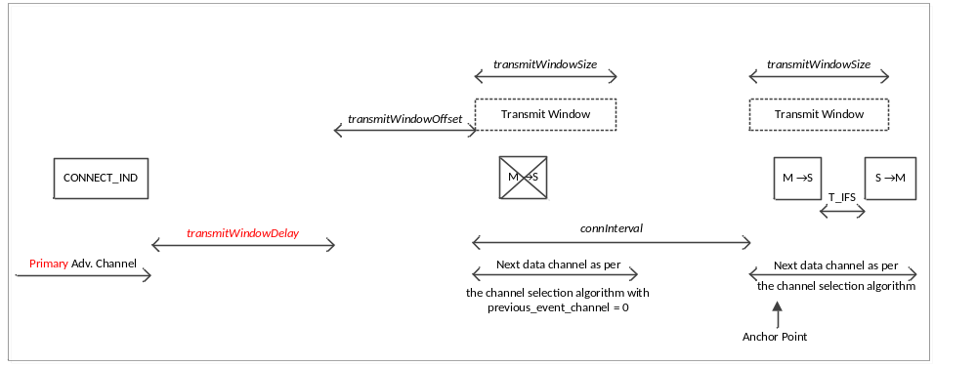Figure 4.16: Slave closing LL connection setup in the second LL connection event with CONNECT_IND

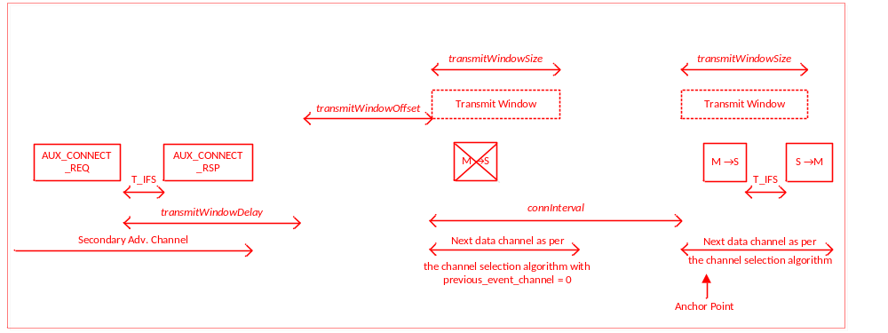Figure 4.X: Slave closing LL connection setup in the second LL connection event with AUX_CONNECT_REQ

[Modified Section] 4.6 Feature Support
4.6 FEATURE SUPPORT
[Editor Note: Add the following lines to table 4.4]
Bit position | Link Layer Feature | Valid from Controller to Controller
12 | LE Extended Advertising | N
13 | LE Periodic Advertising | N

[New Section] 4.6.X LE Extended Advertising
4.6.X LE Extended Advertising
A Controller that supports LE Extended Advertising shall support reception of an Advertising Channel PDU payload of 255 octets and support the following sections of this document.

- Common Extended Advertising Payload Format (Section 2.3.X)
- ADV_EXT_IND (Section 2.3.1.X)
- AUX_ADV_IND (Section 2.3.1.X)
- AUX_CHAIN_IND (Section 2.3.1.X)
- AUX_SCAN_REQ (Section 2.3.2.1)
- AUX_SCAN_RSP (Section 2.3.2.X)
- AUX_CONNECT_REQ (Section 2.3.3.1)
- AUX_CONNECT_RSP (Section 2.3.3.X)
- Connectable Directed Event Type Using ADV_EXT_IND (Section 4.4.2.4.2)
- Scannable Undirected Event Type using ADV_EXT_IND (Section 4.4.2.5.2)
- Scan Requests to Scannable ADV_EXT_IND (Section 4.4.2.5.3)
- Scan Requests to Scannable AUX_ADV_IND (Section 4.4.2.5.4)
- Connectable Undirected Event Type (Section 4.4.2.7)
- Scannable Directed Event Type (Section 4.4.2.8)
- Advertising Data Sets (Section 4.4.2.10)
- Using AdvDataInfo (ADI) (Section 4.4.2.11)
- On-Demand Advertising (Section 4.4.2.13)
- Advertising Data Sets (Section 4.4.3.3)
- Connect Request on the Secondary Advertising Channel (Section 4.4.4.2)

[New Section] 4.6.X LE Periodic Advertising
4.6.X LE Periodic Advertising

A controller that supports LE Periodic Advertising shall support the LE Extended Advertising feature and the following sections of this document.

- AUX_SYNC_IND (Section 2.3.1.X)
- Periodic Advertising (Section 4.4.2.12 & Section 4.4.3.4)

Volume 6, Part D: Message Sequence Charts

[Modified Section] 3.2 Directed Advertising
[Note to Editor: Change occurrence of Directed Advertising Timeout to Advertising Timeout in MSC]

[NEW SECTION] 2.X Periodic Advertiser List
2.X Periodic Advertiser List
The Periodic Advertiser List may be cleared and devices added in as required, before it is made use of (see Figure 2.X).
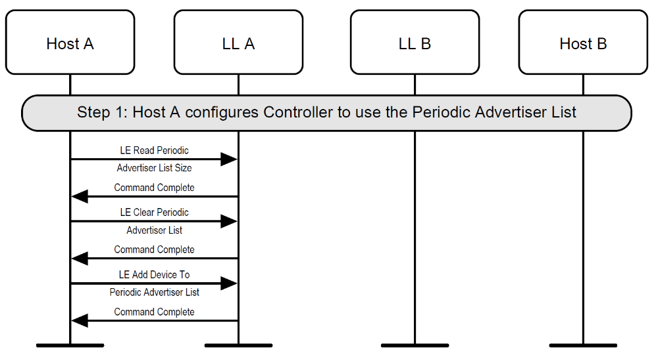
Figure 2.X Periodic Advertiser List

[NEW SECTION] 3.X Advertising Using ADV_EXT_IND
3.X Advertising Using ADV_EXT_IND
A device may enter the Advertising State by enabling advertising a set. It should also configure the advertising set parameters before doing this (see Figure 3.X).
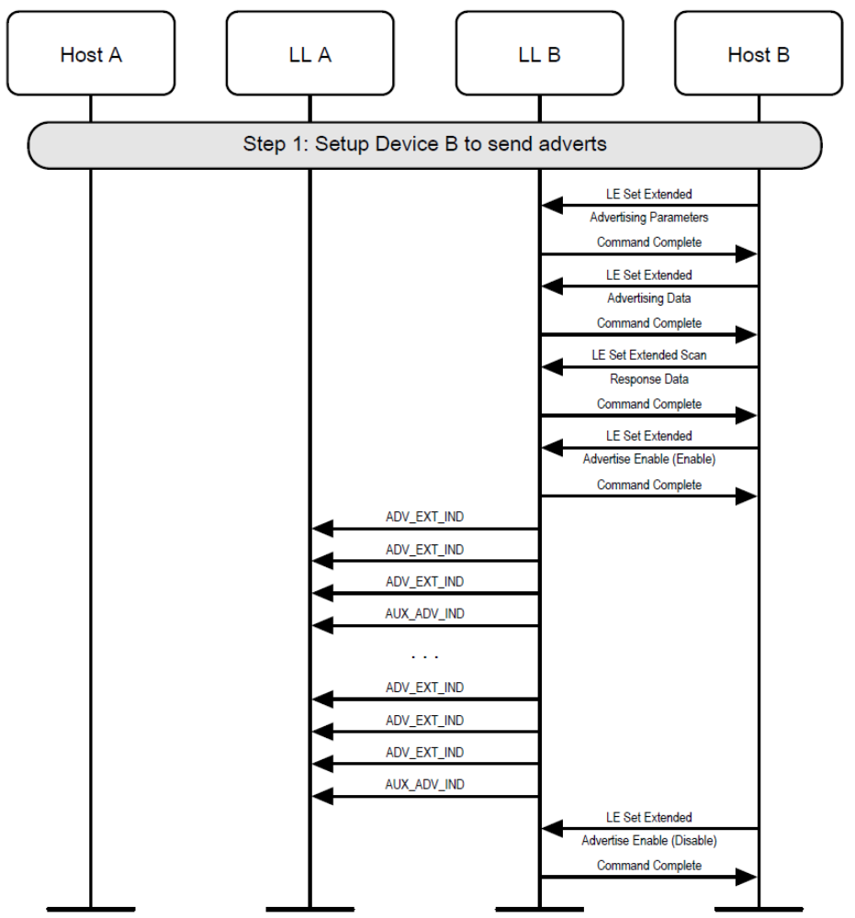
Figure 3.X Advertising using ADV_EXT_IND

[NEW SECTION] 3.X Scan Request Notifications
3.X Scan Request Notifications
A device may enable scan request notifications in an advertising set (see Figure 3.X).
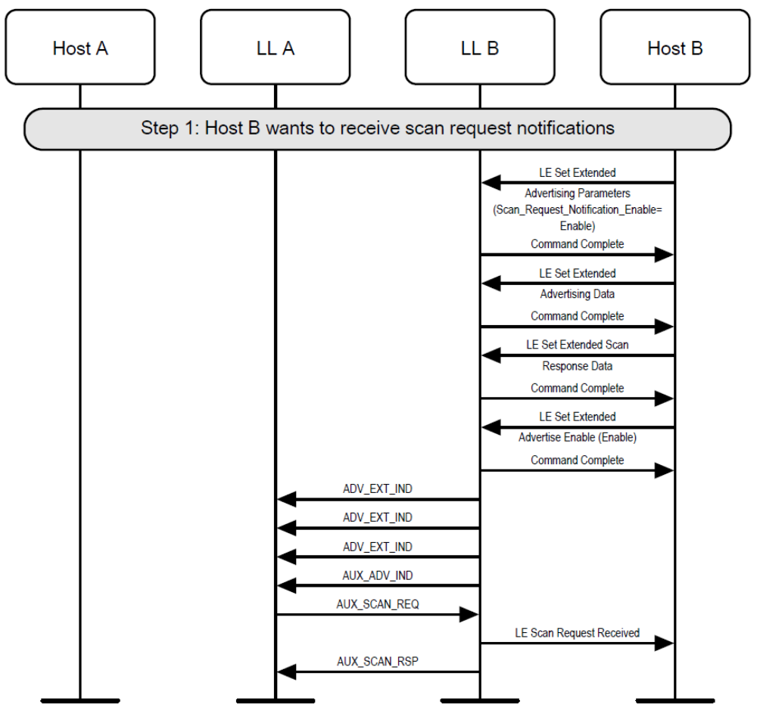
Figure 3.X Scan Request Notifications

[NEW SECTION] 3.X Advertising Duration Ended
3.X Advertising Duration Ended
A device may enter the Advertising State by enabling advertising a set for a limited duration of time (see Figure 3.X).
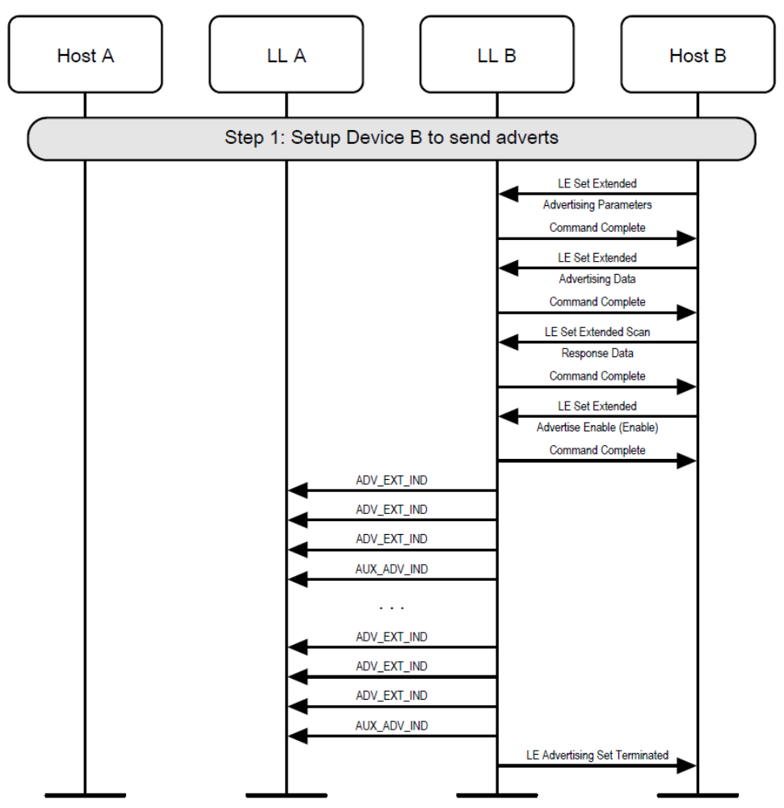
Figure 3.X Advertising Duration Ended

[NEW SECTION] 3.X Periodic Advertising
3.X Periodic Advertising
A device may enter the Advertising State by enabling periodic advertising in a set. It should also configure the advertising set parameters before doing this (see Figure 3.X).

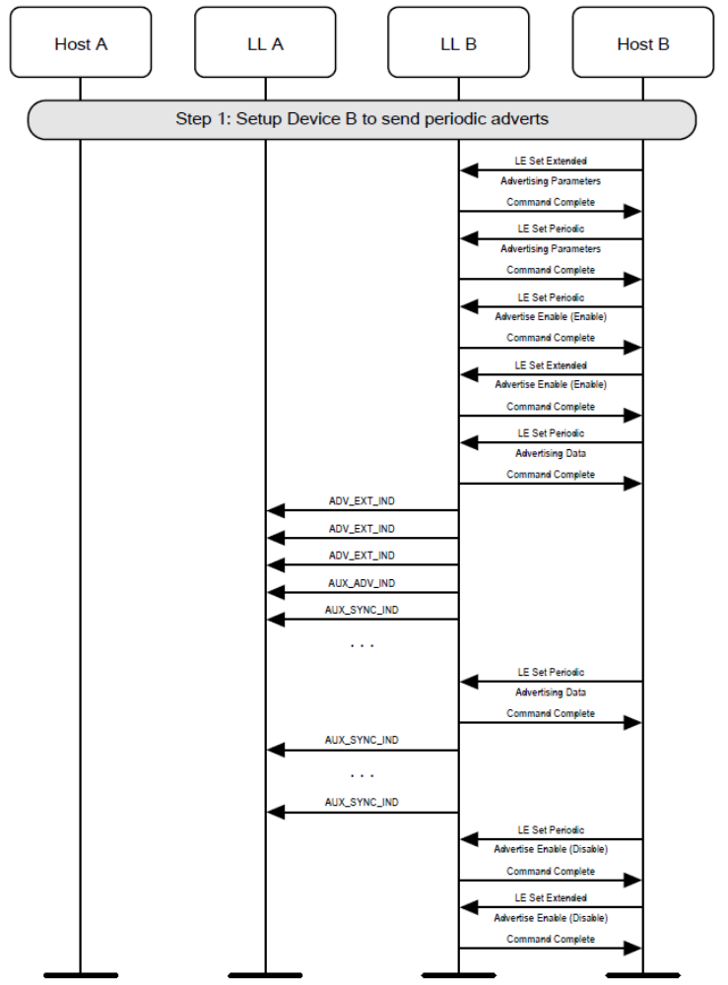
Figure 3.X Periodic Advertising

[NEW SECTION] 4.X Active Scanning on the primary advertising channel
4.X Active Scanning on the primary advertising channel
A device may use active scanning on the primary advertising channel in order to obtain more information about devices that may be useful to populate a user interface (see Figure 4.X).
[Note to the editor: packets that are followed by “(missing)” should be shown as going missing i.e. not reaching the other side. The MSC generator tool is not capable of doing that.]
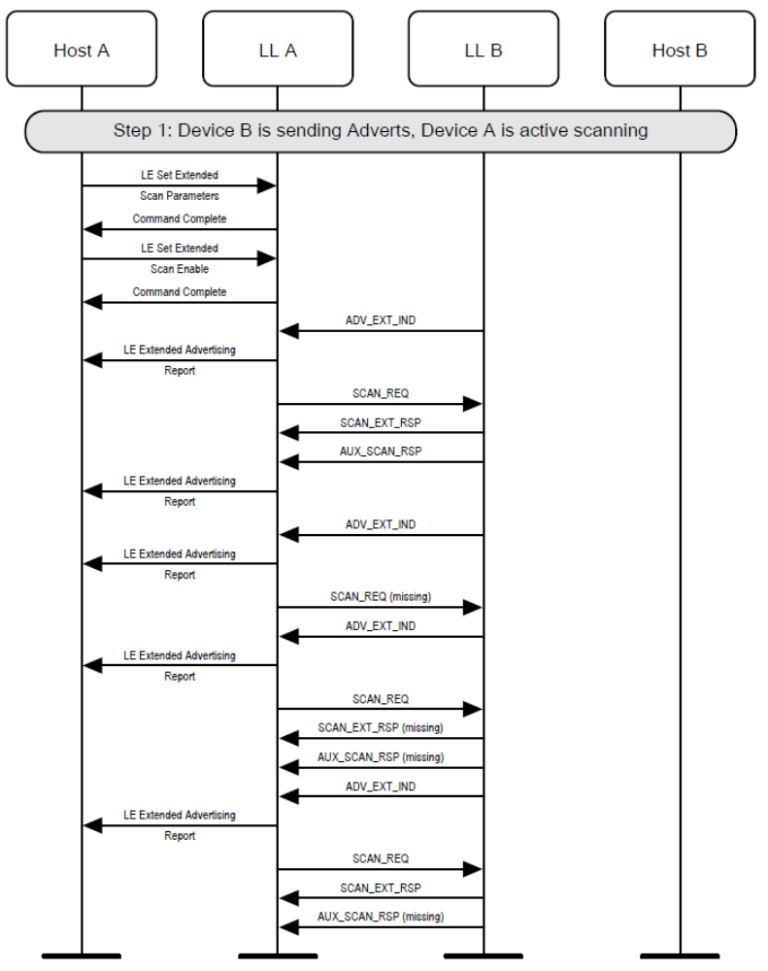
Figure 4.X Extended active scanning on the primary advertising channel

[NEW SECTION] 4.X Active scanning on the secondary advertising channel
4.X Active scanning on the secondary advertising channel
A device may use active scanning on the secondary advertising channel in order to obtain more information about devices that may be useful to populate a user interface (see Figure 4.X).
[Note to the editor: packets that are followed by “(missing)” should be shown as going missing i.e. not reaching the other side. The MSC generator tool is not capable of doing that.]

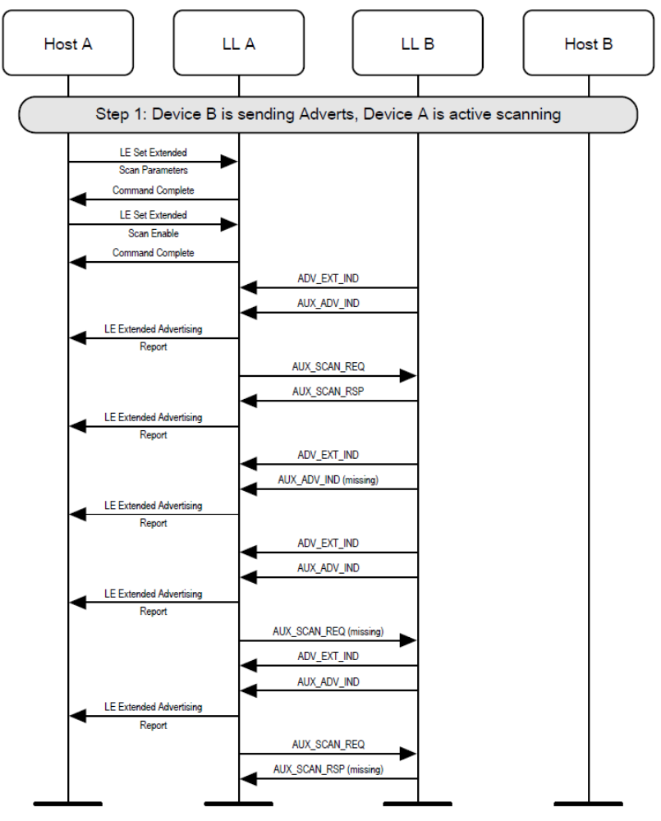
Figure 4.X Extended active scanning on the secondary advertising channel

[NEW SECTION] 4.X Scan Timeout
4.X Scan Timeout
A device may scan for a limited duration of time (see Figure 4.X).
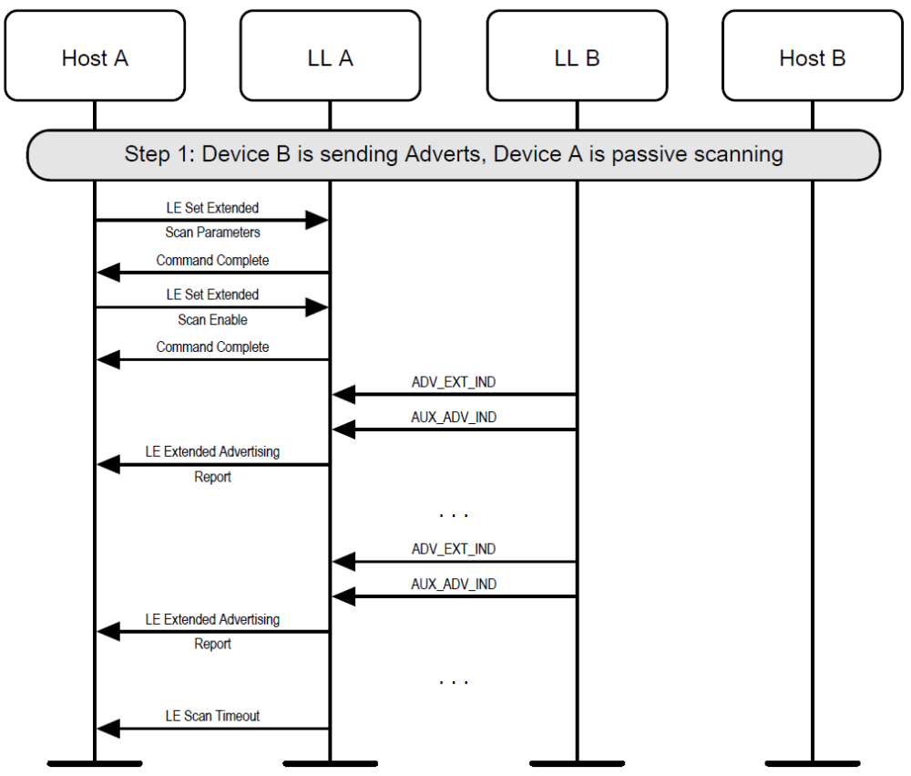
Figure 4.X Scan Timeout

[NEW SECTION] 4.X Periodic Scanning
4.X Periodic Scanning
A device may establish synchronization with a periodic advertiser and report periodic advertising packets to the Host (see Figure 4.X).
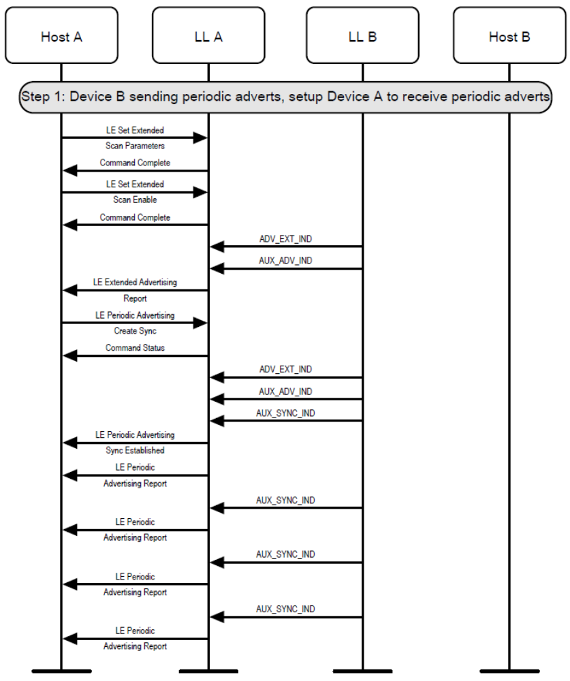
Figure 4.X Periodic Scanning

[NEW SECTION] 4.X Periodic Scanning Cancel
4.X Periodic Scanning Cancel
A device may cancel a pending request to establish synchronization with a periodic advertiser. This example shows an unsuccessful synchronization, followed by cancellation of the synchronization (see Figure 4.X).
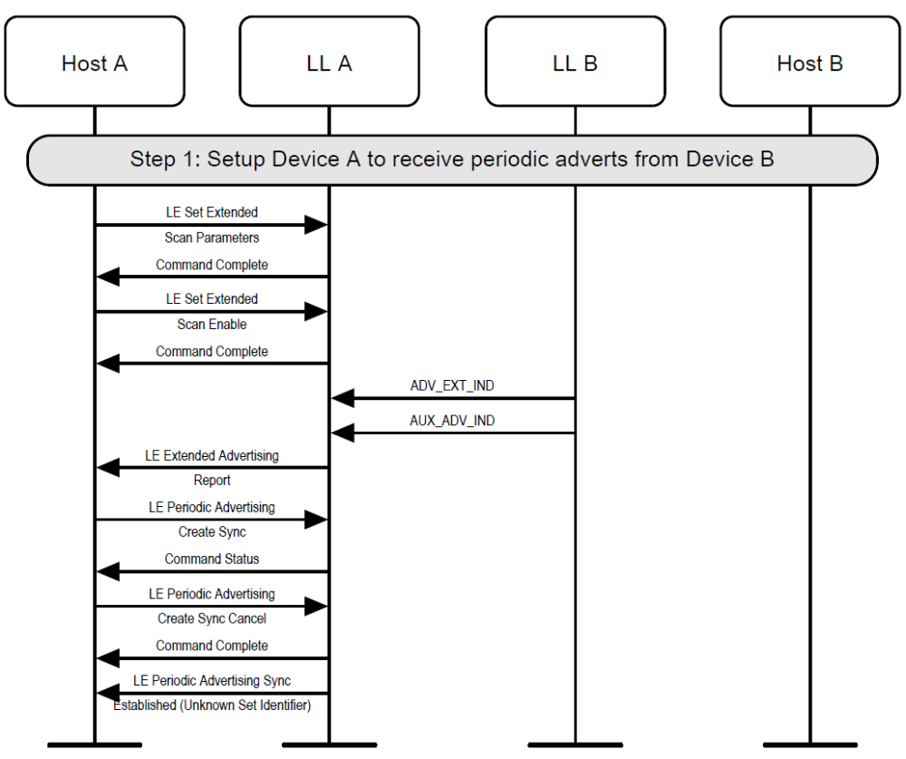
Figure 4.X Periodic Scanning Cancel

[NEW SECTION] 4.X Periodic Scanning Timeout
4.X Periodic Scanning Timeout
A device may lose synchronization with a periodic advertiser (see Figure 4.X).
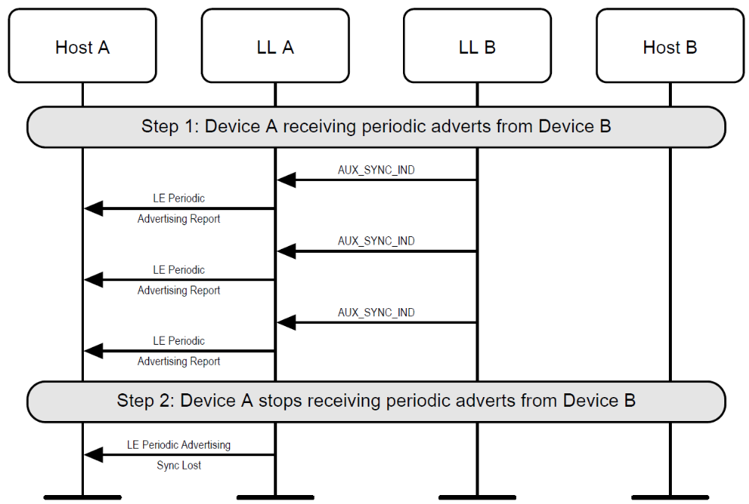
Figure 4.X Periodic Scanning Timeout

[NEW SECTION] 4.X Periodic Scanning Terminate
4.X Periodic Scanning Terminate
Once synchronized with a periodic advertiser, the Host can terminate the synchronization (see Figure 4.X).
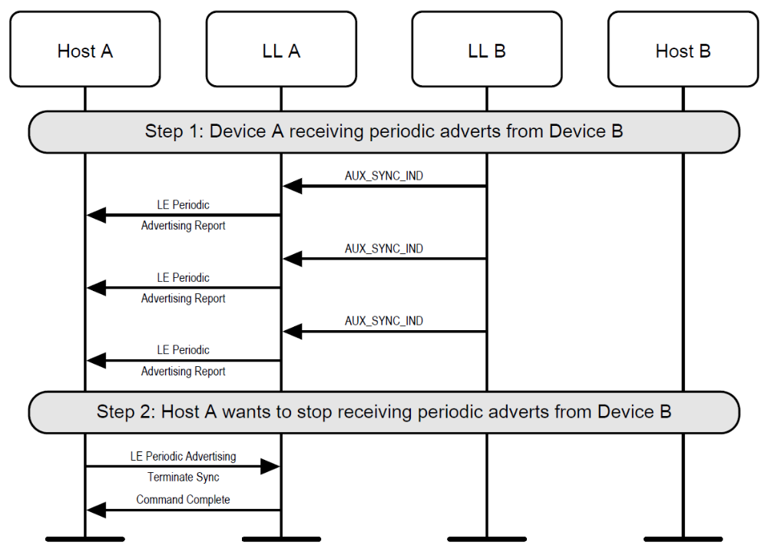
Figure 4.X Periodic Scanning Terminate

[NEW SECTION] 5.X Initiating a Connection on the secondary advertising channel
5.X Initiating a Connection on the secondary advertising channel
A device can initiate a connection to an advertiser on the secondary channel. This example shows a successful initiation, resulting in both devices able to send application data (see Figure 5.X).
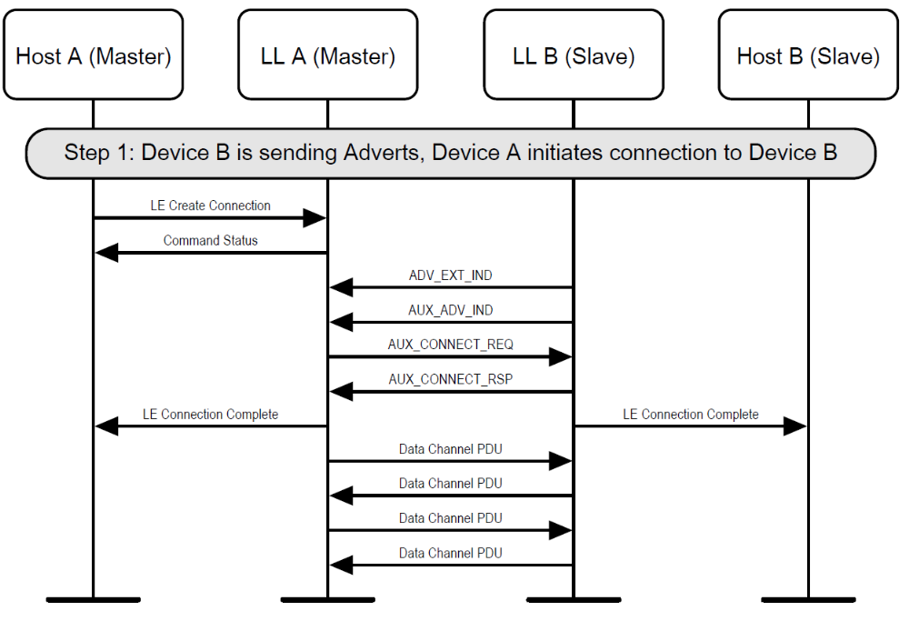
Figure 5.X Initiating a connection on the secondary advertising channel

Core Specification Supplement (CSS)

[Modified Part] Part A: Host Data Types Specification
Part A: Host Data Types Specification

[Modified Section] 1 Host Data Types Definitions and Formats
1 Host Data Types Definitions and Formats
This part defines the basic data types used for Extended Inquiry Response (EIR), Advertising Data (AD), and OOB data blocks. All data types defined here may be used for EIR or AD data types unless stated otherwise. Additional data types may be defined in profile specifications.

The values for the data types are listed in the Bluetooth Assigned Numbers document.

All numerical multi-byte entities and values associated with the following data types shall use little-endian byte order.

[New Part] Part X: Controller Data Types Specification
Part X: Controller Data Types Specification

[New Section] 1 Controller Data Types Definitions and Formats
1 Controller Data Types Definitions and Formats

This part defines the basic data types used for Additional Controller Advertising Data (ACAD).

The values for the data types are listed in the Bluetooth Assigned Numbers document.

All numerical multi-byte entities and values associated with the following data types shall use little-endian byte order.
The data types listed in table 1.1 shall have the same description and format as the types with the same name defined in the specified section of Part A section 1.
Data type | Reference
Service UUID | Part A, Section 1.1
Manufacturer Specific Data | Part A, Section 1.4
Service Data | Part A, Section 1.11
Table 1.1: data types specified in part A

[New Section] 1.1 Channel Map Update Indication
1.1 Channel Map Update Indication
1.1.1 Description
The channel map (channelMap) used for periodic advertisements may be updated at any time by the advertiser. The advertiser can update the channel map by sending the Channel Map Update Indication data type in the extended header of the packet containing the AUX_SYNC_IND PDU. The advertiser’s Host may provide an initial channel map using the LE Set Host Channel Classification HCI Command; however the advertiser’s Controller can update the channel map based on channel assessments without being requested to by the Host. The Channel Map Update Indication data type shall only be present in the extended header of the packet containing the AUX_SYNC_IND PDU.

The NumAdvEvents field shall be used to indicate the number of advertising events after which channelMapNEW shall apply. The advertising event at which the channel map change applies is called instant. The advertising event in which the Channel Map Update Indication data type is transmitted is counted as zero.

Upon first transmission of the data type the advertiser should allow a minimum of 6 advertising events for the channel map change. On each subsequent transmission of the data type the advertiser shall adjust the value of NumAdvEvents such that the instant would remain unchanged.

The channel map used before the instant is known as channelMapOLD. The channel map contained in the Channel Map Update Indication data type and used at the instant and after, is known as channelMapNEW.

When the instant is reached, the channelMapNEW shall be the current channelMap. The lastUnmappedChannel shall not be reset. If the unmappedChannel is an unused channel, then the channelMapNEW will be used when remapping. The only parameter that changes is the channelMap.

The advertiser shall not send a new Channel Map Update Indication data type before the instant.

1.1.2 Format

The Channel Map Update Indication data type size is 6 octets.
Data Type | Octets | Description
<<Channel Map Update Indication>> | 0-4 | ChM
<<Channel Map Update Indication>> | 5 | NumAdvEvents

The ChM field shall contain the channel map indicating Used and Unused data channels. The format of this field is identical to the ChM field in the CONNECT_IND PDU (see Core Specification, Volume 6, Part B, Section 2.3.3.1).

The NumAdvEvents field shall be set to indicate the number of advertising events as described in Section 1.TBD.1.

[New Section] 2 Examples
2 Examples

[New Section] 2.1 Example ACAD – Channel Map Update Indication
2.1 Example ACAD – Channel Map Update Indication
Value | Notes
0x09 | Length of this Data
TBD | <<Channel Map Update Indication>>
0xFF | ChM = 0x1FFFFFF7FF
0xF7 | ChM = 0x1FFFFFF7FF
0xFF | ChM = 0x1FFFFFF7FF
0xFF | ChM = 0x1FFFFFF7FF
0x1F | ChM = 0x1FFFFFF7FF
0x06 | NumAdvEvents = 0x06

References
- LE Advertising Extensions FIPD D05r14
- Bluetooth Core Specification Version 4.2
- Bluetooth Core Specification Supplement (CSS) v6 or later.

Formerly called Connection Rejected Due To Limited Resources
Formerly called Directed Advertising Timeout

